# Around the World

TBC- EID

7th May -NSPCC Number Day

17th May- Walk to School Week

19th May- National Numeracy Day



# This term in English and Novel Study, we will be reading the book ‘Paddington’ by Michael Bond. In English, we will be writing a setting description, a character description, innovating the story of Paddington and towards the end of the term, we will write our own fact file all about Paddington.

# In Maths, we will be investigating and exploring numbers within 100, revisiting adding and subtracting 2-digit numbers using the ‘Make 10’ method and learn how to use the column method to add and subtract 2-digit numbers.

# Our Science topic this term is Living Things and their habitats. Please read this term’s Science knowledge organiser to find out more information.

# For more information see the attached knowledge organsier.

Visit our Academy Twitter and Facebook pages to find out more about what happens at Oasis Don Valley! <http://facebook.com/OasisAcademyDonValley/>  @oasisdonvalley

# Year 2- Class Hargreaves

# Summer Term 1 2021



This term we have had an increase in rocket readers. **Well done!** We have had an average of 18/30 rocket readers per week. Next term can we make that 30/30?

Make sure you are reading with your child **at least 3 times a week** and you are signing this in their journal.

You can also log in to [www.myon.co.uk](http://www.myon.co.uk) for thousands of free books.

# Help at home by….

Use [TTRockstars](https://ttrockstars.com/) to help your child improve their timetable knowledge.

Supporting them in completing their weekly 2Dos on Purple Mash.

Practice spelling the words on the high frequency words list.

Practice counting in 2s, 3s, 5s, and 10s.

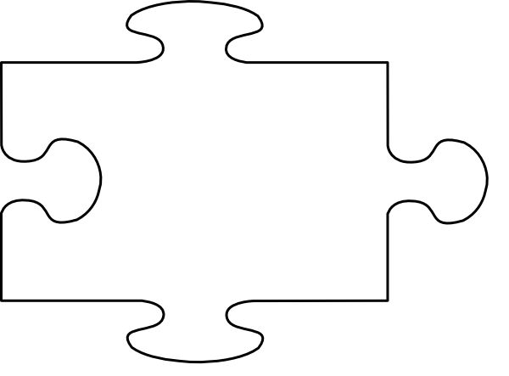



JIGSAW CORNER

This half term our Jigsaw topic is ‘Changing Me’. We will be learning the names for different parts of our bodies and how things change as they grow.



Rowha

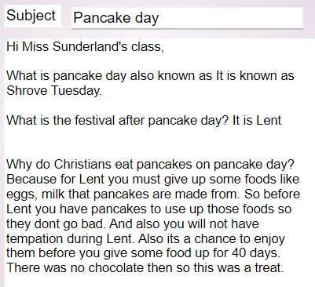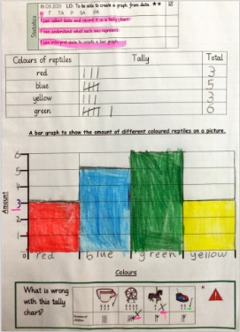

**STAR LEARNERS**

Saniya

[](https://www.google.co.uk/url?sa=i&rct=j&q=&esrc=s&source=images&cd=&cad=rja&uact=8&ved=2ahUKEwjTwb7H6uXfAhVMPBoKHcpeAFIQjRx6BAgBEAU&url=https://www.jigsawpshe.com/international-primary-curriculum-and-jigsaw/&psig=AOvVaw30h_95wvyE7aNGKlM2cfD3&ust=1547299658428358)