The World Around Me

**22.4.21 – National Earth Day**

**3.5.21 – Unseen disability awareness**

**17.5.21 – Walk to school Week**

**21.5.21 – Outdoor Classroom Day**



This half term we will be **reading** the book ‘City of Rust’. This book follows Reiley who races drones until a bounty hunter ruins this and her world is turned upside down! Within **science,** we will be exploring sound. How we hear and why it is at different volumes. In **DT** we will be exploring greenhouses and making our own mini one! We will be making our own stock motion animation within **computing**. As part of our **geography** learning we will be planning a journey, considering the different routes we could take.

# Class Walliams

Summer One - 2021

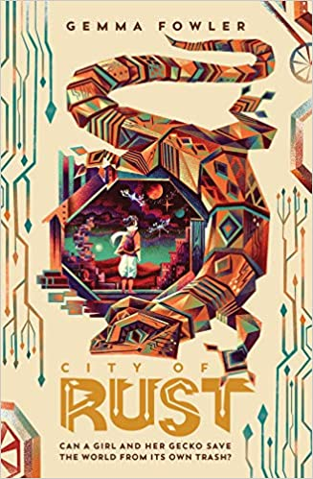





**How to Contact Miss Naylor**

**Home/Academy journals** – every child will be bringing home a journal. It is important that they bring this book to school every day. Within this book there is a section called a message board where you can write notes to the teacher.

**Email** – if you need to send a message to a member of staff you can email them using [info@oasisdonvalley.org](mailto:info@oasisdonvalley.org) your email will be directed to the relevant person.

**Telephone** – at the moment it is difficult for staff to speak with parents at the start and the end of the day due to staggered starts, however you can ring the Academy, leave a message and staff will return your call at the end of the day when they have finished teaching

Star Learner - Rayyan

Rayyan has worked so hard since returning to school! He tries hard in every subject and has been working particularly hard on improving his independence! He is always eager to learn and to take on advice and feedback to help him improve his work.

JIGSAW CORNER

Changing Me

Within Jigsaw this half term we will be looking at what makes us unique. We will identify changes that happen to our bodies and accept ourselves for who we are.



# Help at home by….

* Reading 3 times a week and recording in their reading journal.
* Explore words with your child to help them build understanding.
* Use the knowledge organizer with your child.
* Rehearse all the times tables up to 12 x 12.
* Use Spelling Shed, TTRS and MyOn frequently at home

|  |  |  |  |  |  |  |
| --- | --- | --- | --- | --- | --- | --- |
|  | Week 1 | Week 2 | Week 3 | Week 4 | Week 5 | Week 6 |
| Rocket reader percentages | 25% | 31% | 90% | 97% | 100% | 100% |

[](https://www.google.co.uk/url?sa=i&rct=j&q=&esrc=s&source=images&cd=&cad=rja&uact=8&ved=2ahUKEwjTwb7H6uXfAhVMPBoKHcpeAFIQjRx6BAgBEAU&url=https://www.jigsawpshe.com/international-primary-curriculum-and-jigsaw/&psig=AOvVaw30h_95wvyE7aNGKlM2cfD3&ust=1547299658428358)