**Reading Rockets**

We have been doing so well with our Rocket Readers. In Spring 2 our highest number of readers in a week was

23/30

To be a Rocket Reader, children must read at home at least

3 times a week.

Our world

***TBC*** *Police visit/virtual visit*

**12th April** – Ramadan starts.

**22nd April –** Earth day.

**23rd April –**St. George’s Day.

**7th May** – NSPCC number day

**4th-9th May 2021** – Deaf awareness week.



# For this topic, we will be looking at how we can take care of our world. We will be looking at the environment and recycling and how we can ensure the animals are safe and our world is looked after. We will also be learning about the different people who help us keep safe around the world, learning their jobs and how we can keep ourselves safe. We will be looking at, and comparing, different communities around the world and discussing similarities and differences.

# In Maths we will continue to develop our understanding of number, through doubling and halving numbers, and we will be looking at addition and subtraction within 20. We will be looking at shape and pattern, following criteria of a pattern, and using understanding and recognizing number,

# Class Ahlberg

# Summer Term 1 - 2021

# Help at home by….

* Reading 3 times a week and recording in their reading journal.
* Use the myon.co.uk app to explore more books
* Help your child to complete at least three tasks from the homework menu.
* Access Purple mash and explore the website using the logins in your home learning journals.

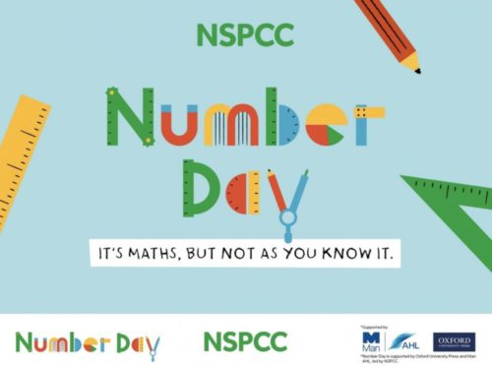

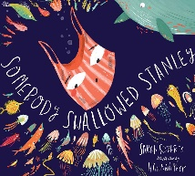

**JIGSAW CORNER**

This term we will be looking at the topic of ‘Changing me’ in our PSHE jigsaw lessons. This includes looking at our body and how it grows and keeping it healthy by eating healthy foods. We will also be looking at our fears and worries and how we can use strategies to help us when we are feeling worried.

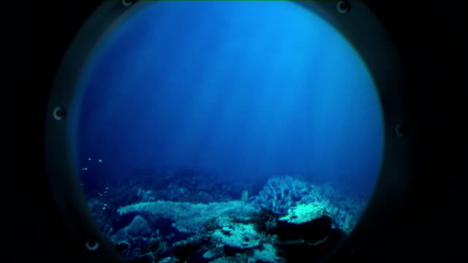

Visit our Academy Twitter and Facebook pages to find out more about what happens at Oasis Don Valley! <http://facebook.com/OasisAcademyDonValley/>  @oasisdonvalley

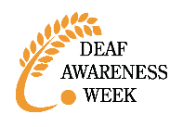



**Communication**

***If you would like to speak to your class teacher, there are many ways you can do so:***

***Home/Academy journals*** *–* every child will be bringing home ajournal. It is important that they bring this book to school every day. Within this book there is a section called a message board where you can write notes to the teacher and teachers can reply.

***Email*** – if you need to send a message to a member of staff you can email them using [info@oasisdonvalley.org](mailto:info@oasisdonvalley.org) your email will be directed to the relevant person – you can also use 2Email on Purple Mash. Here is a video explaining how: <https://vimeo.com/502108097>

***Telephone*** *–* at the moment it is difficult for staff to speak with parents at the start and the end of the day due to staggered starts, however you can ring the Academy, leave a message and staff will return your call at the end of the day when they have finished teaching.

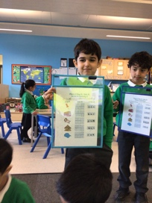**Class Ahlberg’s STAR Learners!**

Well done to Salam and Adam who

are Class Ahlberg’s Star Writer and

Marvellous Mathematician this half

Term!

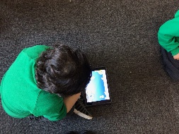[](https://www.google.co.uk/url?sa=i&rct=j&q=&esrc=s&source=images&cd=&cad=rja&uact=8&ved=2ahUKEwjTwb7H6uXfAhVMPBoKHcpeAFIQjRx6BAgBEAU&url=https://www.jigsawpshe.com/international-primary-curriculum-and-jigsaw/&psig=AOvVaw30h_95wvyE7aNGKlM2cfD3&ust=1547299658428358)