The World around me.

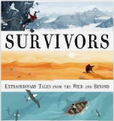

# Our Learning.

# This half term we will be reading the book ‘Survivors’ by David Long. The book contains 23 true stories about people who have had terrifying near death experiences and lived to tell the tale! We will link our learning on ‘Survivors’ to our geography learning, in which we will focus on identifying the key aspects of both earthquakes and volcanoes as well as locating some of the world’s most famous volcanoes. In science we will be revisiting our learning on rocks, focusing on how we can recognise the difference between sedimentary, igneous and metamorphic rocks as well as carrying out investigations into the way igneous rocks are fomed.

# 

# Year 3

# Summer term 1 2021



**22.4.21 – National Earth Day**

**3.5.21 – Unseen disability awareness**

**17.5.21 – Walk to school Week**

**21.5.21 – Outdoor Classroom Day**

# Help at home by….

* Reading 3 times a week and recording in their reading journal.
* Encouraging your child to learn their spellings every week so that they can use them in their writing.
* Help your child complete at least three tasks from the homework menu.
* Rehearse the eight times tables.
* Remember that as well as your daily time at school you should be accessing TTRS, Purple Mash, Myon, Spelling Shed and Lexia to further your learning.

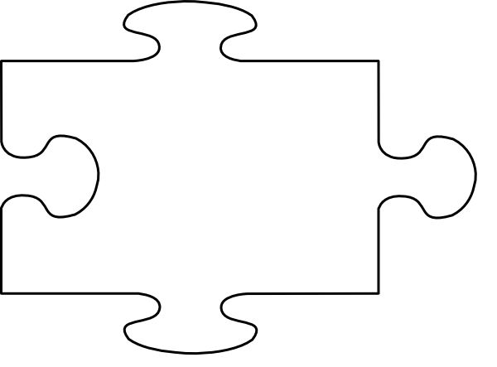

JIGSAW CORNER

Changing Me

Within Jigsaw this half term, we will learn about the changes that will happen to our bodies as we grow. We will also look at what babies need to help them grow and survive.



Star Learners.   
Joud from class Pratchett and   
Jamella from class Morpurgo have been chosen as our star learners this half term. Both Joud and Jamella are ALWAYS children who ALWAYS word hard, show respect and are enthusiastic towards their learning.   
**Well done Joud and Jamella!**

**If you need to contact your child’s teacher.  
Home/Academy journals** – every child will be bringing home a journal. It is important that they bring this book to school every day. Within this book there is a section called a message board where you can write notes to the teacher.

**Email** – if you need to send a message to a member of staff you can email them using [info@oasisdonvalley.org](mailto:info@oasisdonvalley.org) your email will be directed to the relevant person.

**Telephone** – at the moment it is difficult for staff to speak with parents at the start and the end of the day due to staggered starts, however you can ring the Academy, leave a message and staff will return your call at the end of the day when they have finished teaching

[](https://www.google.co.uk/url?sa=i&rct=j&q=&esrc=s&source=images&cd=&cad=rja&uact=8&ved=2ahUKEwjTwb7H6uXfAhVMPBoKHcpeAFIQjRx6BAgBEAU&url=https://www.jigsawpshe.com/international-primary-curriculum-and-jigsaw/&psig=AOvVaw30h_95wvyE7aNGKlM2cfD3&ust=1547299658428358)

Rocket reader %