The World We Live In

# This half term in Geography, we will be looking at the polar regions. We will locate the north and south pole and identify the why the climate is so different to the rest of the world. We will understand how people and animals have adapted to survive in the harsh conditions and understand how explorers have helped shape our understanding of the world.

In **Science,** we will be learning all about the circulatory system. We will dissect a heart and understand how blood travels around our bodies to keep us alive. We will also explore the importance of keeping a healthy. healthy lifestyle.

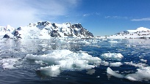

**Ramadan**

**Eid**

St Georges day

Sheffield Book Awards-Coming Soon!

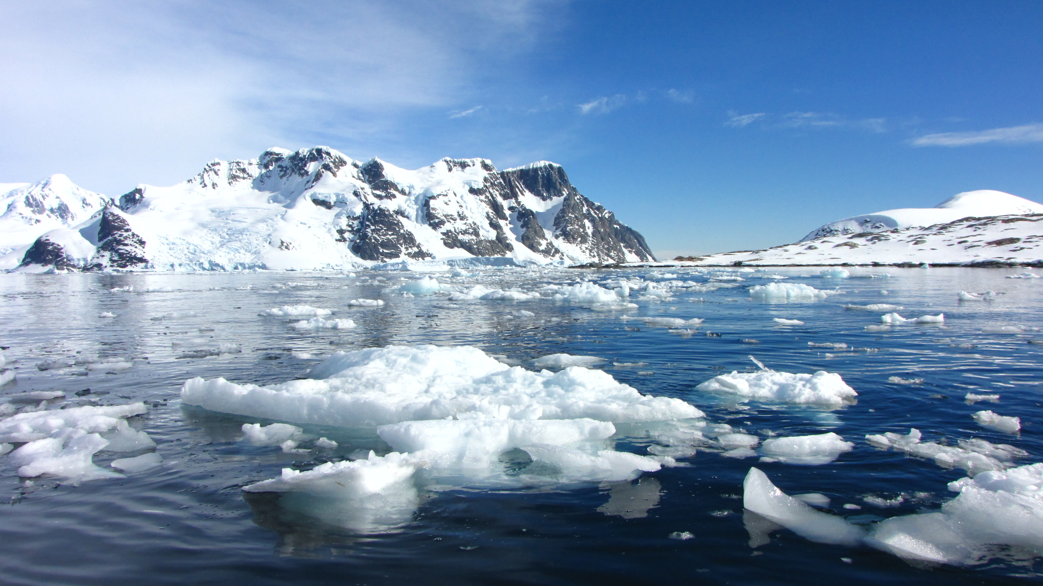



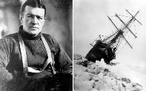

# Class Lewis

# Summer 2

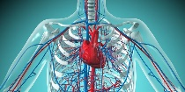

Our average Rocket Reader percentage was 87%. We have had a few 100% weeks let’s make it 100% for the whole term!

We will be **reading** ‘Sky Song’ by Abi Elphinstone.

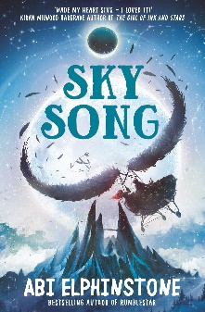

In **English**, the children will be using our class book as the stimulus to write a narrative. The children will develop their story telling skills by building character and setting descriptions. They will solidify their understanding of figurative language and use it effectively to create a positive or negative affect on their reader. We will also be reading a range of non-fiction and poetry texts to improve their inference skills.

# Help at home by….

* Please use the Home Academy Journal as the main point of contact with teachers
* Reading 3 times a week and recording in their reading journal or on Myon!
* Supporting them with the spellings that are available on MS Teams and Spelling Shed.
* Login to TTRS to build their multiplication fluency
* Developing their vocabulary through talk and discussion

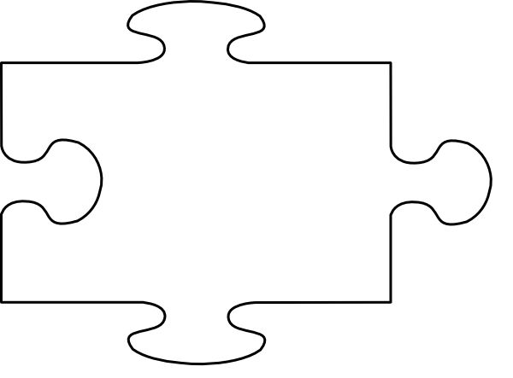

JIGSAW CORNER

Relationships

We will learn about self-esteem and how to look after our mental health. We will also explore feelings and how our bodies change as we get older. We will learn how babies develop.

Spring 2’s star learner was **Leonidas 😊!**

Leonidas has made a great impression since returning to the academy after lockdown. He is focused, determined and doing very well. He has challenged himself in all areas of his learning and we’re very proud of him !

**Maths**

Year 6 will be recapping the 4 operations and using that knowledge to solve problems efficiently. We will also explore angles within shapes and use that knowledge to help us draw 2D shapes. We will then look at 3D shapes and their nets.

Make sure your child is using Prodigy & TTRS each week to keep up with their learning.