Physical Development
Here are some ideas you can do at home to develop gross and fine motor development (this will help them with writing and moving safely)
- Stacking tin cans on top of each other without them falling over 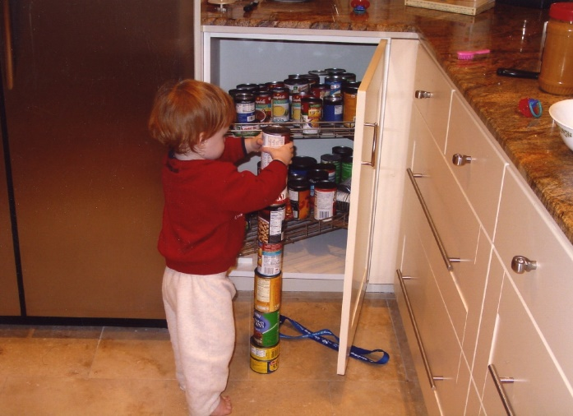

- Following a line with their finger/pencil/paintbrush – adult to draw a line first, this could be on paper, in sand, cardboard

- Balance on different parts of your body e.g. can you balance on one foot? With one hand and one foot on the floor? On your bottom with hands and feet off the floor?
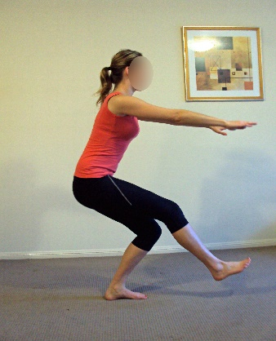
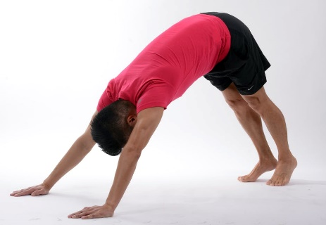
This Photo by Unknown Author is licensed under CC BY-SA-NC
PE With Joe Wicks on Youtube can be viewed by clicking the link below:
https://www.youtube.com/watch?v=6v-a_dpwhro&feature=youtu.be

How long can you hold it for?

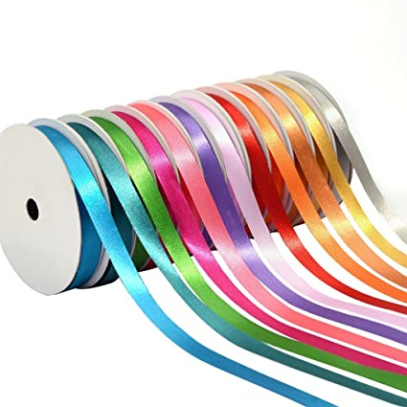
- Can you make big movements with scarves? Or ribbon?
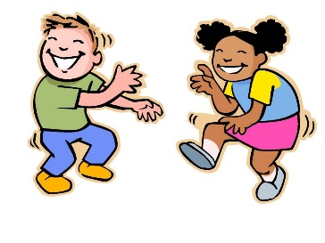

- Perform your own Dough Disco – see youtube and Shonette Bason Woods for ideas
https://www.youtube.com/watch?v=3K-CQrjI0uY
See playdough recipe to make your own playdough

