TALKING ABOUT ‘BEHAVIOUR’ WITH A CHILD OR YOUNG PERSON WITH COMMUNICATION DIFFICULTIES

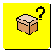 What?
- Children and young people with communication difficulties can find it very hard to talk about their behaviour and to talk about and reflect on ‘behaviour incidents.
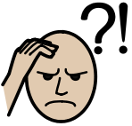
- This can be because the types of questions we ask when trying to find out about behaviour or incidents require the child of young person to understand complex questions, to ‘read-between-the-lines’, reason and understand complex things like feelings in themselves and others.
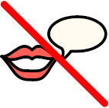
- Some children and young people may not be able to give their ‘side of the story’ easily because they struggle to understand and/or to use express themselves.
- We can make these conversations easier and fairer for children and young people with communication difficulties:
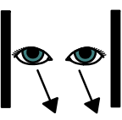
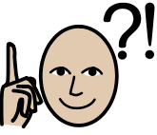

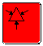 How?

- Visually support:
- Drawing the situation as you talk helps to slow the pace of the conversation, simplify questions, show the child/young person what you are understanding, get the order of events right, explore complicated ideas like ‘feelings’ and problem solve. See the ‘Comic Strip Conversations’ strategy sheet for more information.

And…

- Simplify questions:
  - Questions that require the child/young person to summarise and retell can be too hard:
- e.g. “Tell me what happened”
This requires the child/young person to ‘read-between-the-lines’ and understand what you might be referring to, pick out the important parts of an incident, organise and sequence their ideas, find the words to explain
Try:
- Breaking the question down into simpler, concrete questions e.g.:
“who was there?”, “where were you?”, “what did they say/do first?”
1st next then
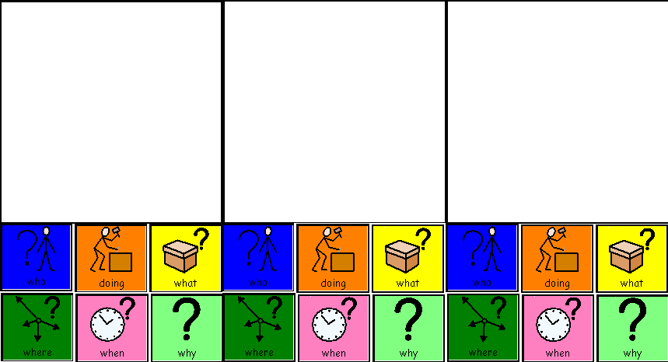

How? cont…

- Questions that require the child or young person to reason, justify, predict and reflect can be too hard:
- e.g. “why…?”, “how…?”, “would/could/should…?”, “if…”
- “why did you do that?”, “why is it wrong to …..?”, “what would happen if….”, “how did s/he feel?”, “how did you feel?”, “what is the problem with what happened/what you did?”, “what were you thinking at the time?”, “what have you thought since?”, “if you knew this would happen, what should you have done?”

Try:
- Saying what happened/what you know and explain how it affected the people involved:
“you threw the pen and it hurt Katie”, “When you felt really cross you slammed the door and the hinges broke. Now the door needs fixing”
- Saying what happened/what you know and giving choices:
“did you throw the pen because you were cross? Bored? worried?”
- Saying what happened/what you know and giving clues/cues:
“His picture was ripped and he started to cry. When people cry this often means they are…?”
- Scaffolding the answer by saying what happened/what you know and seeing if the child/young person can complete the sentence:
“you threw the pen because…?”, “you hid in the cupboard. People don’t know where you are, They might worry you are not safe”
- Repeating the question and modelling the answer
“why is it wrong to shout in the corridors? It’s wrong to shout in the corridor because it might stop the other children listening and thinking”
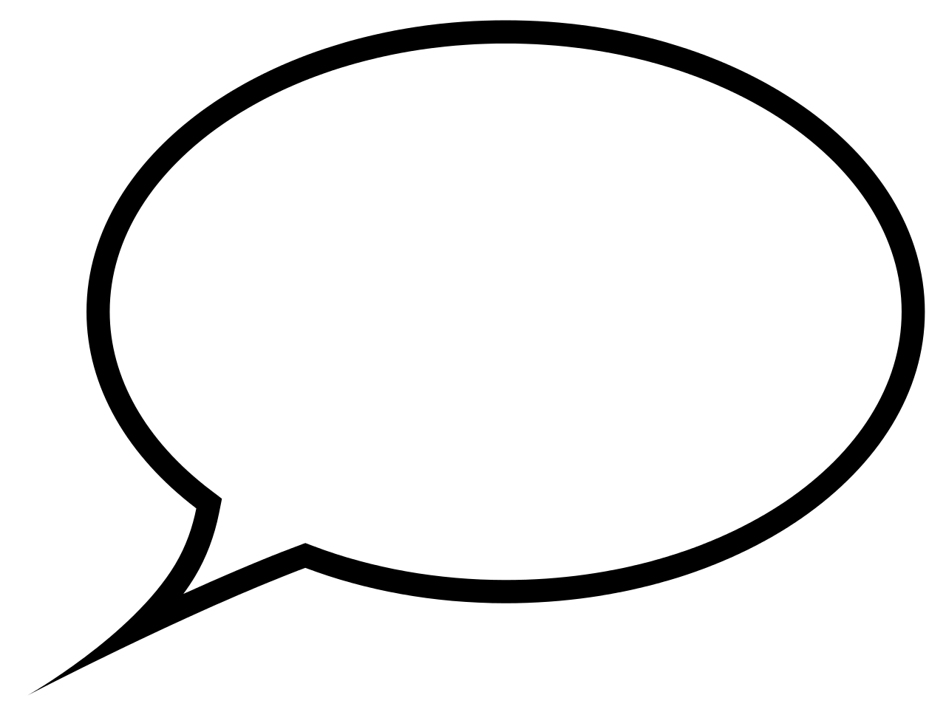Simplify
Scaffold
Model
Give choices

Draw
Who?
Where?
When?
First …
Then …

Tell me what happened.
Why?
How?

What could …
What should …
If …

