Learning Intention: To say the initial sound to match the picture

Initial sounds. Ask your child to tell you the first (initial) sound for each picture. Ask them to tell you what the picture is and then what the first (initial) sound is. You could also ask your child to practise writing the initial sound for each picture.

For example the first picture is an apple and the initial sound would be a.

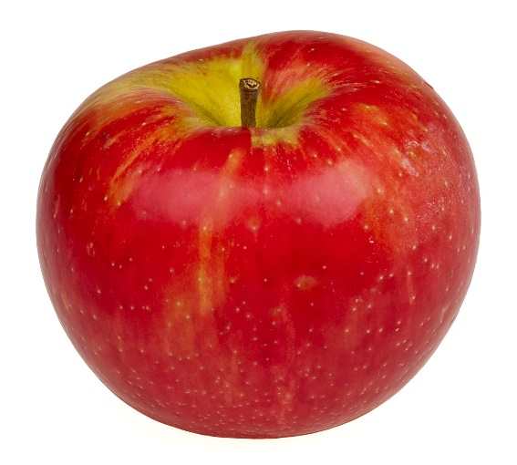

_____ pple

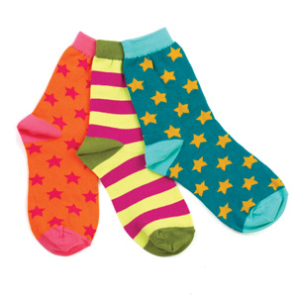

_____ ocks

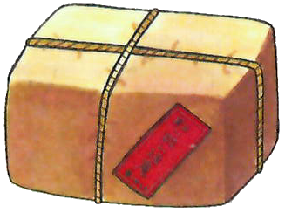

_____ arcel

Learning Intention: To say the initial sound to match the picture

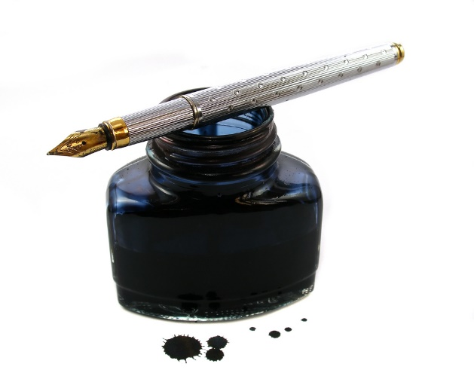

_____ nk

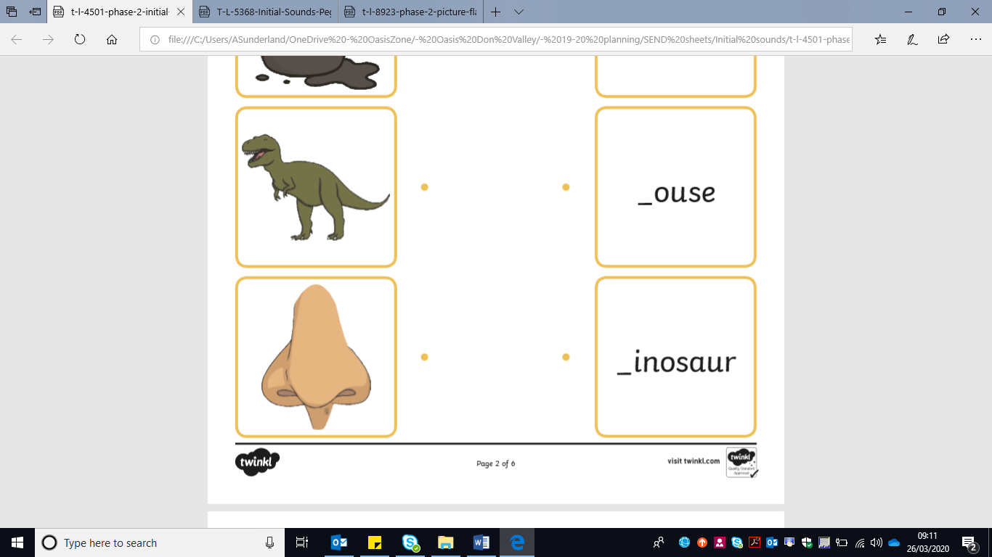

_____ ose

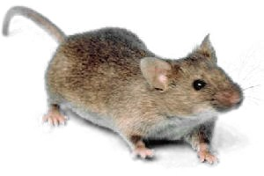

_____ ouse

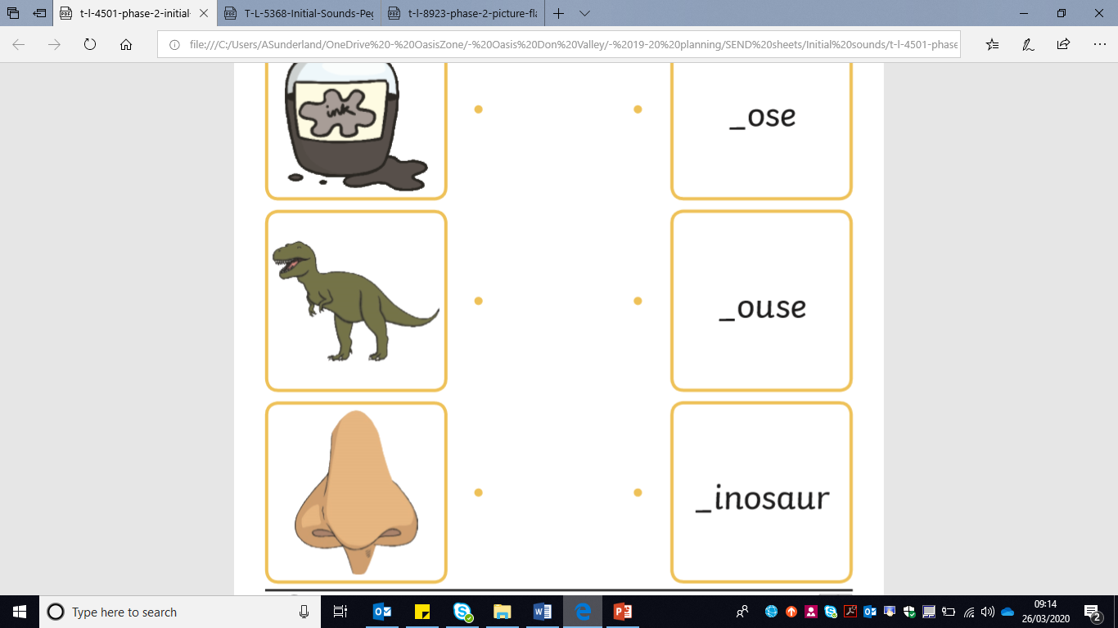

_____ inosaur

Learning Intention: To say the initial sound to match the picture

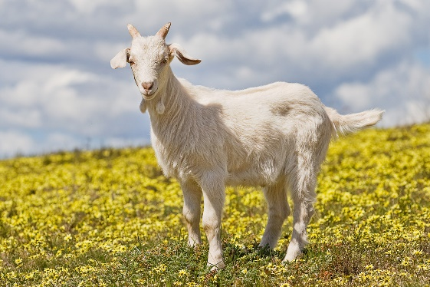

_____ oat

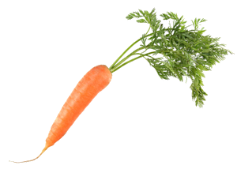

_____ arrot

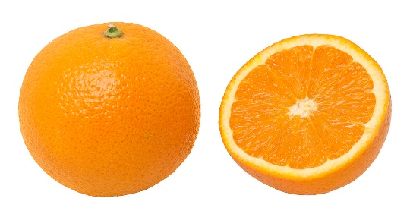

_____ range

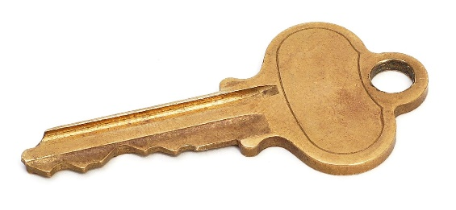

_____ ey

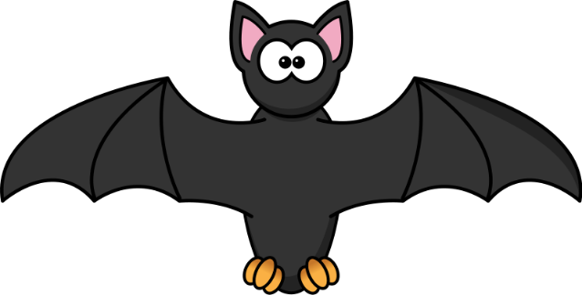

_____ at

Learning Intention: To say the initial sound to match the picture

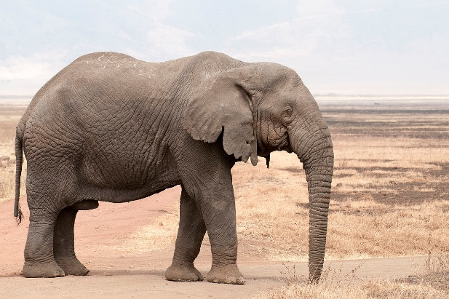

_____ lephant



_____ mbrella



_____ obot

_____ and

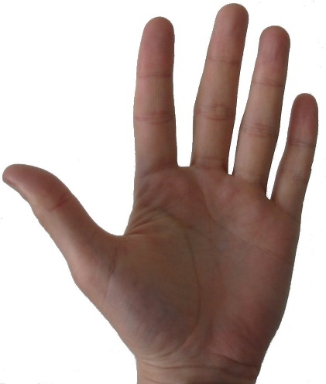

Learning Intention: To say the initial sound to match the picture

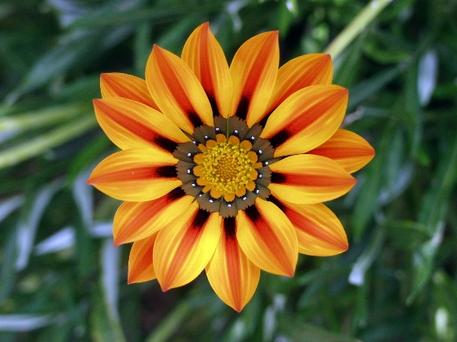

_____ lower

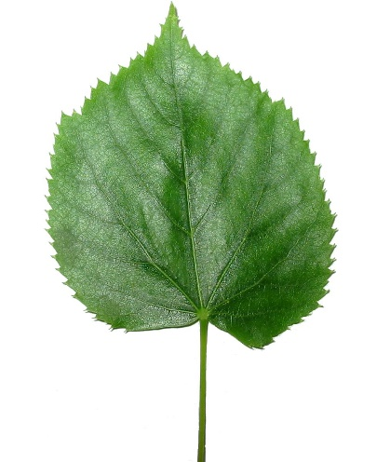

_____ eaf