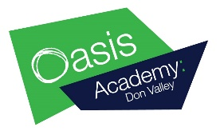
Learning Intention: To read the phase 3 sentences and draw pictures to match.
Oral blending. Read the phase 3 words in the sentences by segmenting the sounds in the words and blending them back together. When you have read and understood the sentence, you can draw a picture to match.
Example –
Mark and Carla got wet
in the rain.

I can hear an owl hoot at
night.

I can see a pair of boots
on the mat.

Learning Intention: To read the phase 3 sentences and draw pictures to match.

Jim has seven silver coins.

Nan is sitting in the
rocking chair.

The farmer is up at six in
the morning.

Learning Intention: To read the phase 3 sentences and draw pictures to match.

I see a goat and a cow
on the farm.

It has been hot this year.

Lee had a chat with his
Dad.

Learning Intention: To read the phase 3 sentences and draw pictures to match.

The forest has sixteen
trees.

The fish and chips are
on a dish.

All the tools are in the
shed.

