Sentence Writing
Learning Intention: To phase 5 spelling to write sentences.
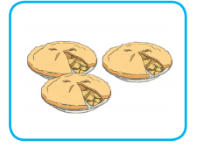
Use the sounds provided to help you write the word in the picture. For example ph = elephant. Then write a sentence using that word. The elephant had a big trunk.
Use the picture clue to write a sentence.
digraph: ey
Use the picture clue to write a sentence.
digraph: ie
Use the picture clue to write a sentence.
digraph: ay
Use the picture clue to write a sentence.
digraph: ph

