Shape Pictures

**Learning Intention: To recognise a range of 2D shapes.**

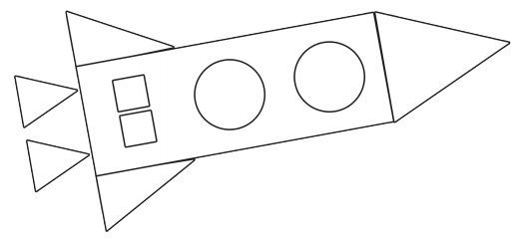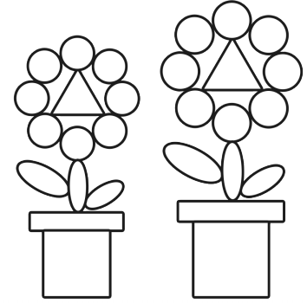

Create a picture using different shapes.

Here are some examples.

Label the shapes you use.