Next time you open a packet of raisins, some carrot sticks or apple pieces, count out how many you have. If you’re eating them with a friend, count how many they have too. Can you write the numbers down? | Ask your grown- up to tell you a number. Place this number of raisins or cereal pieces on your plate. If your grown - up says ‘one more’, can you add one more and say the number you have? If your grown- up says ‘one less’, can you eat one then count the number you have left?  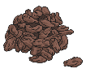 | Write out the numbers 0-20 on some paper or card, cut them up and then ask a grown up to mix the numbers up- don’t peek! Then, see how quickly you can put them into the correct order. You could ask someone to time you and then see if you can get faster when you try again.  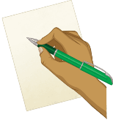 | Play the “What’s Missing?” game with someone. Find 5-10 objects inside your home. Arrange them on a tray. Have someone look at them for 5 seconds and then cover eyes while you take one of the items away. Can they guess what is missing? Then let your friend remove an item and you try to guess what is missing.  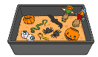
Play a game of maths ‘I Spy’. What can you see around you? How many? For example, “I spy 2 blue cars.” | 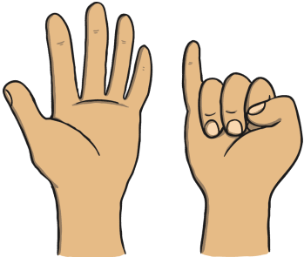  Sing number-themed counting rhymes and use your fingers or small props to help count the items, e.g. 10 Green Bottles | 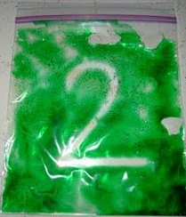  .Create a sensory squishy bag. This can be used for letter and number formation. (See instructions below). | Ask a grown up to draw a spotty snake. How many spots does it have? Can you count them Can you draw a snake that has one less spot?
Maths Home Learning Bingo

How to Make a Sensory Squishy Bag
For one sensory bag, you will need:
- 1 cup of flour
- 6 tablespoons of water
- 6 tablespoons of food colouring
- A zip-lock lunch bag
- Cello tape
- Small mixing bowl
What to do:
- First, place the flour into a mixing bowl.
- Next, add the water and food colouring to the flour.
- Then, mix all the ingredients until they are well-blended.
- Scoop the mixture into a plastic bag.
- Before fastening the bag, place it onto a flat surface. Gently push any excess air out to avoid air bubbles.
- Press the clips of the bag closed and ensure there are no holes.
- Place cello tape along the opening to secure the opening.
- Enjoy! Use your squishy bags to practice letter and number formation.

