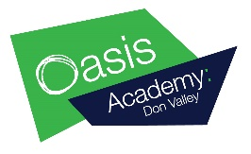
YouTube videos
There are lots of videos online, for example on YouTube, that have songs that support children with their phonics and learning of tricky words. We recommend watching a different video each day before encouraging your child to find a favourite one and learn it off by heart.
You can watch and sing along to these songs as many times a day as you like!
Here is a list that we recommend:

Phase 3 Phonics YouTube videos.
https://www.youtube.com/watch?v=R087lYrRpgY
https://www.youtube.com/watch?v=aNcBWSBxSp0
https://www.youtube.com/watch?v=0QwrkowksKk
https://www.youtube.com/watch?v=ri4u0TjAZ38

Phase 4 Phonics YouTube videos.
https://www.youtube.com/watch?v=3NOzgR1ANc4
Phase 5 Phonics YouTube videos.
https://www.youtube.com/watch?v=YPW-ZkhRUPY
https://www.youtube.com/watch?v=R3S5sJw7MfI

Tricky word/ sight word YouTube videos.
https://www.youtube.com/watch?v=TvMyssfAUx0
https://www.youtube.com/watch?v=R087lYrRpgY
https://www.youtube.com/watch?v=jbKAxxvIIcg

