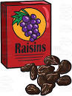  Next time you open a packet of snacks, count out how many you have. Then, see if you can divide them into 3 groups.  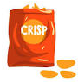 | 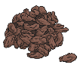  Ask your grown- up to tell you a number. Place this number of raisins or cereal pieces on your plate. If your grown - up says ‘1/2’ can you split them into the write number of groups and count how many are in 1/2? | Write a shopping list of what you would buy if you were in charge, including prices of each of the items. Then, see if you can add up all of the prices to find out how much your shopping would cost!  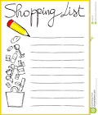 | Keep a log of what you do each day. When you move on to a different activity, look at the clock and see what time it is. Keep a record of this to show your teacher when you go back to school!  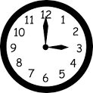
Create your own board game! On each square, come up with a multiplication question from your 2, 3 or 5 times table. Play it with your adult.  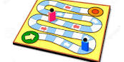 | Bake a cake with an adult. Can you cut the cake into quarters? Can you cut it into eighths?  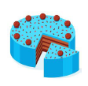 | Measure the perimeter of each room. Which one has the biggest perimeter?  Remember: The perimeter is the length of all the sides added together.  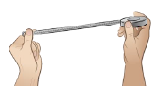 | Create a song to help you remember your 2, 5 or 10 times tables. You could even teach it to younger siblings to help them too!
Maths Home Learning Bingo
Have a go at these maths activities to help you with some of the basic maths skills you will need when we come back to school!

