Phonics Home Learning Bingo
Have a go at these phonics activities, you could change the sounds for each one once you have finished and practice some other sounds!
Can you read the sounds on this  page and think of a word that has each one in it?  igh oo  ee ie  ow air | Play a game with your grown-up. Take it in turns to give instructions. For example, ‘touch your f-ee-t’ or ‘stand u-p’.  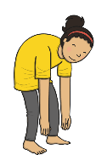 | Can you spell out any of the pictures? Tell your grown-up which sound it begins with and which sound it ends with. Do all the words have the same number of sounds?  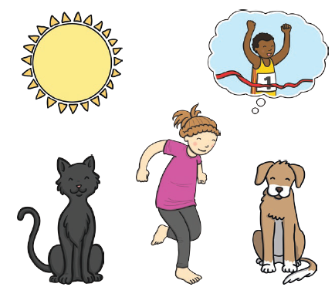
Look at things around the room  and say the sound they have in the middle. Write these words down and add the sound buttons. | Can you look in a book and find  any of these words? Which words  did you spot the most?  the to  I go  no | Play a game with your grown-up. Ask your grown-up to read a sound to you. Can you write the sound down? You could use different colours.

