

Look at the below picture and see if you can write a story about it. Be as creative as possible! Once you have completed your story see if you can act it out with other members of your family.

Title: ­­­­­­­­­­­­­­­________________________________________________________________________________________________________________________________________

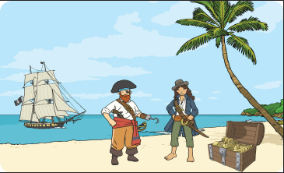

Who? ________________________________________________________________________________________________________________________________________

Where? ______________________________________________________________________________________________________________________________________

_______________________________________________________________________________________________________________________________________________

What was the problem? ______________________________________________________________________________________________________________________

_______________________________________________________________________________________________________________________________________________

How was it resolved? _________________________________________________________________________________________________________________________

______________________________________________________________________________________________________________________________________________

How does your story end? ____________________________________________________________________________________________________________________

_______________________________________________________________________________________________________________________________________________