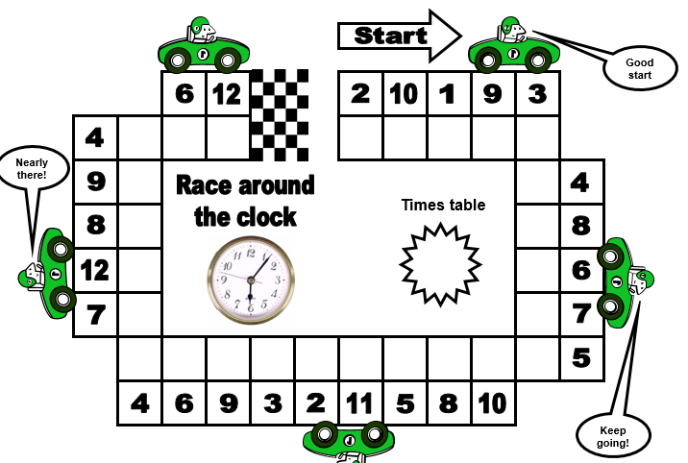

Focus on your 4, 6 or 5 times tables. As you move around the track, multiply the number around the outside by the times table you have chosen write the answers in the blank squares.