March 2020

Dear Parent/Carers,
During this difficult period of time we are fully committed to supporting the ongoing education of all of our Oasis Don Valley children. To this end we are providing a range of learning resources and independent study materials to be used if the Academy is closed or for prolonged absence of a child. We have also set up a page on the Academy website which we will update on a weekly basis each Monday, during any period of closure.
As you will be aware all children have already been provided each half term with a Knowledge Organiser containing the essential knowledge for each subject (these are currently available on the Academy website under the curriculum tab). This resource will be the foundation of children’s independent study and they have already been shown how to work effectively from this resource.
However, to further support students with their use of the Knowledge Organisers we have also provided additional materials for students to complete in their time at home. These materials include…
- Activities leaflet – 35 activities that you can do at home to continue your child’s learning. These include what’s missing and letter games, measuring tasks and number fact tasks.
- Activities menu – These activities are mainly practical and can be done in the home.
- Knowledge organiser: Healthy Me Quiz – A set of questions to test knowledge of the last topic. How much can you remember?
- Phase 2 and 3 sound mats – to help children with their writing, reading and letter formation.
- Capital letters and lower case letter formation – to practise capital letters and lower case letter formation.
- Mark making books – To be used to complete tasks sent on activities leaflet or activities menu.
- Extra reading books – to read and listen to at home.
- Name writing sheets – children to practise forming the letters of their name in sequence.
- Pencil control sheets – to practise pencil control.
- Number formation – to practise number formation from 0 – 20.
- Practise the 100 High Frequency words – you can write them in sentences, put them on bits of paper and stick them round the house, make 2 sets of them and play snap, stick to someone’s head and they have to try and guess what it is
- A list of websites to use at home

Initially we are providing your child with resources that we expect will ensure continuation of education beyond the Easter holidays. If the situation calls for further extended periods of closure or absence then additional work will be provided through the Academy website as referenced above.

Guidance on all of these resources is provided for your child in the following pages and will also be available on our website https://www.oasisacademydonvalley.org/

Thank you for everything you have done so far during these challenging conditions, I am extremely proud of our response as an academy and as a wider community and we would also like to thank you for your ongoing support in ensuring every child continues to receive their education.

Yours sincerely

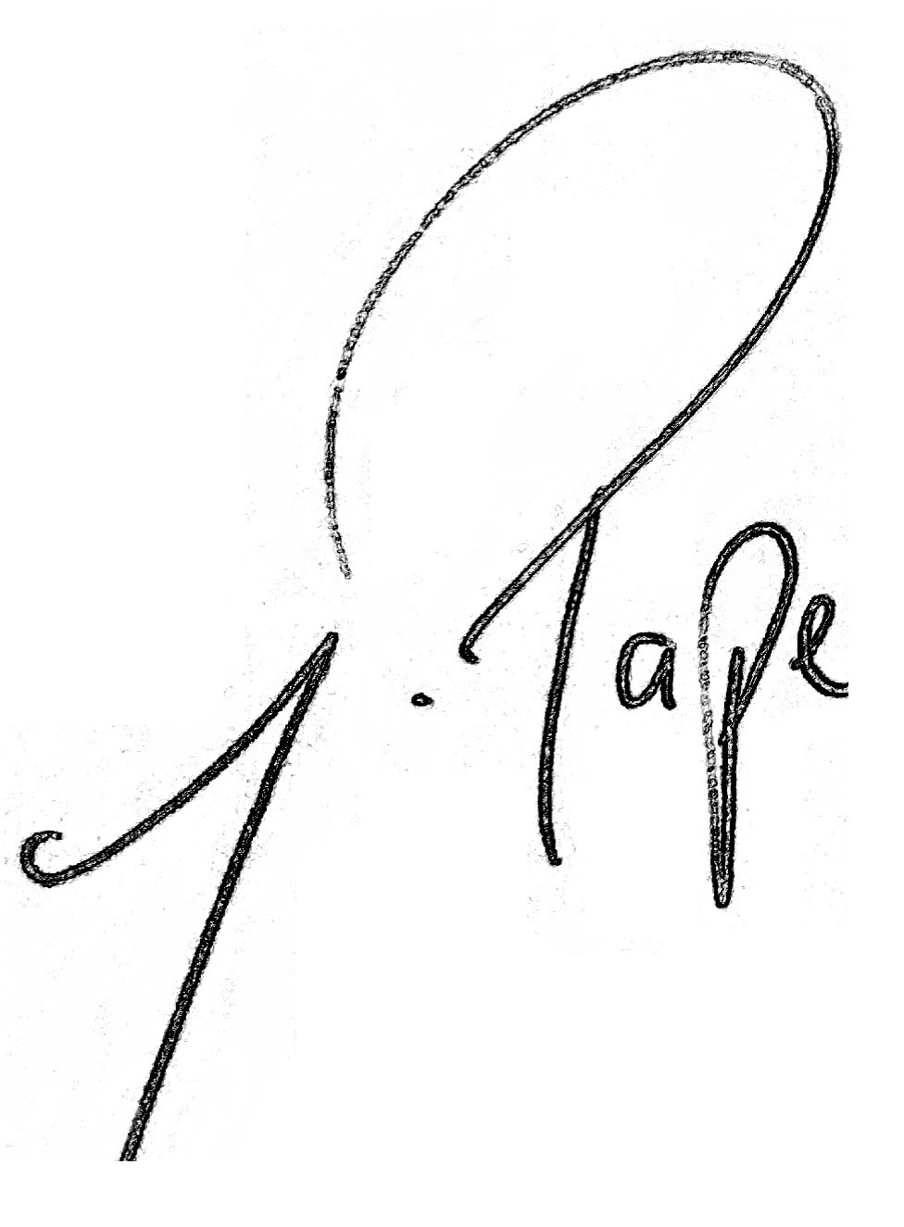

Mr J Pape
Principal

