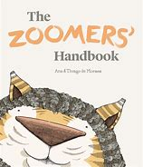
Menu for Zoomer animals

Zoomer animal:
Starter:

Main course:

Dessert:

