Tuesday 15h December 2020
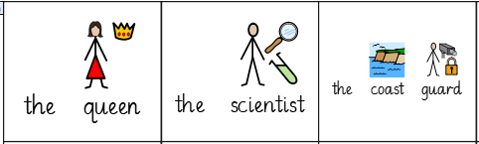
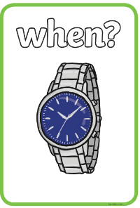
LO: To identify key information from part of the story.
Plan | I T TA P SA PA
 | I can recall key information from the text.
 | I can discuss the key information.
 | I can identify the four W’s.
