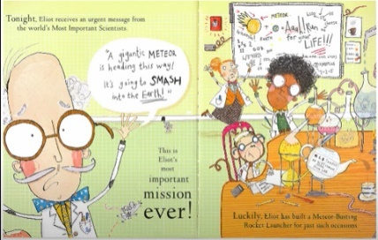**Tuesday 15th December 2020**

LO :To identify key information from part of the story. ★★

|  |  |  |
| --- | --- | --- |
| Plan | I T TA P SA PA | 🗹 |
| I can recall key information from the story. |  |
| I can identify the appropriate information. |  |
| I can form my letters correctly. |  |

