 **Tuesday 15th December 2020**

L.O: To read and write the time to o’clock and half past.★★★

|  |  |  |
| --- | --- | --- |
| Time | I T TA P SA PA | 🗹 |
| I can compare the difference between o’clock and half past. |  |
| I can explain how I know I have drawn the correct time. |  |
| I can identify activities that could occur at these times. |  |

The time is seven o’clock in the evening.

The time is half past three in the afternoon.

The time is eleven o’clock in the morning.

The time is half past seven in the morning.

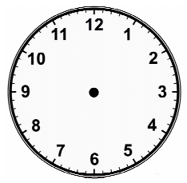





Green Challenge **Tuesday 15th December 2020** ★★★

The time is one hour after four o’clock. Can you draw the time?



Green Challenge **Tuesday 15th December 2020** ★★★

The time is one hour after four o’clock. Can you draw the time?



Green Challenge **Tuesday 15th December 2020** ★★★

The time is one hour after four o’clock. Can you draw the time?

