 **Tuesday 15th December 2020**

L.O: To read and write the time to o’clock and half past.★★

|  |  |  |
| --- | --- | --- |
| Time | I T TA P SA PA | 🗹 |
| I can draw o’clock and half past times. |  |
| I can begin to explain the differences in o’clock and half past. |  |
| I can draw the hands to the correct size. |  |

Playtime

Breakfast

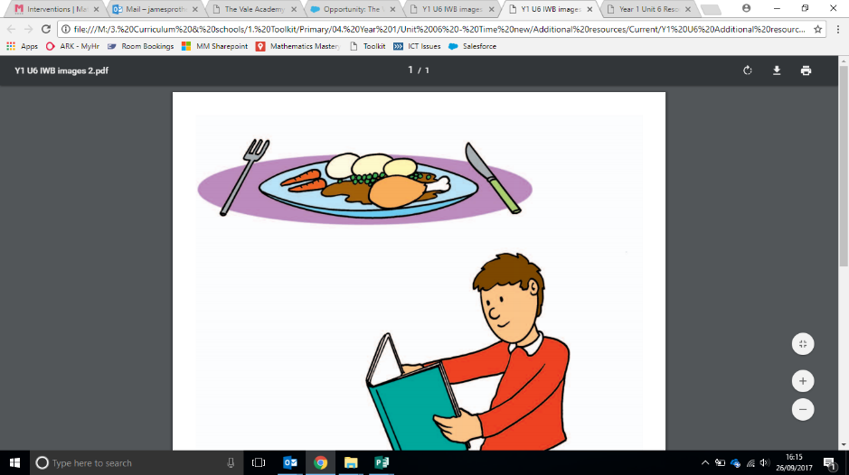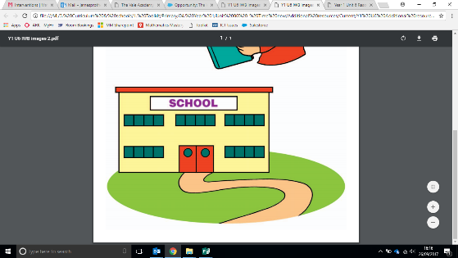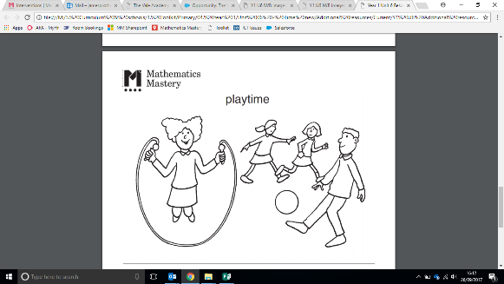

The time is five o’clock in the evening.

The time is half past three in the afternoon.

Home time

Dinner time

The time is ten o’clock in the morning.

The time is half past seven in the morning.

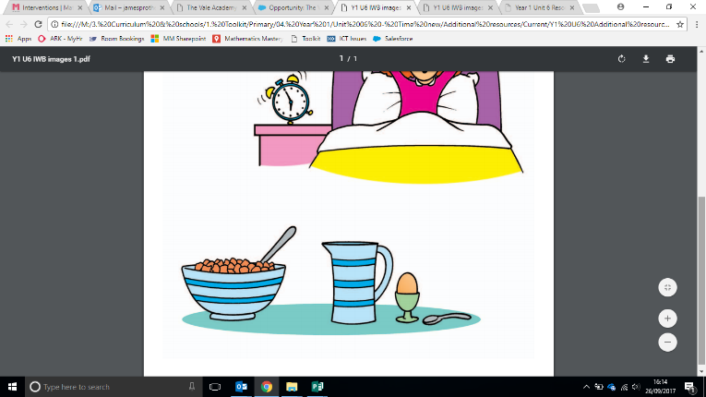

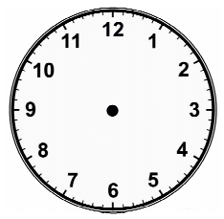





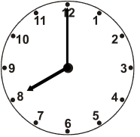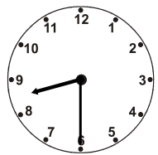

Green Challenge **Tuesday 15th December 2020** ★★

What’s the same? What’s different?

Green Challenge **Tuesday 15th December 2020** ★★

What’s the same? What’s different?

Green Challenge **Tuesday 15th December 2020** ★★

What’s the same? What’s different?

Green Challenge **Tuesday 15th December 2020** ★★

What’s the same? What’s different?