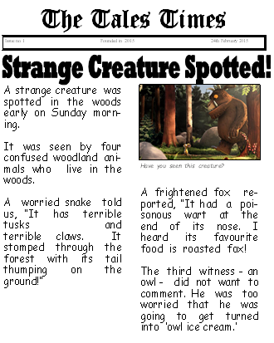 **Thursday 10th December 2020**

LO: To draw key features and information from a report. ★★

|  |  |  |
| --- | --- | --- |
| SPaG | I T TA P SA PA | 🗹 |
| I can identify the headline. |  |
| I can begin to retrieve information from a text. |  |
| I can identify the four W’s. |  |

