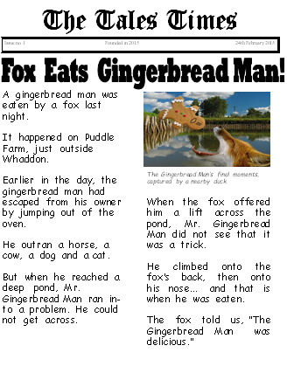
Thursday 10th December 2020
LO: To draw key features and information from a report.
SPaG | I T TA P SA PA
 | I can explain what a heading is and I can identify this within a report.
 | I can underline key information from the report.
 | I can explain the four W’s are and find them within a report.
Who is the report about?
When did the event happen?
Where did the event happen?
What is it about?
Headline

