 **Monday 14th December 2020**

L.O: To read the time to o’clock and half past.★★★

|  |  |  |
| --- | --- | --- |
| Time | I T TA P SA PA | 🗹 |
| I can compare the difference between o’clock and half past. |  |
| I can explain how I know when the time is. |  |
| I can explain when it becomes the afternoon. |  |

Playtime

Breakfast

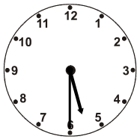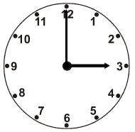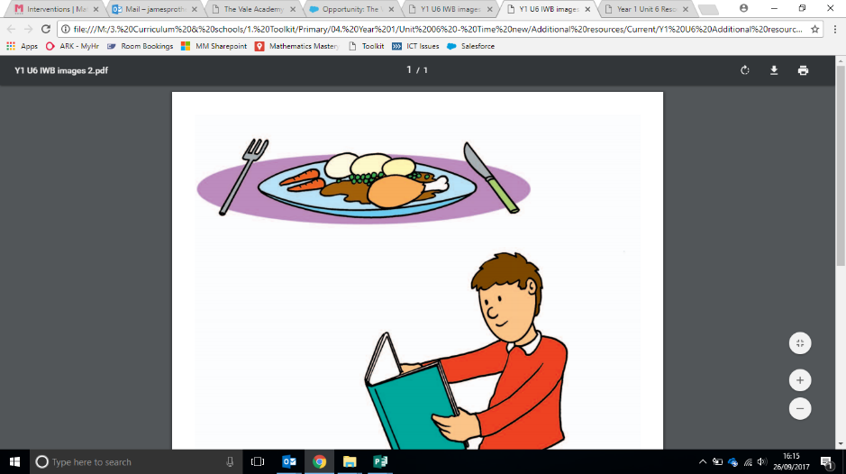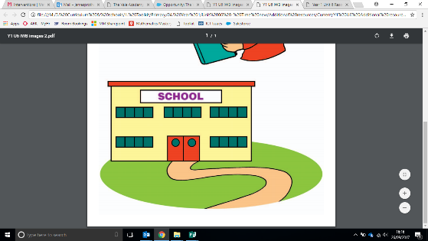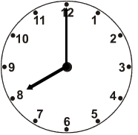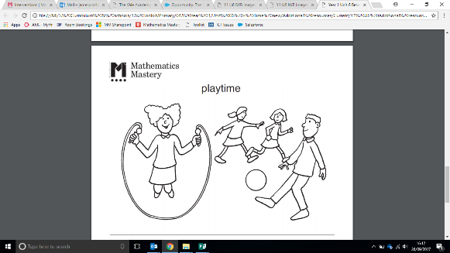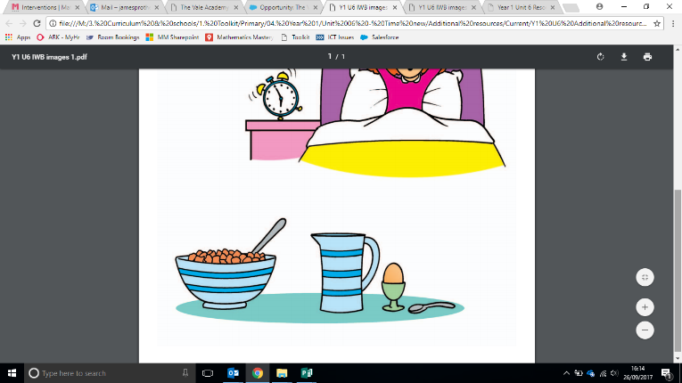

The time is ________________________ in the _____________________.

The time is ________________________ in the _____________________.

Home time

Dinner time

The time is ________________________ in the _____________________.

The time is ________________________ in the _____________________.

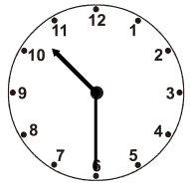

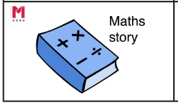

Green Challenge **Monday 14th December 2020** ★★★

Write a maths story about your day including times. Write whether it is in the morning or afternoon that the activities occur.

**For example: I wake up at half past seven in the morning. I eat my lunch at 12 o’clock in the afternoon.**

Green Challenge **Monday 14th December 2020** ★★★

Write a maths story about your day including times. Write whether it is in the morning or afternoon that the activities occur.

**For example: I wake up at half past seven in the morning. I eat my lunch at 12 o’clock in the afternoon.**

Green Challenge **Monday 14th December 2020** ★★★

Write a maths story about your day including times. Write whether it is in the morning or afternoon that the activities occur.

**For example: I wake up at half past seven in the morning. I eat my lunch at 12 o’clock in the afternoon.**

Green Challenge **Monday 14th December 2020** ★★★

Write a maths story about your day including times. Write whether it is in the morning or afternoon that the activities occur.

**For example: I wake up at half past seven in the morning. I eat my lunch at 12 o’clock in the afternoon.**