 **Monday 14th December 2020**

L.O: To read the time to o’clock and half past.★

|  |  |  |
| --- | --- | --- |
| Time | I T TA P SA PA | 🗹 |
| I can begin to read o’clock and half past times. |  |
| I can identify the different hands on the clock. |  |
| I can discuss if the events are morning or afternoon. |  |

Playtime

Breakfast

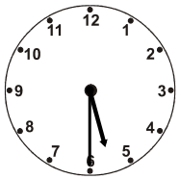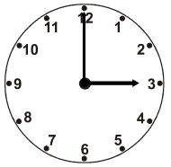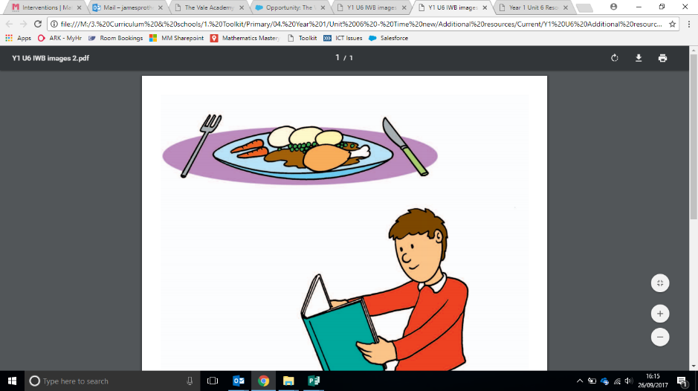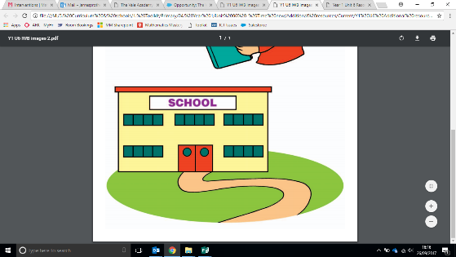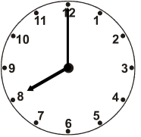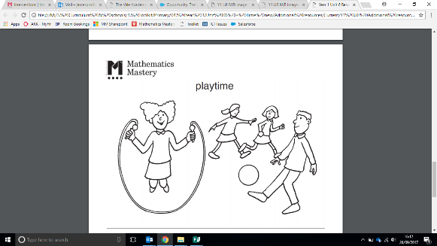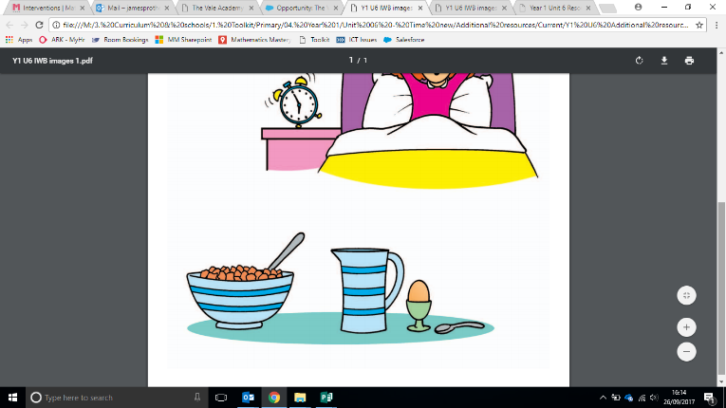

The time is half past______________ in the morning / afternoon.

The time is _____________o’clock in the morning / afternoon.

Home time

Dinner time

The time is half past ____________ in the morning / afternoon.

The time is ___________o’clock in the morning / afternoon.

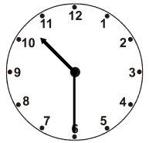

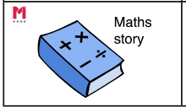

Green Challenge **Monday 14th December 2020** ★

Put the events in chronological order.

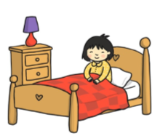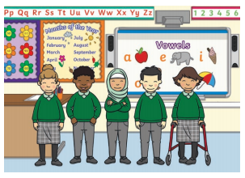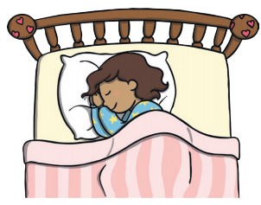

Green Challenge **Monday 14th December 2020** ★

Put the events in chronological order.



Green Challenge **Monday 14th December 2020** ★

Put the events in chronological order.



Green Challenge **Monday 14th December 2020** ★

Put the events in chronological order.

