 **Monday 14th December 2020**

L.O: To read the time to o’clock and half past.★★

|  |  |  |
| --- | --- | --- |
| Time | I T TA P SA PA | 🗹 |
| I can read o’clock and half past times. |  |
| I can use the key vocabulary to describe the time of day. |  |
| I can identify activities that occur in morning and afternoon. |  |

Playtime

Breakfast

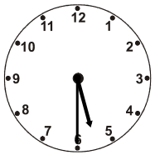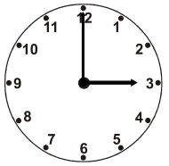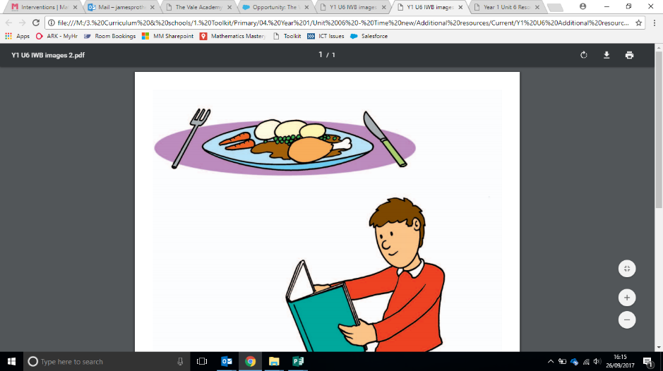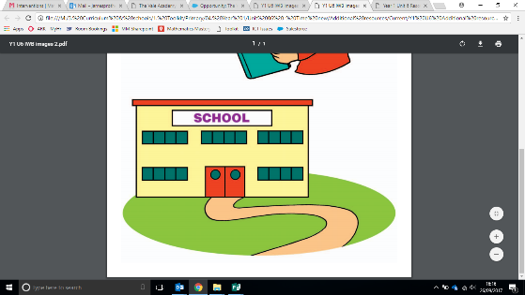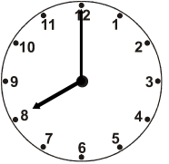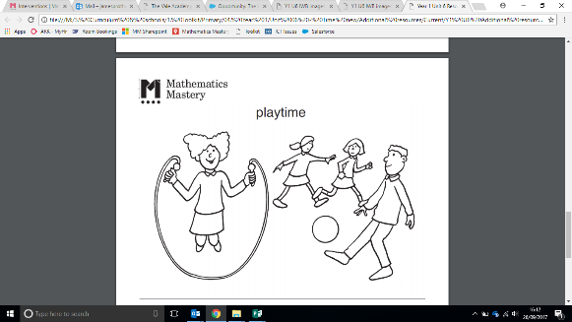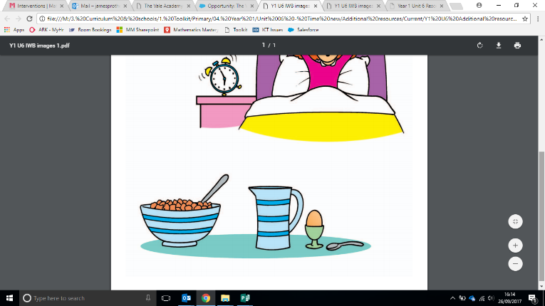

The time is ________________________ in the morning / afternoon.

The time is ________________________ in the morning / afternoon.

Home time

Dinner time

The time is ________________________ in the morning / afternoon.

The time is ________________________ in the morning / afternoon.

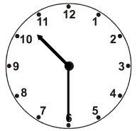

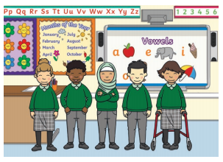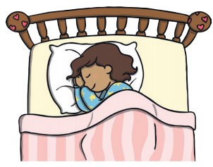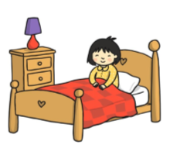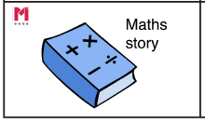

Green Challenge **Monday 14th December 2020** ★★

Which event is the odd one out? Can you explain why?

Green Challenge **Monday 14th December 2020** ★★

Which event is the odd one out? Can you explain why?

Green Challenge **Monday 14th December 2020** ★★

Which event is the odd one out? Can you explain why?

Green Challenge **Monday 14th December 2020** ★★

Which event is the odd one out? Can you explain why?