Oasis Academy Don Valley

Topic Homework Menu

Year 2

Starters

Make a recipe for your own marvellous medicine.

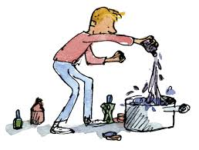

Pick an animal – Can you draw the lifecycle and explain it?

Design your own Bee-Bot mat and write an algorithm for this. 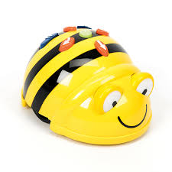

Mains

Create a poster about praying – is this different in different religions?

Write a book review on your favourite book. This could your own book or a book we have read in school.

Make an instrument using materials from home.

Use your instrument to make own tune – can you add lyrics to make a song?

Try some new foods – why are they good for your body?

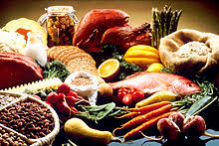

Desserts

Write a character description of Grandma.

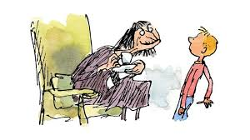

Observational drawing is when you look closely at an object and sketch all the small detail. Can you choose an object from around your house and sketch it? Try to use different tones and textures.

Write a food diary over a few days – have you managed to have a well-balanced diet?

Make an edible potion with an adult.

