Spelling Menu

Write your word and then use a coloured pencil to divide the word into syllables.  e.g. caterpillar | Write your word 5 times then switch hands and write it with your other hand. | Write your word using one colour for the vowels and another for the consonants.  (vowels: a, e, i, o, u)
Ransom word! Make your words out of letters cut from magazines and newspapers. | Scramble the letters up in your word and see if a family member or friend can put them back together again. | Create silly sentences using your spelling words.
Identify the prefix and suffixes and research what they mean. | Create your own word search with spellings. Put your answers in a different colour or get someone to complete it. | Draw a picture to define each word. Write a sentence about your picture using the word.
Write your word but replace the vowels with a line and see if you or someone else can fill in the gaps.  q—st—n = question | Write words in a line that never ends and see if you can colour each word in a different colour afterwards. | Write your spelling out in bubble writing.
Can you make any other words from the letters in your word?  e.g: catch – hat, cat | Write questions where the answer to them is a spelling. | Create a riddle for the word (particularly good for nouns).
Rhyme your word with as many words as possible – can you make them into a song? | Is your word a homophone? Find the others! | Set a timer – how many times can you write your word perfectly with legible handwriting?
Come up with a code for each letter of the alphabet and then write your word in code. | Find synonyms & antonyms for your word. Draw them as enemies. | 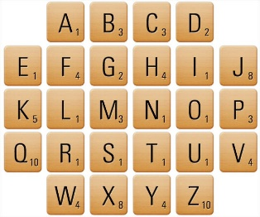  In scrabble, each letter is worth a value. What is the total value of your word?

