 | Reading 9:00 – 9:30 | English 9:30 – 10:30 | Maths 11:00 – 12:00 | Spelling  13:00-13:30 | Times tables  13:30-14:00 | Curriculum  14:00-15:00
Monday | - Listen to your child read and let them discuss what they have read. Encourage them to read with expression and intonation. Make sure you sign your child’s home academy journal. | - Look at the image below.  Create a question matrix for the image.  What is happening in the picture?  What would you like to find out about the picture? | - Use the blank clocks in your home learning file. Tell your child a time and see if they can draw the correct time on the clocks.  Have they drawn the hour and minute hands clearly?  Have they drawn the time accurately? | - Use the spelling menu and choose an activity.  League  plague  rogue  vague  fatigue  unique  antique  mosque  cheque  technique | - Use the times tables booklet and complete the super fingers activity. | - Use the homework menu and complete an activity.
Tuesday | - With your child, look in magazines and newspapers. Choose a story that your child Is interested in and discuss the story together. | - The image shows a natural disaster. Research the natural disaster that is happening in the image.  Create an information poster about the natural disaster. | - Work on​Times Table Rockstars​ - your child will have an individual login to access this ​(20 mins on SOUND CHECK). Then, Play on ​Hit the Button​ - focus on 4 and 8 times tables (hit the answer). | - Use the spelling menu and choose an activity.  League  plague  rogue  vague  fatigue  unique  antique  mosque  cheque  technique | - Use the times tables booklet and complete multiplication snap. | - Use the homework menu and complete an activity.
Wednesday | - You could share a story together. This could be a chapter book where you read and discuss a chapter a day. | - Imagine you are a child experiencing the natural disaster.  Write a paragraph describing how you feel. How is the disaster effecting your personality and your appearance?  Use powerful adjectives and adverbs. | - Work with your child to complete the activities that have been set for them on Mathletics. | - Use the spelling menu and choose an activity.  League  plague  rogue  vague  fatigue  unique  antique  mosque  cheque  technique | - Use the times tables booklet and complete rhyme time. | - Use the homework menu and complete an activity.
Thursday | - Choose a reading activity from the ‘reading activity menu’ and complete based on the book you read yesterday. | - Write a postcard to a family member recounting your ‘experience’ of the natural disaster. | - Practise counting forwards and backwards from any given number in 8’s. Then, work on ​Times Table Rockstars​ - your child will have an individual login to access this ​(20 mins on SOUND CHECK). | - Use the spelling menu and choose an activity.  League  plague  rogue  vague  fatigue  unique  antique  mosque  cheque  technique | - Use the times tables booklet and complete one less = 9 activity. | - Use the homework menu and complete an activity.
Friday | - Watch Newsround and discuss world events. | 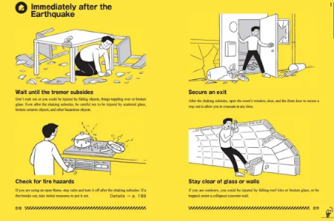  - Create a government advert on how to stay safe during a natural disaster.  Here is an example. | - Play on ​Hit the Button​ - focus on 4 and 8 times tables.  Then create a timetable of your day. As you complete each activity on your timetable can your child record the time as both digital and analogue time? | - Use the spelling menu and choose an activity.  League  plague  rogue  vague  fatigue  unique  antique  mosque  cheque  technique | - Use the times tables booklet and complete looking for patterns. | - Use the homework menu and complete an activity.
Year 3

