Times Tables
Games and Strategies

We are having a big push in school on learning times tables!
We often are asked at parents’ evening what can be done to help children at home with their maths – learning times tables is a brilliant way of helping your child and it really can make a huge
difference.

I am sure we all remember standing up, chanting tables at school.
Learning by rote is one strategy, but there are also other activities we can do with children to help them learn their tables.

The aim of this booklet is to show you some strategies we use in school and that you could try at home to help children with their tables.

We hope you find it useful.

Learning Tables
In the table below are the National Curriculum times tables expectations for each year group. The children will be tested on their times tables regularly in school.
 | Expectations for times tables for each year group
Year 1 | Count in multiples of 2, 5 and 10.  Recall and use all doubles to 10 and corresponding halves.
Year 2 | Recall and use multiplication and division facts for the 2, 5 and 10 times tables including recognising odd and even numbers.
Year 3 | Recall and use multiplication and division facts for the 3, 4 and 8 times tables.
Year 4 | Recall and use multiplication and division facts for tables up to 12 x 12
Year 5 | Revision of all times tables and division facts up to 12 x 12
Year 6 | Revision of all times tables and division facts up to 12 x 12

Useful Tips
- Stick to one table at a time to minimise confusion.
- Start with chanting and writing them out slowly in order.
- Then move on to completing the answers quickly in order – on paper or
verbally with your child.
- Finally, move on to completing the answers in any order. o Keep reminding your child that 3 x 4 is the same as 4 x 3 – this is
effectively halves the number of tables facts.
- Each table has a square number 3 x 3, 7 x 7 etc. These are special numbers that can act as a memory hook – emphasise them!
- Talk about the numbers as you are encountering them “5 x 7 = 35 that’s
our house number” – this makes more memory hooks.
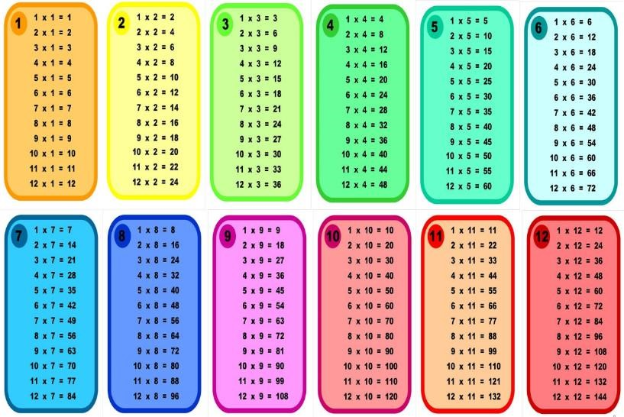
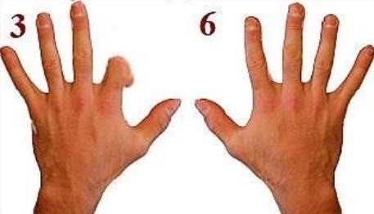
9
x table on your fingers

1.

Hold your hands in front
of you with your

fingers spread out.

2.

For 9 x 4 bend your 4
^{th}

finger down (like

the picture).

3.

You have 3 fingers in front of the bent

finger and 6 after the bent finger. Thus the

answer must be 36!

4.

The technique works for the 9 times tables up to 10.

Super Fingers!  This is a game for two players.  The game is basically a version of rock, paper, scissors but with  numbers. Two players count to 3 and then make a number using their fingers.  Both players then have to multiply both numbers together and the quickest wins. |  | Multiplication Snap!  You will need a deck of cards for this game.  - Flip over the cards as though you are playing snap.  - The first to say the fact based on the cards turned over (2 and 3 say 6) gets the card.  - The person to get all of the cards wins.

Rhyme Time!
Silly rhymes can help children learn tricky tables, e.g.,
8 x 8 = 64 ‘He ate and ate and was sick on the floor, eight times eight is 64.’ 3 x 3 = 9 ‘Swing from tree to tree on a vine, three times three is nine.’
7 x 7 = 49 ‘Seven times seven is like a rhyme, it all adds up to 49.’
4 x 4 = 16 ‘A 4 by 4 is a mean machine. I’m going to get one when I am 16.’

One Less = Nine
This is a strategy for learning the 9 x tables. The key to it is that for any answer in the nine times tables, both digits add up to 9. Try it and see!
- Subtract 1 from the number you are multiplying by. E.g. 7 x 9 – one less than 7 is 6.
- This number becomes the first number in the answer, 7 x 9 = 6_
- The two numbers in the answer add up to 9 so the second number must be 3, 7 x 9 = 63

Bingo!

This game will need 2 players.

Make a grid of six squares on a piece of paper and ask your child to write a
number in each square from their target tables. Give them a question and if they
have the answer they mark the answer off. First one to
mark off all their
numbers is the winner!

Looking for Patterns
Being able to spot the patterns in numbers is an important skill and can also help with learning times tables. Children can investigate these multiplication rules;
- Odd number x odd number = odd number (3 x 5 = 15)
- Even number x even number = even number (4 x 6 = 24)
- Odd number x even number = even number (3 x 6 = 18)

Websites www.topmarks.co.uk  -Hit the Button  -Coconut Multiples  -Maths Fishing  -Times Tables Grid www.timetables.co.uk  -Times Tables Shooting  -Times Tables Memory  -Spuq Balloons  -Times Tables Rally  www.youtube.com  -Mr.DeMaio | Tricky Sixes  Six times tables can be tricky to learn.  One helpful trick is that in the 6 times tables, when you multiply an even number by 6, they both end in the same digit.  2 x 6 = 12 4 x 6 = 24 6 x 6 = 36  8 x 6 = 48
Double, Double!
A quick trick for learning the fours is just to double, double. Double the number and then double it again.
For example;
3 x 4 double 3 is 6, double 6 is 12
- x 4 double 5 is 10, double 10 is 20
- x 4 double 6 is 12, double 12 is 24 9 x 4 double 9 is 18, double 18 is 36

Speed Tables!
Time challenges can be a really good way of helping times tables become automatic. Some ideas we use in school are;
-measuring the time it takes to write the tables, then trying to beat the time.
-seeing how many times you can write that table in 1 minute.
-race/challenge against other people
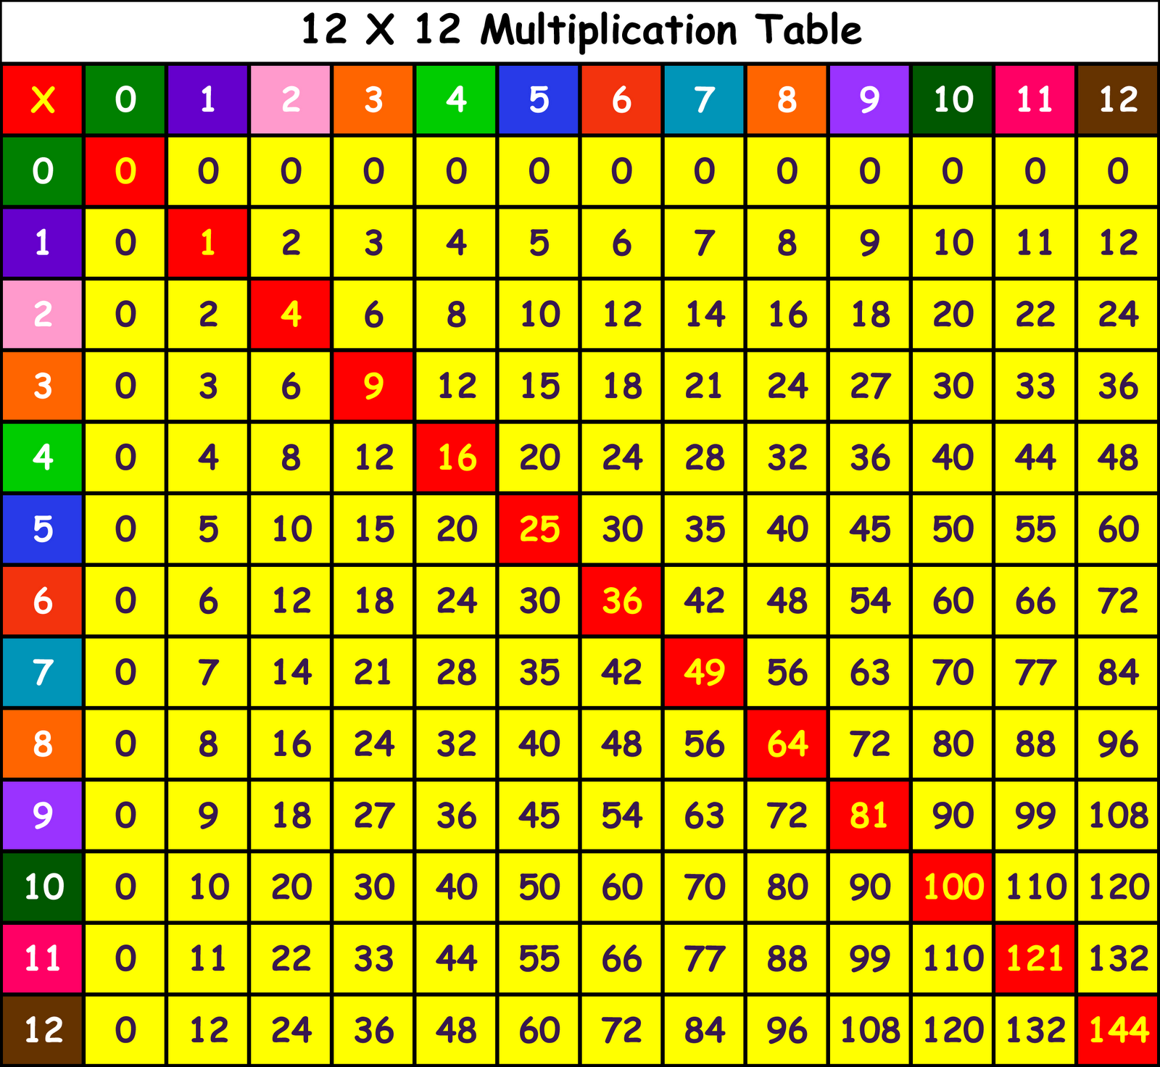
Time
s

Table Square

The times table square could be used fo
r;

-

Revising tables

-

Exploring patterns

-

Checking answers in independent work

