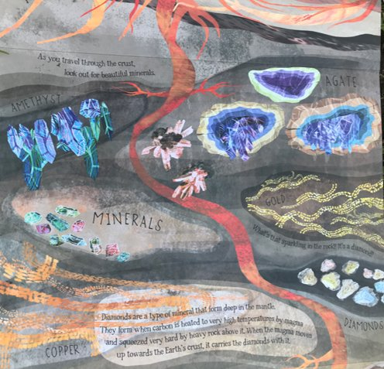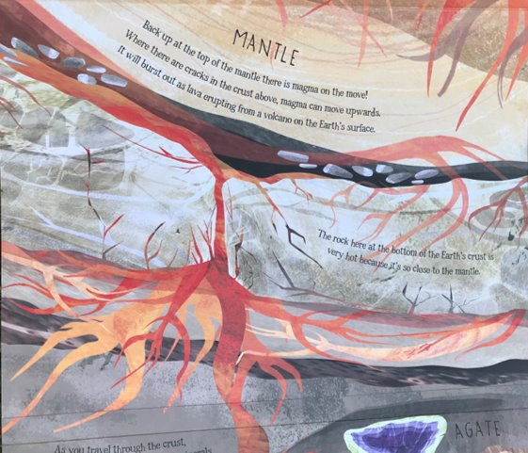



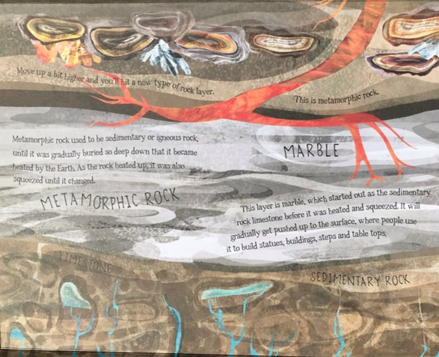

Read pages 13-15.

Recap what you already know about the different layers underground.

Which layer do you like the best and why?

Which layer is the worst and why?

How do diamonds end up in the earth’s crust?