Websites and apps for home learning Y5
- https://www.topmarks.co.uk/
- https://www.mathletics.com/uk/
- https://www.bbc.co.uk/bitesize/

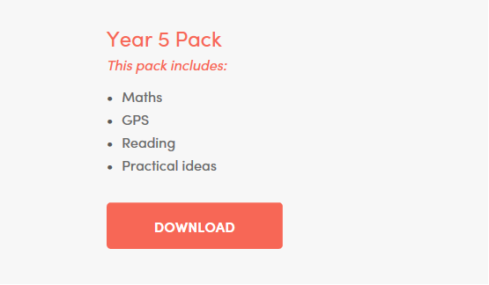
- http://classroomsecrets.com/free-home-learning-packs/
- https://tpet.co.uk/latest-resources/
- https://www.tts-group.co.uk/home+learning+activities.html
- https://thereadingrealm.co.uk/2020/03/12/free-reading-realm-home-learning-pack-nature-and-animals/amp/?__twitter_impression=true

http://www.twinkl.co.uk/offer (Month free trial for parents and carers to access resources) The screen will come up with a register – people will need to click the ‘register now’ and then enter the following into ‘offer code’: UKTWINKLHELPS
- https://whiterosemaths.com/resources/
- https://thebookwhisper2.wixsite.com/mysite/post/free-resources
- https://www.oxfordowl.co.uk/for-home/find-a-book/library-page/ - This has FREE books that the children can access

There is always something your child can be doing!
- Reading (fiction, non-fiction, poetry, biographies, newspapers)
- Learn their Y5/6 spellings
- Revisit Y1-Y4 spellings – do they know these? Can they use them in sentences?
- Online quizzes and tests
- Story writing, diary writing, poetry or a report on a topic of their choice

