March 2020

Dear Parent/Carers,

During this difficult period of time we are fully committed to supporting the ongoing education of all of our Oasis Don Valley children. To this end we are providing a range of learning resources and independent study materials to be used if the Academy is closed or for prolonged absence of a child. We have also set up a page on the Academy website which we will update on a weekly basis each Monday, during any period of closure.
As you will be aware all children have already been provided each half term with a Knowledge Organiser containing the essential knowledge for each subject (these are currently available on the Academy website under the curriculum tab). This resource will be the foundation of children’s independent study and they have already been shown how to work effectively from this resource.
However, to further support students with their use of the Knowledge Organisers we have also provided additional materials for students to complete in their time at home. These materials include…

- Reading (fiction, non-fiction, poetry, biographies, newspapers) and recording this in your home academy journal.
- Learn their Y5/6 spellings from the spelling list.
- Story writing, diary writing, poetry or a report on a topic of their choice
- Complete activities on their daily timetable.
- Complete activities set on Purple Mash, Mathletics and Times Table Rock Stars (all children’s log ins are in their home academy journals).
- Use the knowledge organiser to learn about the different topics and take the knowledge organiser quiz to consolidate the learning!
- Complete the activities from our website recommendation.
- Work through the activities on your homework menu.
- Children have been given books to write in; this is where all their work should be recorded for the period of time that we are off.
- Your child will also be given an extra reading book to enjoy

Initially we are providing your child with resources that we expect will ensure continuation of education beyond the Easter holidays. If the situation calls for further extended periods of closure or absence then additional work will be provided through the Academy website as referenced above.

Guidance on all of these resources is provided for your child in the following pages and will also be available on our website https://www.oasisacademydonvalley.org/

Thank you for everything you have done so far during these challenging conditions, I am extremely proud of our response as an academy and as a wider community and we would also like to thank you for your ongoing support in ensuring every child continues to receive their education.

Yours sincerely

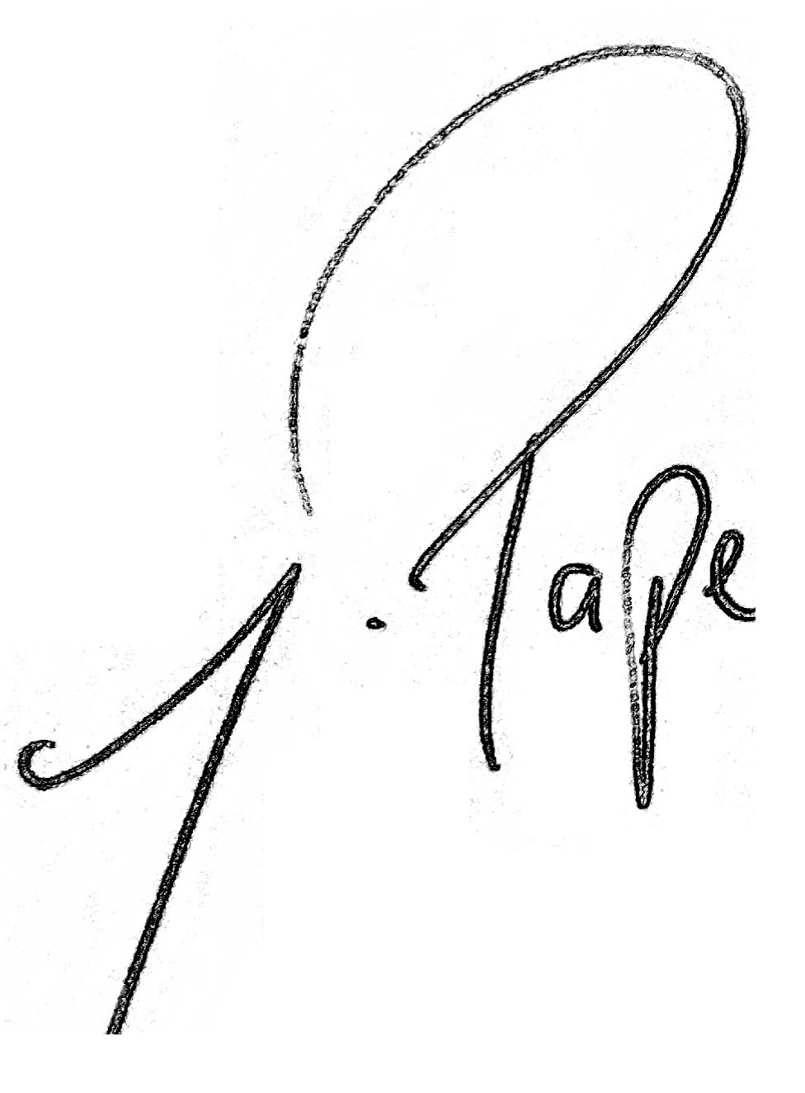

Mr J Pape
Principal

