**A description of a beach**

|  |
| --- |
| **As I look at the beach(1) I can see the black rocks(2) with waves(3) crashing violently against then and I can also see a tiny, yellow boat(4) that is as lonely as a spaceship. The sand looks as sticky as a swamp(5) and the sky is as dark as night.**  **I can smell the salty(6) sea(7). I can smell greasy fish and chips(8) from the van(9). And I can hear a massive dog barking loudly (10) down the beach.**  **I can hear the white seagulls(11) squawking and the waves crashing against the rocks and the little children shouting happily about their golden sandcastles(12).** |

**Write the correct number under each picture.**

**C:\Users\Louise\AppData\Local\Microsoft\Windows\Temporary Internet Files\Low\Content.IE5\KY5CE1V0\MC900150140[1].WMF C:\Users\Louise\AppData\Local\Microsoft\Windows\Temporary Internet Files\Low\Content.IE5\TWNXJK1A\MC900229131[1].WMF C:\Users\Louise\AppData\Local\Microsoft\Windows\Temporary Internet Files\Low\Content.IE5\M4OSG78E\MC900212235[1].WMF** 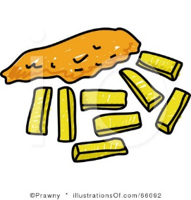

**______ ______ ______ ______**

**C:\Users\Louise\AppData\Local\Microsoft\Windows\Temporary Internet Files\Low\Content.IE5\TAEEZCSX\MC900352103[1].WMF** [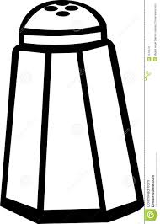](http://www.google.com/url?sa=i&rct=j&q=&esrc=s&frm=1&source=images&cd=&cad=rja&uact=8&ved=0CAcQjRw&url=http://pixgood.com/salt-clipart.html&ei=0lJFVLWsMYTTaIS3goAH&bvm=bv.77880786,d.ZGU&psig=AFQjCNHn1oX9vk0zgK3zJEu3tsmKB8RTJA&ust=1413915715445300)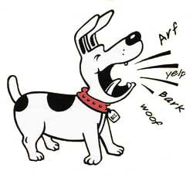 **C:\Users\Louise\AppData\Local\Microsoft\Windows\Temporary Internet Files\Low\Content.IE5\KY5CE1V0\MC900356441[1].WMF**

**______ ______ ______ ______**

**C:\Users\Louise\AppData\Local\Microsoft\Windows\Temporary Internet Files\Low\Content.IE5\L7HKRBAI\MC900292204[1].WMF 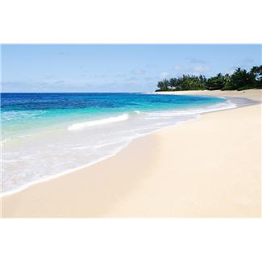 C:\Users\Louise\AppData\Local\Microsoft\Windows\Temporary Internet Files\Low\Content.IE5\26LPX6X7\MC900243705[1].WMF C:\Users\Louise\AppData\Local\Microsoft\Windows\Temporary Internet Files\Low\Content.IE5\TAEEZCSX\MC900151193[1].WMF**

**______ ______ ______ ______**

**Find and label examples of:**

adjectives

senses

capital letters

full-stops

senses

onomatopoeia

colours

similes

adverbs