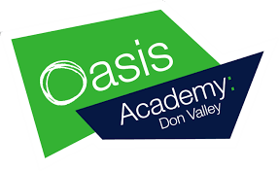
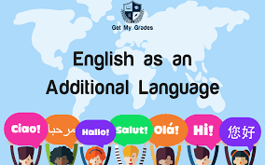
Websites and learning to support students with English as an additional language.

www.agendaweb.org

This is a great website, it helps you understand English grammar through playing games! We recommend you click on:

- Grammar exercises
- Vocabulary exercises
- Verbs exercises
- Listening – comprehension
- Reading – comprehension
- Audio stories – fairy-tales
- Videos – lessons - cartoons

http://learnenglishkids.britishcouncil.org/grammar-vocabulary
We recommend you click on the ‘Grammar and Vocabulary’ section however this is really fun website so just explore! Perfect for looking at with younger brothers or sisters!

