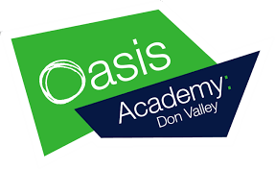
Other Online Resources
There are wide range of online resources available to students and families to support and extend their learning.
Check out some the links below …
Online Resources:  - BrainPop  - Curiosity Stream  - Tynker  - Outschool  - Udemy  - iReady  - Beast Academy (Math)  - Khan Academy  - Creative Bug  - Discovery Education | Youtube Channels:  - Crash Course Kids  - Science Channel  - SciShow Kids  - National Geographic Kids  - Free School  - Geography Focus  - TheBrainScoop  - SciShow  - Kids Learning Tube  - Geeek Gurl Diaries  - Mike Likes Science  - Science Max  - SoulPancake | 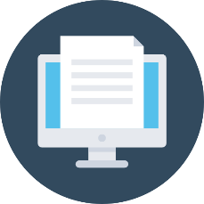  Free Learning Websites:  - https://www.starfall.com/h/  - https://www.abcya.com/  - https://www.funbrain.com/  - https://www.splashlearn.com/  - https://www.storylineonline.net/  - https://pbskids.org/  - https://www.highlightskids.com/  - https://kids.nationalgeographic.com/  - https://www.coolmath4kids.com/  - http://www.mathgametime.com/  - https://www.uniteforliteracy.com/  - http://www.literactive.com/  - http://www.sciencekids.co.nz/  - https://www.switchzoo.com/  - https://www.seussville.com/  - https://www.turtlediary.com/  - https://www.e-learningforkids.org/

Other Learning Platforms
Scholastic has created a free learn-from-home site with 20+ days of learning and activities - Click Here!
Pretend to travel the world. Go on a virtual tour of these 12 famous museums - Click Here!
List of thinking games by Year Group - Click Here!

