PE – Muscular and Skeletal System Booklet

The Structure and Function of the Muscular System

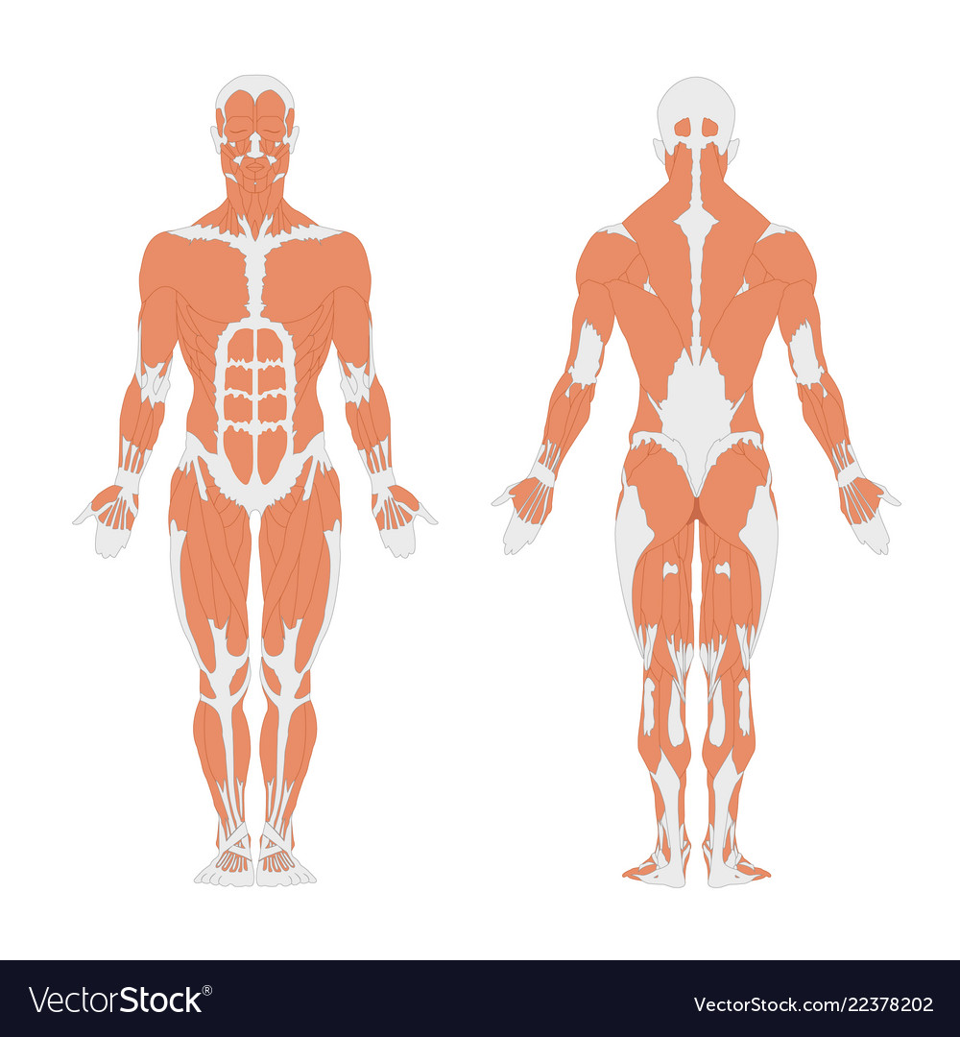

Muscular System
You must be able to name and locate the following muscles:
• deltoid • trapezius • latissimus dorsi • pectorals • biceps • triceps • abdominals • quadriceps • hamstrings • gluteals • gastrocnemius

Deltoid – a thick triangular muscle covering the shoulder joint and used for raising the arm away from the body.
Trapezius – large triangular muscles extending over the back of the neck and shoulders and moving the head and shoulder blade.
Latissimus dorsi – muscle chiefly of the middle and lower back that extends, adducts, and rotates the arm medially and draws the shoulder downward and backward.
Pectorals – muscles that cover the front of the ribcage and serve to draw the forelimbs towards the chest.
Biceps – A muscle with two heads or points of origin. The large muscle at the front of the upper arm that flexes the forearm.
Triceps – The muscle that extends (straightens) the forearm.
Abdominals – A large group of muscles in the front of the abdomen that assists in the regular breathing movement and supports the muscles of the spine while lifting and keeping abdominal organs such as the intestines in place.
Qudriceps – large fleshy muscle group covering the front and sides of the thigh.
Hamstrings – muscles at the back of the thigh that function to flex and rotate the leg and extend the thigh:
Gluteals – The gluteal muscles are a group of three muscles which make up the buttocks
Gastrocnemius - the chief muscle of the calf of the leg, which flexes the knee and foot. It runs to the Achilles tendon from two heads attached to the femur

Major muscles of the body

Muscles and Sporting Examples
Muscle | Muscle Movement | Sporting Example
Deltoiod | Flexion, extension, abduction | Blocking the ball in volleyball with arms straight above the head.
Trapezius | Abduction of shoulder | Arm moving back as an athlete prepares to throw a discus
Latissmus dorsi | Adduction | Bringing your arms into your body during a star jump.
Pectorals | Adduction, flexion | Tackling in rugby to hold onto an opponent.
Biceps | Flexion | Upward movement in a bicep curl.
Triceps | Extension | Downward movement in a bicep curl.
Abdominals | Flexion | A sit-up
Quadriceps | Extension | Extension of the leg at the knee to kick a football.
Hamstring | Flexion | Bending at the knee when preparing to kick a football.
Gluteals | Extension, Abduction, Rotation | Sprinter as they sprint down a 100m track.
Gastrocnemius | Flexion (pointing of toes) | A gymnast pointing their toes during a cartwheel
Skeletal System
You must be able to name and locate the following bones:
• neck vertebra • vertebra • radius • rib • humerus • ulna • femur • tibia • fibula • wrist • kneecap

Neck Vertebra - is comprised of seven vertebral bodies that make up the upper most part of the spine. These vertebrae connect the spine to the skull.

Vertabra - The 33 vertebrae that fit together to form a flexible, yet extraordinarily tough, column that serves to support the back through a full range of motion.

Radius - The radius or radial bone is one of the two large bones of the forearm, the other being the ulna.

Ribs - are the long curved bones which form the rib cage, part of the axial skeleton. In humans, ribs surround the chest, enabling the lungs to expand and thus facilitate breathing by expanding the chest cavity.

Humerus - The humerus is the long bone in the upper arm. It is located between the elbow joint and the shoulder.

Ulna - The ulna is a long bone found in the forearm that stretches from the elbow to the smallest finger.

Femur - The femur is the only bone located within the human thigh. It is both the longest and the strongest bone in the human body, extending from the hip to the knee.

Tibia - also known as the shinbone or shank-bone, is the larger, stronger, and anterior (frontal) of the two bones in the leg below the knee in vertebrates (the other being the fibula, behind and to the outside of the tibia), and it connects the knee with the ankle bones.

Fibula - The fibula or calf bone is a leg bone on the lateral side of the tibia, to which it is connected above and below. It is the smaller of the two bones and, in proportion to its length, the slenderest of all the long bones.

Wrist – connects the hand to the forearm.

Kneecap - The patella, also known as the kneecap, is a flat, circular-triangular bone which articulates with the femur (thigh bone) and covers and protects the anterior articular surface of the knee joint.

The Skeletal System
Physical Activity Log
List all of the physical activity you have taken part in this week, from walking to and from somewhere to playing football or just exercising in the house.

Fitness Tracker
Keep a record of all the exercise you do each day from now.
 | Type of Exercise | Total (Minutes)
Monday

Tuesday

Wednesday

Thursday

Friday

Saturday

