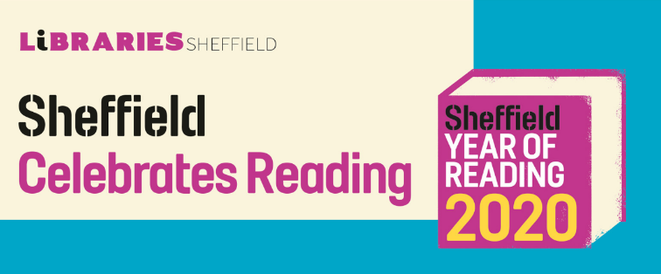
Want to read a book or magazine on your phone or ipad for free?
The Sheffield eLibrary is free to use for Sheffield Libraries members. Simply register for the services using your library card number.
Available 24/7 on your computer, smartphone and tablet, we offer something of appeal to all ages and interests.
Go to the website or download the library app and follow the instructions.
http://shefflibraries.blogspot.com/p/e-library-services.html
Haven’t got a library card?
Register online here:
https://www.sheffield.gov.uk/home/libraries-archives/the-elibrary
Services include …

eMagazines
Hundreds of bestselling magazines to dip into, delve deep within a subject or explore new hobbies and interests. Titles include: New Scientist, Hello Magazine, The Economist and BBC Good Food. Once downloaded, eMagazines are yours to keep forever.

eBooks
Relax with hundreds of free to access ebooks. From old classics to the latest bestsellers, hop into history, delve into mystery and romp through a romance without paying for the content. eBooks automatically ‘return’ themselves after three weeks. Alternatively renew for a further few weeks. Either way, there is no risk of fines.

eAudiobooks
Sit back, relax and listen to free eAudiobooks. A great escape when doing housework or trapped in the car. All eAudiobooks are free to download so there is no need to pay costly subscriptions. eAudiobooks ‘return’ themselves after three weeks unless you renew, so there is no danger of accumulating fines.

