During your time off you need to complete the following tasks to continue and enhance your learning in art. You must attempt all tasks.
Task one: Define the words/ phrases below using full sentences.
Ceramics:
Poly Printing:
Embellishment:
Imprinting:
Aesthetically pleasing:
Three dimensional:
Improvisation:
Modelling:
Task Two: Record the process of poly printing below – if you cannot remember use the internet to research. Below is a useful video to watch to help you.
https://www.youtube.com/watch?v=cHF9Vn2Fl9E
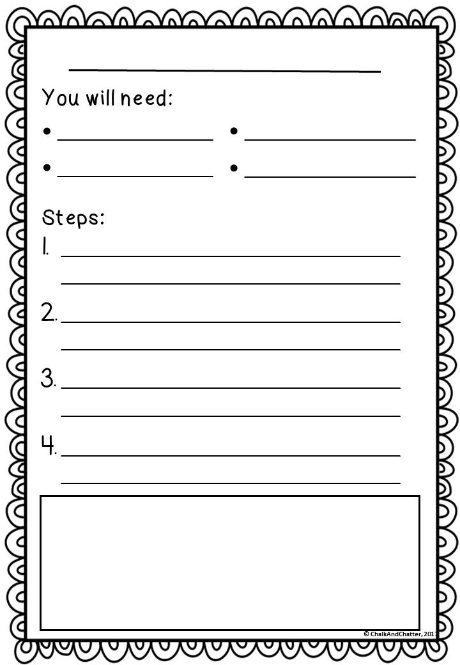

A pinch pot - A pinch pot is a simple form of hand-made pottery. A pinch pots makes a bowl shape object that can be duplicated to create a fill sphere.
Task three: watch the following YouTube clip which teaches you how to make a pinch pot and answer the following
https://www.youtube.com/watch?v=KjhnLu36j4A
What are the Martials required to make a pinch pot? List them below.

Task four: Use the video to help you record a method of making a pinch pot – draw a small illustration for each step of the method.

Task five: Below is the work of Mary O’Malley answer the questions based on what you see and your own research.
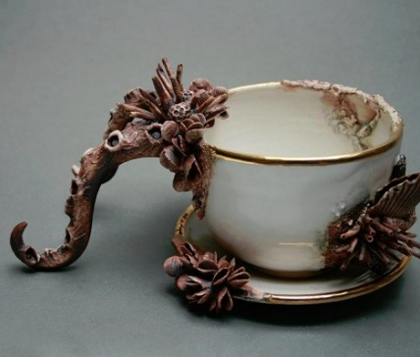
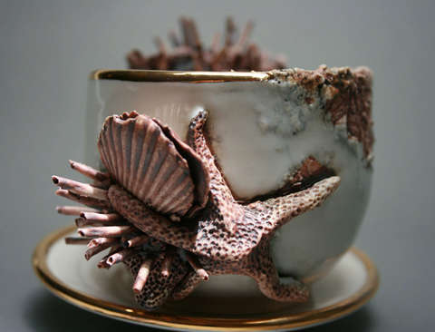
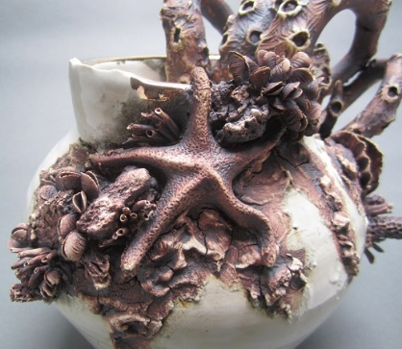

What similarities does the work of Mary O’Malley have to the work of Mairi Stone?
……………………………………………………………………………………………………………………………………………………………………………………………………………………………………………………………………………………………………………..............
What differences can you see between the work of Mary O’Malley and Mairi Stone?
……………………………………………………………………………………………………………………………………………………………………………………………………………………………………………………………………………………………………………..............
Task six: Below design a ceramic object using the work of Mary O’Malley to inspire your design – this could be a mug, teapot or ornament of your choice.

