Additional revision and further learning for Y7 Term 3 – Poetry
Term 3 Literary Heritage Topic – Poetry
Next term, Y7 will be studying Poetry with a focus on metaphor. To support with their learning, students are asked to read these poems so that they are familiar with the content of each before teaching. The poems they will be studying are:
- ‘Fog’
- ‘November Night’
- ‘Dreams’
- ‘Sally’
- ‘Frogs’
- ‘Pigeons’
- ‘The Eagle’
- ‘The Tyger’
- ‘Owl’ (Unseen Poem)
- ‘A Case of Murder’
In addition to this, students can do the following annotation activities to enhance their understanding of each poem.
- Read it through once. Write any questions that pop into your head.
- Circle any words that you do not understand and look them up in a dictionary or on the internet. Write the definitions on the poem.
- Identify the rhyming scheme using a new letter for each end rhyme within the poem. For example, AB AB if the lines rhyme ever other line
- Identify metaphorical language used within the poem. Think about what is being described, what it is being compared to and why the poet used it.
- Is anything repeated? For example, words, letters or sounds. Think about why the poet choose to repeat this?
- Look closely at punctuation. Do the lines end with full stops (called end stopped), commas or are the lines continuous (called enjambment)
- Circle any words that are interesting or striking. What do these words make you think of (connotations). What do these words reveal about the speaker’s attitude towards the topic? (tone)
- Reread the poem. If you are still having a hard time understanding the poem, repeat the annotation process!

There are also a number of revision PowerPoints and videos that will support you with term 3’s topic of Poetry. Please use the link below to access BBC Bitesize
https://www.bbc.co.uk/bitesize/topics/zmbj382
You will then need to select:
Secondary – KS3 – English – Understanding Poetry
Then work through the PowerPoints and videos for this section.
At the end, there are tests you can take. Take the test and then check the score to see how much you have learnt, know and remembered. Repeat the following week as a way of checking that you have mastered the information.

Grammar
There are a number of revision PowerPoints and videos that will support you with your English grammar lessons. Please use the link below to access BBC Bitesize
https://www.bbc.co.uk/bitesize/topics/zmbj382
You will then need to select:
Secondary – KS3 – English – Spelling, punctuation and grammar
Then work through the PowerPoints and videos for this section.
At the end, there are tests you can take. Take the test and then check the score to see how much you have learnt, know and remembered. Repeat the following week as a way of checking that you have mastered the information.

Additional revision and further learning for Y8 Term 3 – Animal Farm
Term 3 Literary Heritage Topic – Animal Farm
Next term, Y8 will be studying Animal Farm by George Orwell. To support their understanding of the text, students can watch one of the following (or both) film adaptations of the novel.
1954 Cartoon version (in colour)
https://www.bing.com/videos/search?q=youtube+animal+farm&&view=detail&mid=BCE9F8273CEC8DB978A0BCE9F8273CEC8DB978A0&&FORM=VRDGAR&ru=%2Fvideos%2Fsearch%3Fq%3Dyoutube%2Banimal%2Bfarm%26FORM%3DHDRSC3
1999 Film (in colour) https://www.bing.com/videos/search?q=youtube+animal+farm&&view=detail&mid=49B83674F65B6AECC35249B83674F65B6AECC352&&FORM=VRDGAR&ru=%2Fvideos%2Fsearch%3Fq%3Dyoutube%2Banimal%2Bfarm%26FORM%3DHDRSC3
If the above links don’t work, simply type into Bing – Animal Farm and click videos. The cartoon version is this one
and the 1999 film is this one.
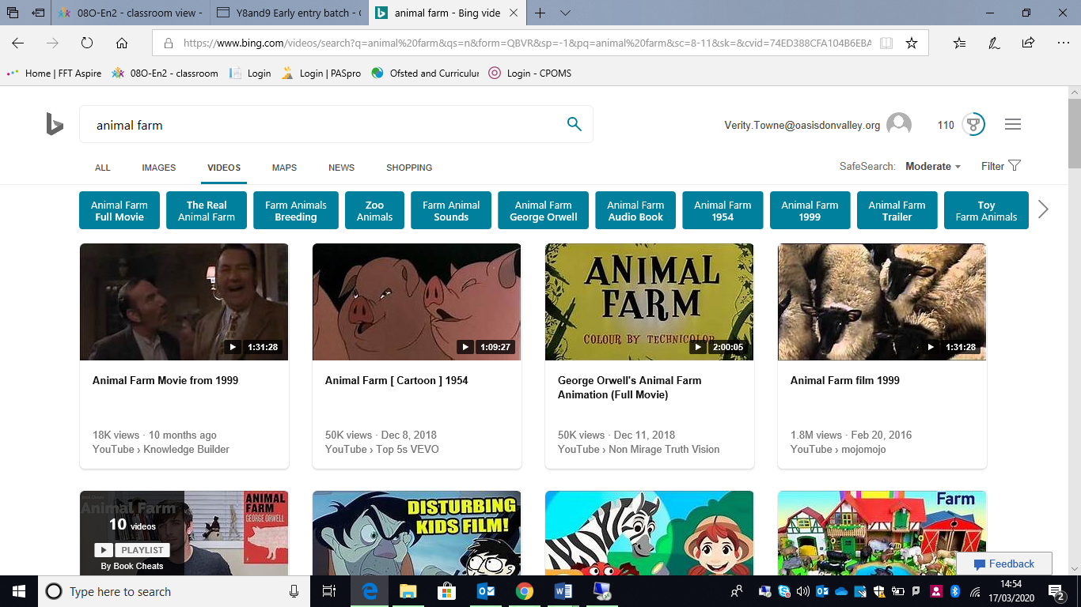
There are also a number of revision PowerPoints and videos that will support you with term 3’s topic of Animal Farm. Please use the link below to access BBC Bitesize
https://www.bbc.co.uk/bitesize/topics/zmbj382
You will then need to select:
Secondary – GCSE – English Literature – OCR – Post 1914 Prose/ Drama – Animal Farm
Then work through the PowerPoints and videos for this section.
At the end, there are tests you can take. Take the test and then check the score to see how much you have learnt, know and remembered. Repeat the following week as a way of checking that you have mastered the information.
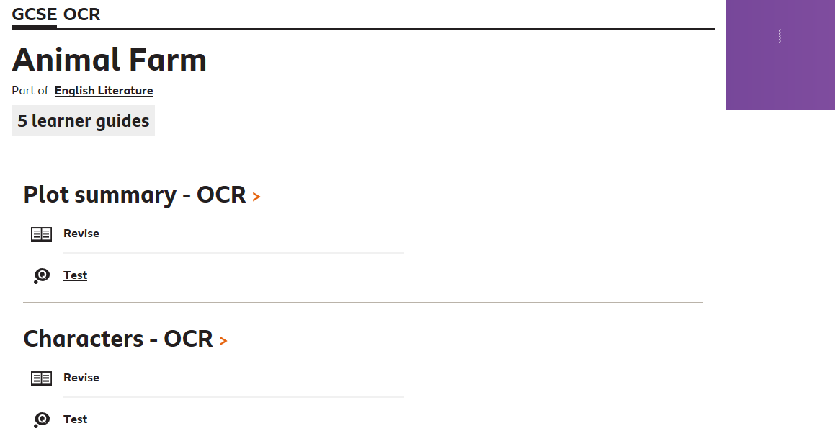
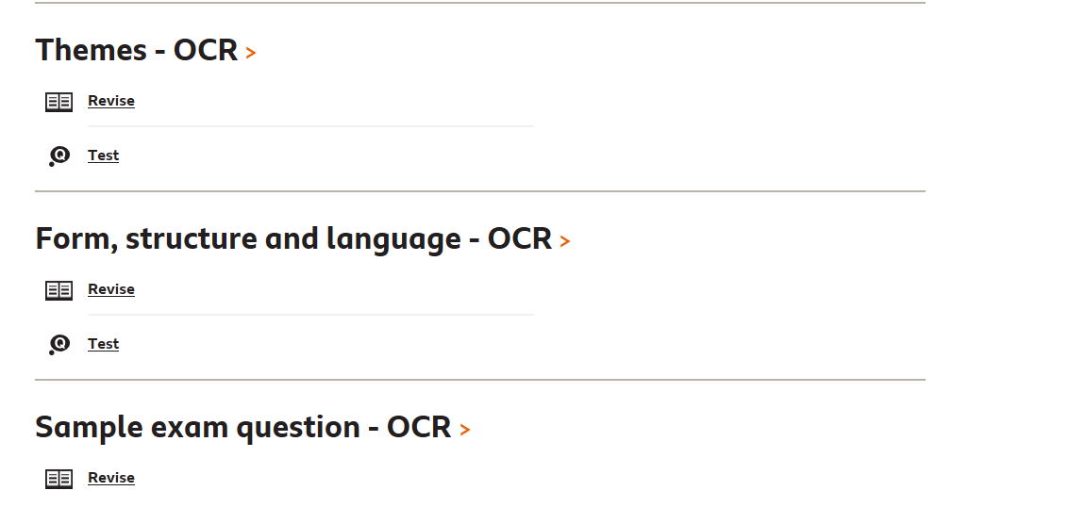

Grammar
There are a number of revision PowerPoints and videos that will support you with your English grammar lessons. Please use the link below to access BBC Bitesize
https://www.bbc.co.uk/bitesize/topics/zmbj382
You will then need to select:
Secondary – KS3 – English – Spelling, punctuation and grammar
Then work through the PowerPoints and videos for this section.
At the end, there are tests you can take. Take the test and then check the score to see how much you have learnt, know and remembered. Repeat the following week as a way of checking that you have mastered the information.

In addition to the spelling, punctuation and grammar, you can then further your knowledge by completing the reading and writing skills sections.
