Additional revision and further learning for Y8 Term 3 – Animal Farm
Term 3 Literary Heritage Topic – Animal Farm
Next term, Y8 will be studying Animal Farm by George Orwell. To support their understanding of the text, students can watch one of the following (or both) film adaptations of the novel.
1954 Cartoon version (in colour)
https://www.bing.com/videos/search?q=youtube+animal+farm&&view=detail&mid=BCE9F8273CEC8DB978A0BCE9F8273CEC8DB978A0&&FORM=VRDGAR&ru=%2Fvideos%2Fsearch%3Fq%3Dyoutube%2Banimal%2Bfarm%26FORM%3DHDRSC3
1999 Film (in colour) https://www.bing.com/videos/search?q=youtube+animal+farm&&view=detail&mid=49B83674F65B6AECC35249B83674F65B6AECC352&&FORM=VRDGAR&ru=%2Fvideos%2Fsearch%3Fq%3Dyoutube%2Banimal%2Bfarm%26FORM%3DHDRSC3
If the above links don’t work, simply type into Bing – Animal Farm and click videos. The cartoon version is this one
and the 1999 film is this one.
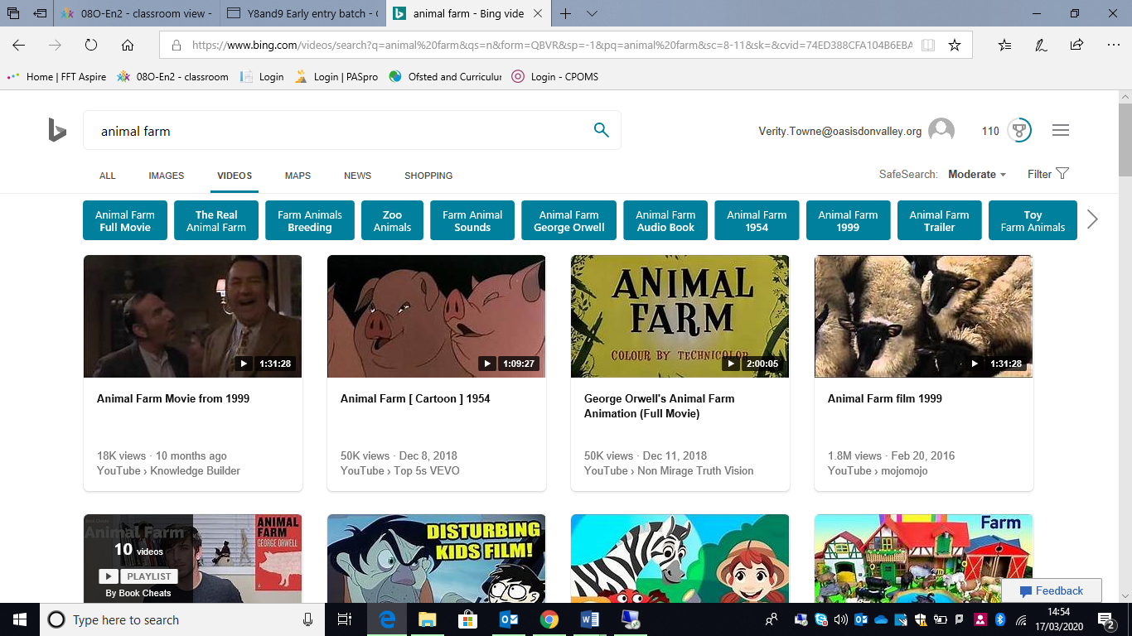
There are also a number of revision PowerPoints and videos that will support you with term 3’s topic of Animal Farm. Please use the link below to access BBC Bitesize
https://www.bbc.co.uk/bitesize/topics/zmbj382
You will then need to select:
Secondary – GCSE – English Literature – OCR – Post 1914 Prose/ Drama – Animal Farm
Then work through the PowerPoints and videos for this section.
At the end, there are tests you can take. Take the test and then check the score to see how much you have learnt, know and remembered. Repeat the following week as a way of checking that you have mastered the information.
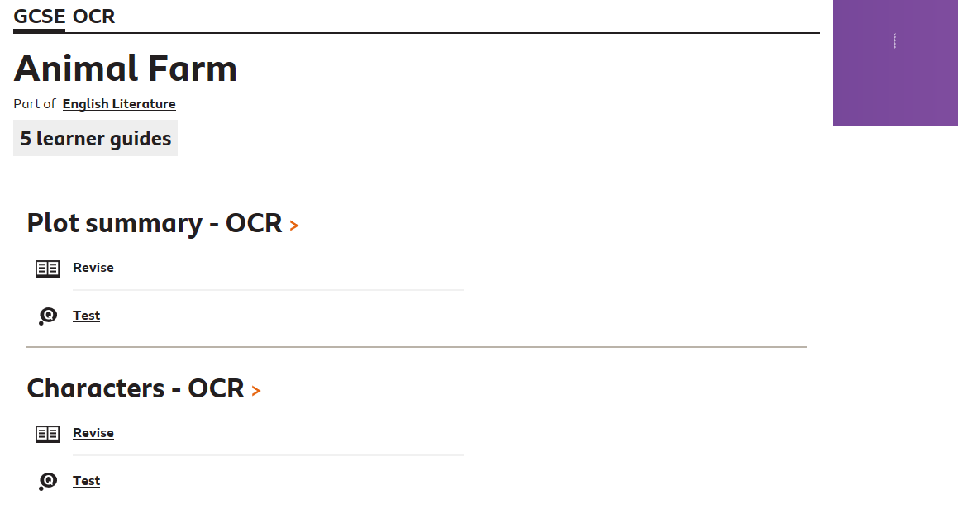
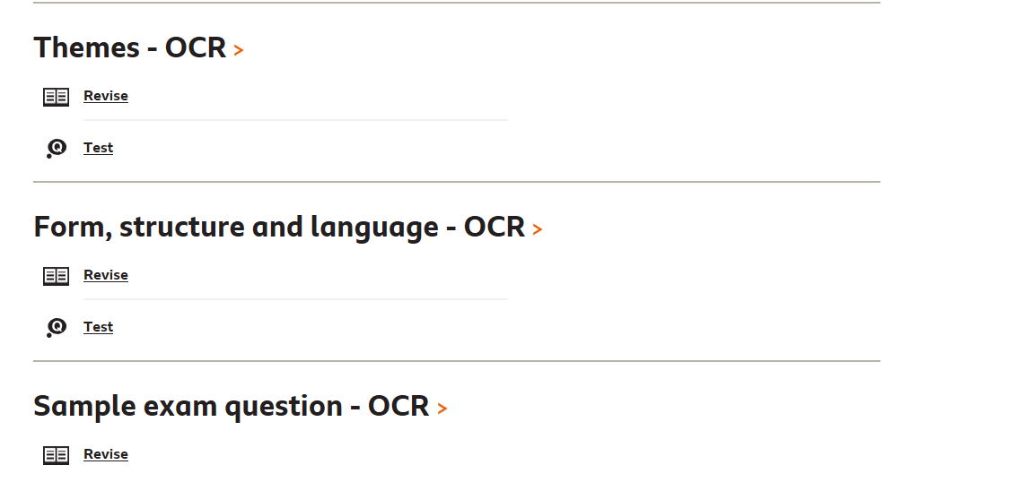

Grammar
There are a number of revision PowerPoints and videos that will support you with your English grammar lessons. Please use the link below to access BBC Bitesize
https://www.bbc.co.uk/bitesize/topics/zmbj382
You will then need to select:
Secondary – KS3 – English – Spelling, punctuation and grammar
Then work through the PowerPoints and videos for this section.
At the end, there are tests you can take. Take the test and then check the score to see how much you have learnt, know and remembered. Repeat the following week as a way of checking that you have mastered the information.

In addition to the spelling, punctuation and grammar, you can then further your knowledge by completing the reading and writing skills sections.
