Poetry
Y7 Term 3
Literary Heritage

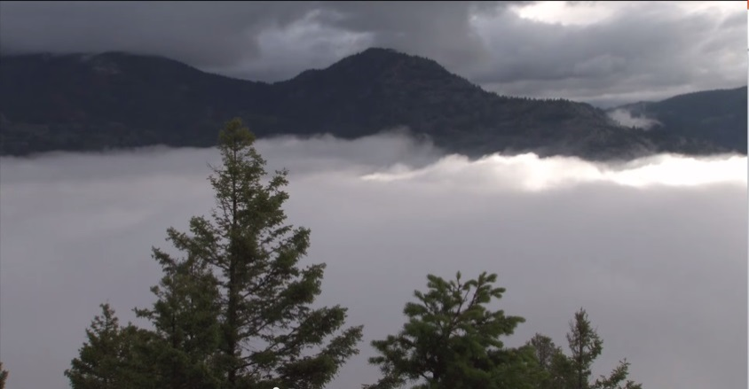

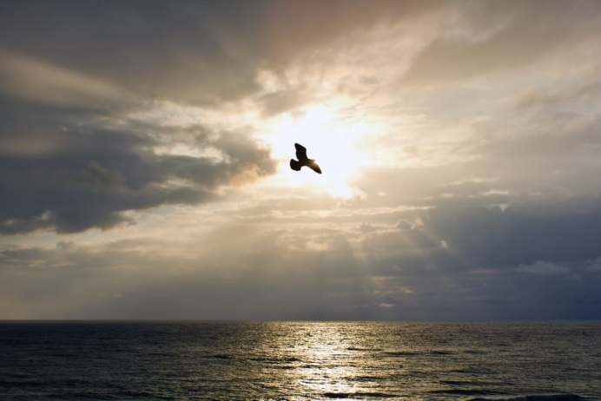

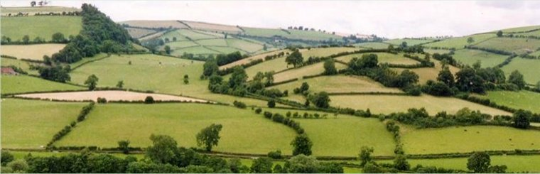

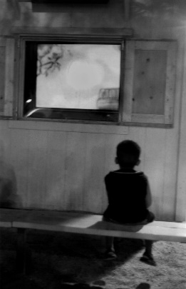
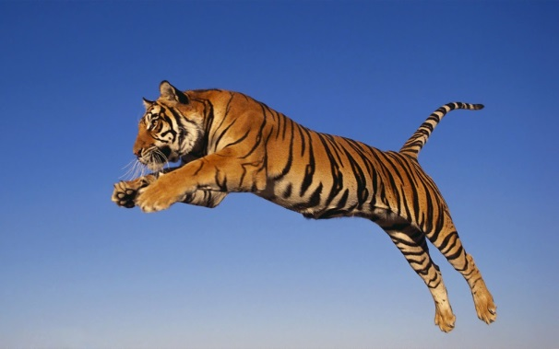
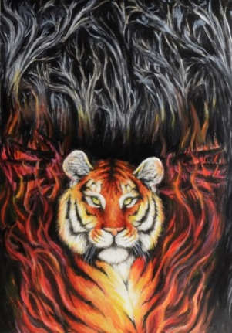
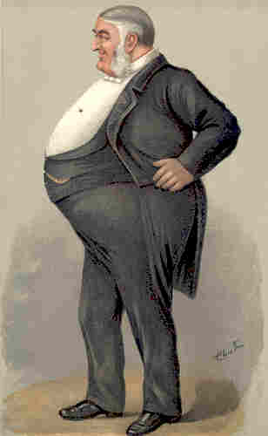

Student activity booklet
Name: _____________________

Additional revision and further learning for Y7 Term 3 – Poetry
Term 3 Literary Heritage Topic – Poetry
Next term, Y7 will be studying Poetry with a focus on metaphor. To support with their learning, students are asked to read these poems so that they are familiar with the content of each before teaching. The poems they will be studying are:
- ‘Fog’
- ‘November Night’
- ‘Dreams’
- ‘Sally’
- ‘Frogs’
- ‘Pigeons’
- ‘The Eagle’
- ‘The Tyger’
- ‘Owl’ (Unseen Poem)
- ‘A Case of Murder’
In addition to this, students can do the following annotation activities to enhance their understanding of each poem.
- Read it through once. Write any questions that pop into your head.
- Circle any words that you do not understand and look them up in a dictionary or on the internet. Write the definitions on the poem.
- Identify the rhyming scheme using a new letter for each end rhyme within the poem. For example, AB AB if the lines rhyme ever other line
- Identify metaphorical language used within the poem. Think about what is being described, what it is being compared to and why the poet used it.
- Is anything repeated? For example, words, letters or sounds. Think about why the poet choose to repeat this?
- Look closely at punctuation. Do the lines end with full stops (called end stopped), commas or are the lines continuous (called enjambment)
- Circle any words that are interesting or striking. What do these words make you think of (connotations). What do these words reveal about the speaker’s attitude towards the topic? (tone)
- Reread the poem. If you are still having a hard time understanding the poem, repeat the annotation process!

There are also a number of revision PowerPoints and videos that will support you with term 3’s topic of Poetry. Please use the link below to access BBC Bitesize
https://www.bbc.co.uk/bitesize/topics/zmbj382
You will then need to select:
Secondary – KS3 – English – Understanding Poetry
Then work through the PowerPoints and videos for this section.
At the end, there are tests you can take. Take the test and then check the score to see how much you have learnt, know and remembered. Repeat the following week as a way of checking that you have mastered the information.

Grammar
There are also a number of revision PowerPoints and videos that will support you with your English grammar lessons. Please use the link below to access BBC Bitesize.
https://www.bbc.co.uk/bitesize/topics/zmbj382
You will then need to select:
Secondary – KS3 – English – Spelling, punctuation and grammar
Then work through the PowerPoints and videos for this section.
At the end, there are tests you can take. Take the test and then check the score to see how much you have learnt, know and remembered. Repeat the following week as a way of checking that you have mastered the information.
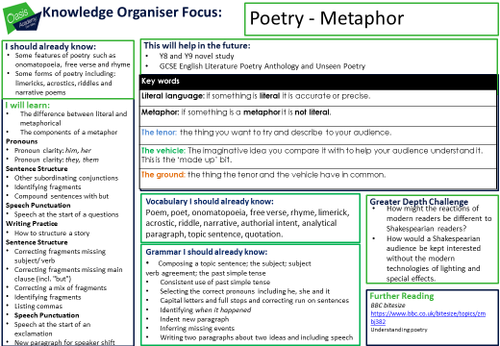
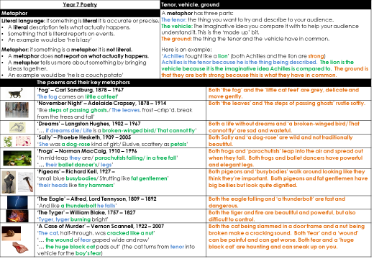
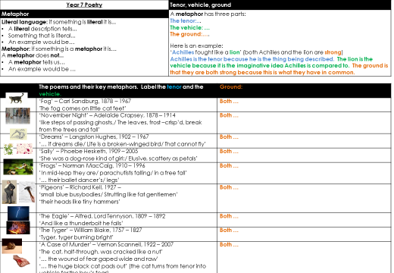
The poems
‘Fog’ – Carl Sandburg, 1878 – 1967
- Adelaide Crapsey, 1878 – 1914
‘Dreams’ – Langston Hughes, 1902 – 1967
‘Sally’ – Phoebe Hesketh, 1909 – 2005
‘Frogs’ – Norman MacCaig, 1910 – 1996
‘Pigeons’ – Richard Kell, 1927 –
- Alfred, Lord Tennyson, 1809 – 1892
‘The Tyger’ – William Blake, 1757 – 1827
‘The Tyger’ Abridged – William Blake, 1757 – 1827
‘A Case of Murder’ – Vernon Scannell, 1922 – 2007

Activity resources
2 – Metaphor: The part being described
3 – Writing your own ‘Fog’ poem
4 – Tenors and Vehicles
5 – ‘Sally’: What do we learn?
6 - Frogs
6 – ‘Frogs’: Norman MacCaig
7 – ‘Pigeons’: Label the vehicle
8 – Ground in ‘Pigeons’
11 – ‘A Case of Murder’ - Sequencing

Fog
Carl Sandburg, 1878 – 1967

The fog comes
on little cat feet.

It sits looking
over harbor and city
on silent haunches
and then moves on.

Adelaide Crapsey, 1878 – 1914

Listen. . .
With faint dry sound,
Like steps of passing ghosts,
The leaves, frost-crisp’d, break from the trees
And fall.

Dreams
Langston Hughes, 1902 - 1967

Hold fast to dreams
For if dreams die
Life is a broken-winged bird
That cannot fly.

Hold fast to dreams
For when dreams go
Life is a barren field
Frozen with snow.

Sally
Phoebe Hesketh, 1909 – 2005

She was a dog-rose kind of girl:
Elusive, scattery as petals;
Scratchy sometimes, tripping you like briars.
She teased the boys
Turning this way and that, not to be tamed
Or taught any more than the wind.
Even in school the word ‘ought’ had no meaning
For Sally. On dull days
She’d sit quiet as a mole at her desk
Delving in thought.
But when the sun called
She was gone, running the blue day down
Till the warm hedgerows prickled the dusk
And moths flickered out.

Her mother scolded; Dad
Gave her the hazel switch,
Said her head was stuffed with feathers
And a starling tongue.
But they couldn’t take the shine out of her,
Even when it rained
You felt the sun saved under her skin.
She’d a way of escape
Laughing at you from the bright end of a tunnel,
Leaving you in the dark.

Frogs
Norman MacCaig, 1910 – 1996

Frogs sit more solid
than anything sits. In mid-leap they are
parachutists falling
in a free fall. They die on roads
with arms across their chests and
heads high.

I love frogs that sit
like Buddha, that fall without
parachutes, that die
like Italian tenors.

Above all, I love them because,
pursued in water, they never
panic so much that they fail
to make stylish triangles
with their ballet dancer's
legs.

Pigeons
Richard Kell, 1927 –

They paddle with staccato feet
In powder-pools of sunlight,
Small blue busybodies
Strutting like fat gentlemen
With hands clasped
Under their swallowtail coats;
And, as they stump about
Their heads like tiny hammers
Tap at imaginary nails
In non-existent walls.
Elusive ghosts of sunshine
Slither down the green gloss
Of their necks an instant, and are gone.

Summer hangs drugged from sky to earth
In limpid fathoms of silence:
Only warm dark dimples of sound
Slide like slow bubbles
From the contented throats.

Raise a casual hand –
With one quick gust
They fountain into air.

Alfred, Lord Tennyson,1809 – 1892 line no

He clasps the crag with crooked hands; 1
Close to the sun in lonely lands, 2
Ring'd with the azure world, he stands. 3

The wrinkled sea beneath him crawls; 4
He watches from his mountain walls, 5
And like a thunderbolt he falls. 6

The Tyger
William Blake, 1757 – 1827

Tyger Tyger, burning bright,
In the forests of the night;
What immortal hand or eye,
Could frame thy fearful symmetry?

In what distant deeps or skies.
Burnt the fire of thine eyes?
On what wings dare he aspire?
What the hand, dare seize the fire?

And what shoulder, & what art,
Could twist the sinews of thy heart?
And when thy heart began to beat,
What dread hand? & what dread feet?

What the hammer? what the chain,
In what furnace was thy brain?
What the anvil? what dread grasp,
Dare its deadly terrors clasp!

When the stars threw down their spears
And water'd heaven with their tears:
Did he smile his work to see?
Did he who made the Lamb make thee?

Tyger Tyger burning bright,
In the forests of the night:
What immortal hand or eye,
Dare frame thy fearful symmetry?

The Tyger – Abridged
William Blake 1757 – 1827

Tyger Tyger, burning bright,  In the forests of the night;  What immortal hand or eye,  Could frame thy fearful symmetry?  What the hammer? what the chain,  In what furnace was thy brain?  What the anvil? what dread grasp,  Dare its deadly terrors clasp!  When the stars threw down their spears  And water'd heaven with their tears:  Did he smile his work to see?  Did he who made the Lamb make thee?  Tyger Tyger burning bright,  In the forests of the night:  What immortal hand or eye,  Dare frame thy fearful symmetry? | immortal – something that can live forever; thy – your; symmetry – the same on both sides  furnace – a container that is heated to a high temperature and used to melt or burn things  anvil – a heavy block of iron on which pieces of metal are made into a particular shape with a hammer  clasp – grab  thee – you

A Case of Murder
Vernon Scannell, 1922 – 2007

They should not have left him there alone,
Alone that is except for the cat.
He was only nine, not old enough
To be left alone in a basement flat,
Alone, that is, except for the cat.
A dog would have been a different thing,
A big gruff dog with slashing jaws,
But a cat with round eyes mad as gold,
Plump as a cushion with tucked-in paws---
Better have left him with a fair-sized rat!
But what they did was leave him with a cat.
He hated that cat; he watched it sit,
A buzzing machine of soft black stuff,
He sat and watched and he hated it,
Snug in its fur, hot blood in a muff,
And its mad gold stare and the way it sat
Crooning dark warmth: he loathed all that.
So he took Daddy's stick and he hit the cat.
Then quick as a sudden crack in glass
It hissed, black flash, to a hiding place
In the dust and dark beneath the couch,
And he followed the grin on his new-made face,
A wide-eyed, frightened snarl of a grin,
And he took the stick and he thrust it in,
Hard and quick in the furry dark.
The black fur squealed and he felt his skin
Prickle with sparks of dry delight.
Then the cat again came into sight,
Shot for the door that wasn't quite shut,
But the boy, quick too, slammed fast the door:
The cat, half-through, was cracked like a nut
And the soft black thud was dumped on the floor.
Then the boy was suddenly terrified
And he bit his knuckles and cried and cried;
But he had to do something with the dead thing there.
His eyes squeezed beads of salty prayer
But the wound of fear gaped wide and raw;
He dared not touch the thing with his hands
So he fetched a spade and shovelled it
And dumped the load of heavy fur
In the spidery cupboard under the stair
Where it's been for years, and though it died
It's grown in that cupboard and its hot low purr
Grows slowly louder year by year:
There'll not be a corner for the boy to hide
When the cupboard swells and all sides split
And the huge black cat pads out of it.

2 – Metaphor: The part being described
 | Sentence | What is the thing being described? | What is it being compared to? | Does the thing being described come BEFORE or AFTER what it is being compared to? | Extension: What does the comparison tell you about the thing being described?
 | 1. I wandered lonely as a cloud.
 | 2. As snug as a gun, the pen rests between my finger and my thumb.
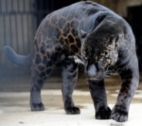 | 3. The panther paces over and over, like a dance around a centre.
 | 4. My love is like a red, red rose that's newly sprung in June.
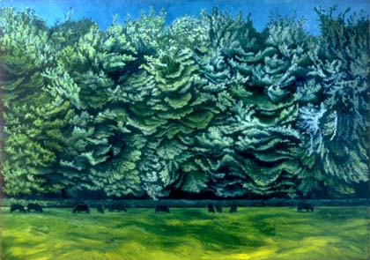 | 5. Like children playing, the wind ran through the trees.

3 – Writing your own ‘Fog’ poem
You are going to write a poem like ‘Fog’.  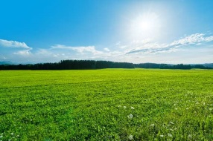  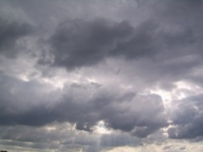  You will need to choose a weather and an animal to write about.  Some types of weather:  - Light rain  - Windy  - Heavy rain  - Cold and bright  - Hot and sunny  - Cloudy  - What other type of weather could you write about? | Here are some animals you could compare your weather to. It doesn’t have to be these animals!  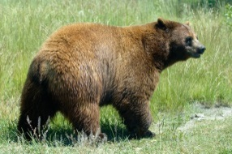  - Donkey  - Crocodile  - Lizard  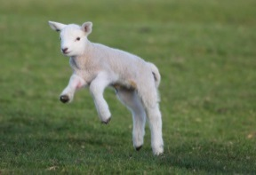  - Bear  - Lamb  - Fish  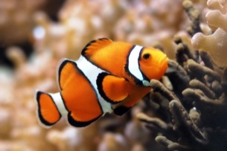  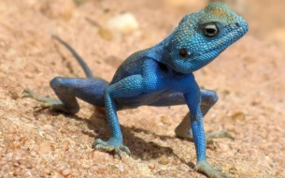  - What other animals  could you write about?

What weather will you write about? | How do they move in the same way? | How do they act in the same way? | What else do they have in common?
Which animal will you compare it to?

Here are two examples of other poems inspired by ‘Fog’:
Snow  The snow comes  On silent deer feet.  It steps across  Fields and roads  Lightly, not wanting to  Stir warm dozers. | Rain  The rain taps down  With pigeon’s feet.  It tips and taps  In the city patiently,  Awaiting its turn  To swoop away.

How will you use these poems to write your own poem?

You will need to:
- Describe your weather moving and acting in the same way as your animal.
- Keep your poem brief (30 words max).
- Think about where to start each new line for your poem.

Your poem

Title:

4 – Tenors and Vehicles
The tenor is the thing that is being described to the audience.
The vehicle is the imaginative idea that you compare the tenor to. It is the part that is not literal. It is the ‘made up’ bit.
Highlight the tenor and the vehicle in each of these sentences. | Extension: what do the tenor and the vehicle have in common?
Achilles fought like a lion.
The room was as silent as a graveyard.
Your room is a pigsty.
The room was like a furnace.
Robert is like a bull in a china shop.
The eagle is like a bolt of lightning.
She was volcanic with anger.

5 – ‘Sally’: What do we learn?
Write down three things you learn about Sally from each of these metaphors.
She was a dog-rose kind of girl | This tells us that Sally is pretty – but not beautiful in the ‘traditional’ sense.  Dog-rose is common in lots of gardens and parks. Sally might spend a lot of time outside.  By comparing her to something that natural, we get the impression she might be wild and untamed.
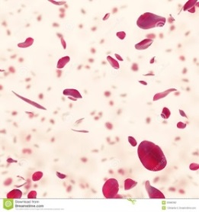
Scattery as petals
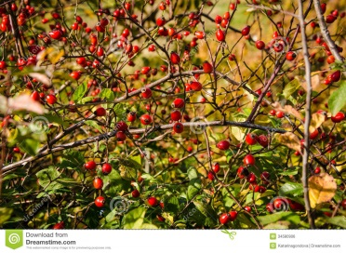
Tripping you like briars
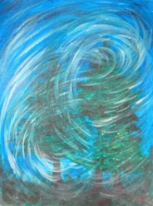
Or taught any more than the wind
Write down the quotations you want to write about here:

Write down the quotations you want to write about here:

6 – Frogs
You are going to write a poem about frogs. The poem will describe the frog doing three things: swimming, fighting and jumping.
You need to write a good metaphor about each of these actions.
What the frog is doing |  | Choose what you are going to compare this action to | How are these two things similar?
Swimming | 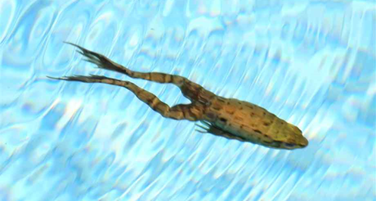 | Paragliding  Trampolining  Abseiling
Fighting | 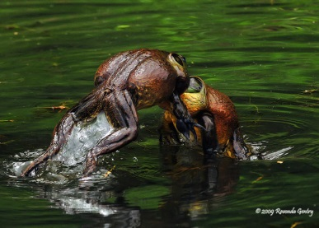 | Boxing  Sumo wrestling  Belly flopping
Jumping | 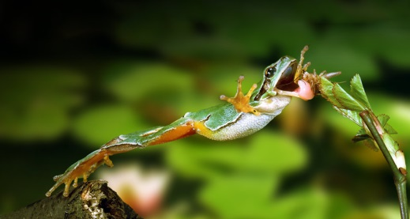 | A water fountain  A cannon  A baseball throw

6 – ‘Frogs’: Norman MacCaig
Tenor  In this poem, Norman MacCaig is writing about frogs. | Vehicle  What does Norman MacCaig compare frogs to? | Ground  Things the tenor and vehicle have in common
Frogs sitting
Frogs jumping
Frogs dying
Frogs swimming

7 – ‘Pigeons’: Label the vehicle
5. The sound of pigeons cooing

3. The movement of pigeons’ heads

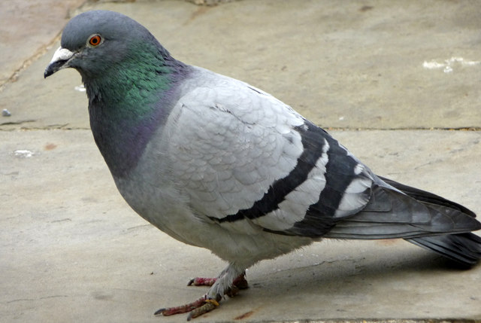
1. The sound pigeons’ feet make when walking

4. The way light looks on their feathers

6. The way pigeons fly into the air

2. The way pigeons walk

8 – Ground in ‘Pigeons’
What pigeons sound like
Tenor | 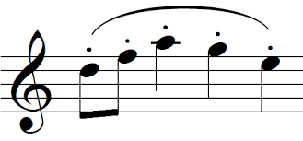 | Ground
The sound pigeons feet make when walking
Vehicle
They paddle with staccato
feet

Tenor |  | Ground
The sound of pigeons cooing
Vehicle
warm dark dimples of sound
Slide like slow bubbles
From the contented throats.

What pigeons look like
Tenor |  | Ground
The way pigeons walk
Vehicle
‘Strutting like fat gentlemen’

Tenor | 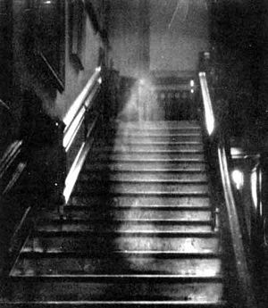 | Ground
The way light looks on their feathers
Vehicle
‘Elusive ghosts of sunshine’

Tenor | 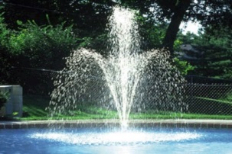 | Ground
The way pigeons fly into the air
Vehicle
‘They fountain into air’

11 – ‘A Case of Murder’ - Sequencing
These statements summarise each sentence in the poem. They tell what happened in the poem in the correct order.
You need to find a quotation for each of these statements from the poem.
Try to use a maximum of 12 words for each quotation.
The first two have been done for you.
- A boy was left home alone with a cat.
Alone that is except for the cat.
- The boy was nine, and too young to be left alone at home.
He was only nine, not old enough / To be left alone
- It might have been better to leave the boy with a dog, or even a rat.

- But the boy was left alone with a cat.

- The boy hated the cat.

- He hit the cat with Daddy’s stick.

- The cat ran away, and the boy chased it with the stick.

- The boy felt excited as the cat cried.

- The cat tried to run out of the door. The boy slammed the door on the cat, and killed it.

- The boy cried and realised he had to do something with the cat’s body.

- The boy used a shovel to throw the cat under the stairs. For years after, the boy felt guilty about the cat under the stairs.

