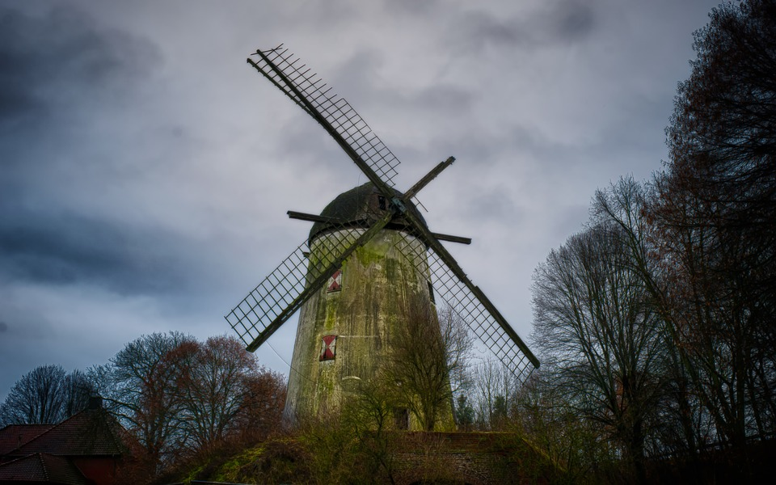

Y8 Term 3

Literary Heritage

Animal Farm

**Student activity booklet**

Name: _____________________

**Additional revision and further learning for Y8 Term 3 – Animal Farm**

**Term 3 Literary Heritage Topic – Animal Farm**

Next term, Y8 will be studying Animal Farm by George Orwell. To support their understanding of the text, students can watch one of the following (or both) film adaptations of the novel.

1954 Cartoon version (in colour)

<https://www.bing.com/videos/search?q=youtube+animal+farm&&view=detail&mid=BCE9F8273CEC8DB978A0BCE9F8273CEC8DB978A0&&FORM=VRDGAR&ru=%2Fvideos%2Fsearch%3Fq%3Dyoutube%2Banimal%2Bfarm%26FORM%3DHDRSC3>

1999 Film (in colour) <https://www.bing.com/videos/search?q=youtube+animal+farm&&view=detail&mid=49B83674F65B6AECC35249B83674F65B6AECC352&&FORM=VRDGAR&ru=%2Fvideos%2Fsearch%3Fq%3Dyoutube%2Banimal%2Bfarm%26FORM%3DHDRSC3>

If the above links don’t work, simply type into Bing – Animal Farm and click videos. The cartoon version is this one and the 1999 film is this one.

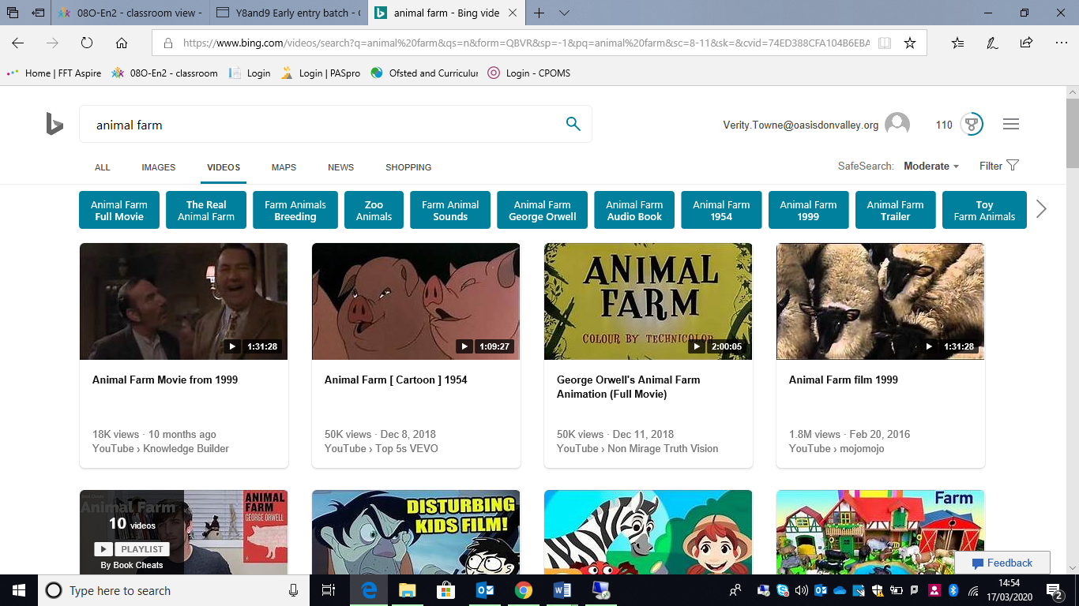

There are also a number of revision PowerPoints and videos that will support you with term 3’s topic of Animal Farm. Please use the link below to access BBC Bitesize.

<https://www.bbc.co.uk/bitesize/topics/zmbj382>

You will then need to select:

Secondary – GCSE – English Literature – OCR – Post 1914 Prose/ Drama – Animal Farm

Then work through the PowerPoints and videos for this section.

At the end, there are tests you can take. Take the test and then check the score to see how much you have learnt, know and remembered. Repeat the following week as a way of checking that you have mastered the information.

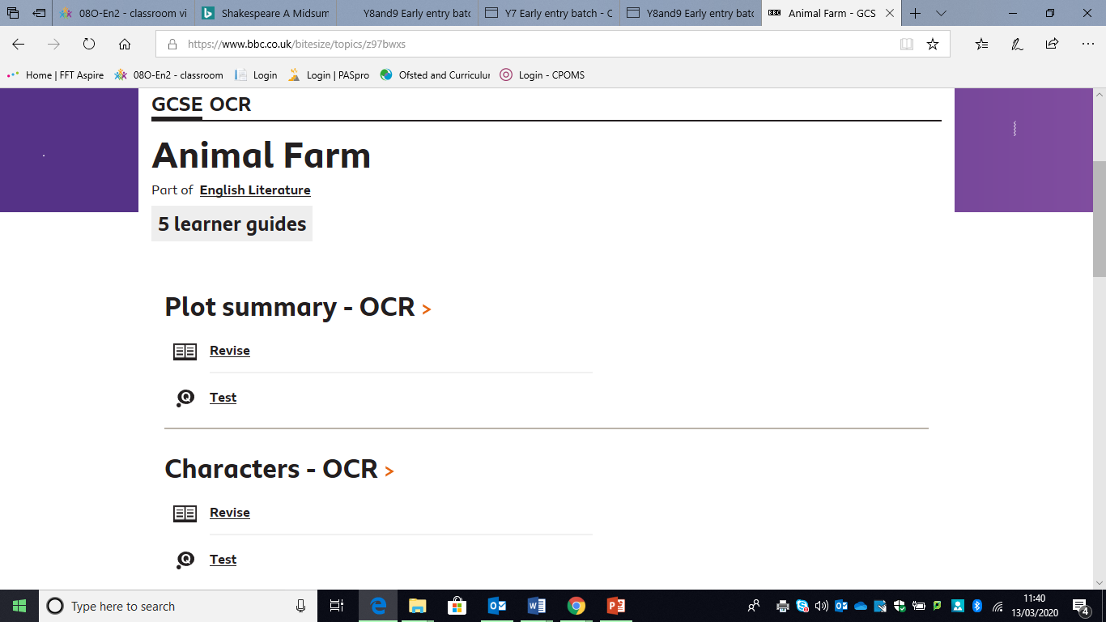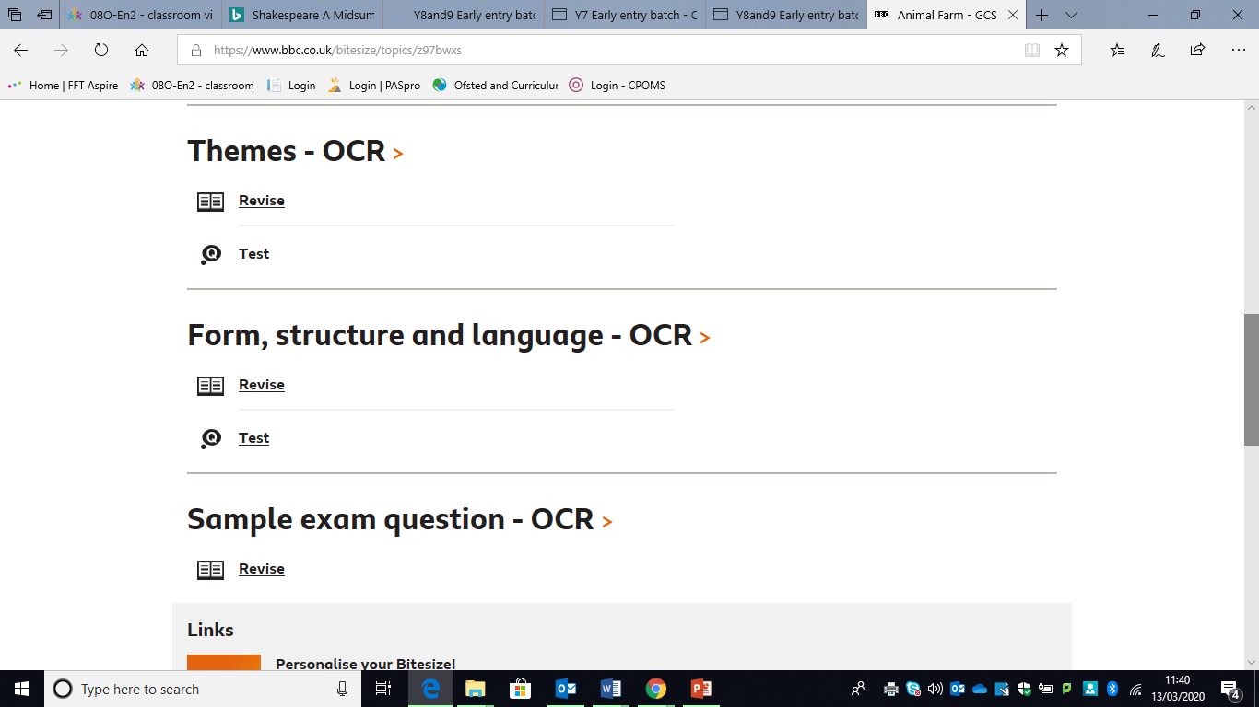

**Grammar**

There are also a number of revision PowerPoints and videos that will support you with your English grammar lessons. Please use the link below to access BBC Bitesize

<https://www.bbc.co.uk/bitesize/topics/zmbj382>

You will then need to select:

Secondary – KS3 – English – Spelling, punctuation and grammar

Then work through the PowerPoints and videos for this section.

At the end, there are tests you can take. Take the test and then check the score to see how much you have learnt, know and remembered. Repeat the following week as a way of checking that you have mastered the information.

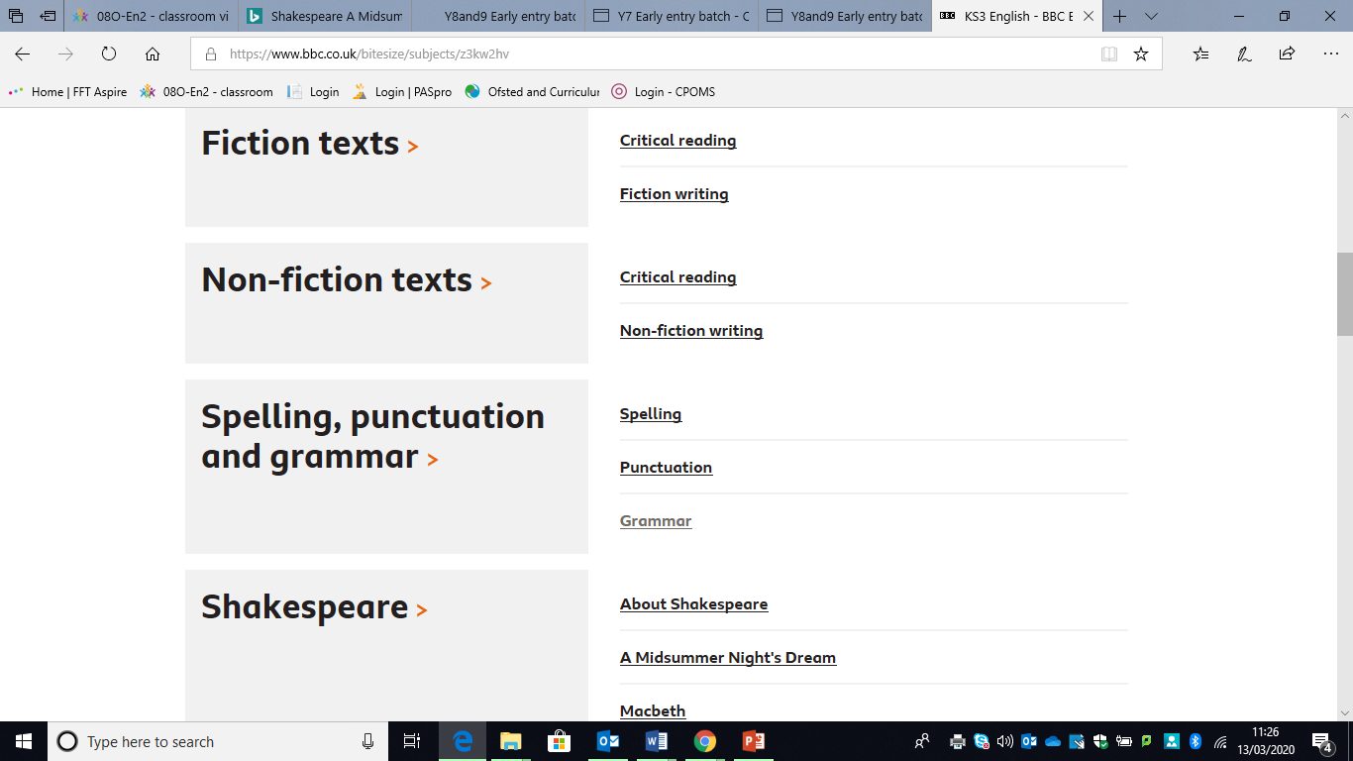

In addition to the spelling, punctuation and grammar, you can then further your knowledge by completing the reading and writing skills sections.

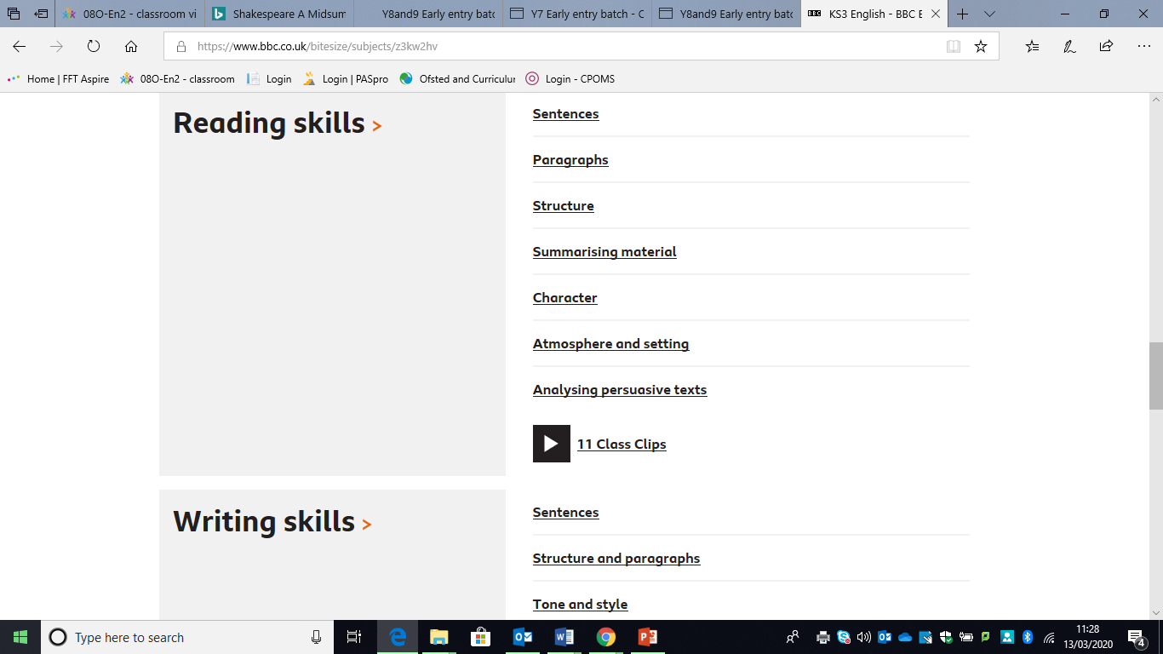

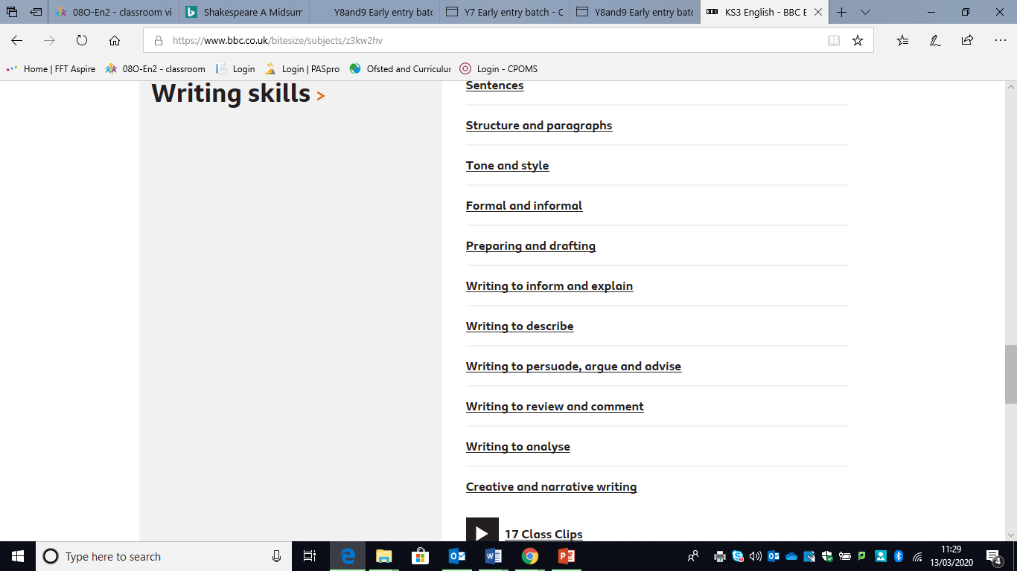

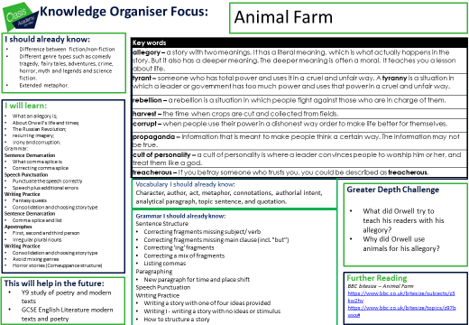

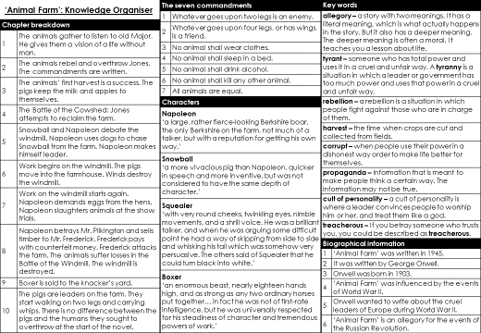

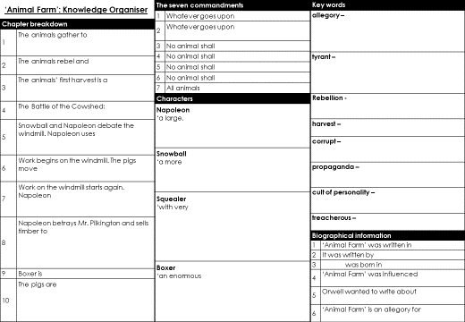

**Plot Summary**

1. The animals of Manor Farm have always been miserable under Mr. Jones and his men. They have come to accept their difficult lives as part of the natural order of things.
2. 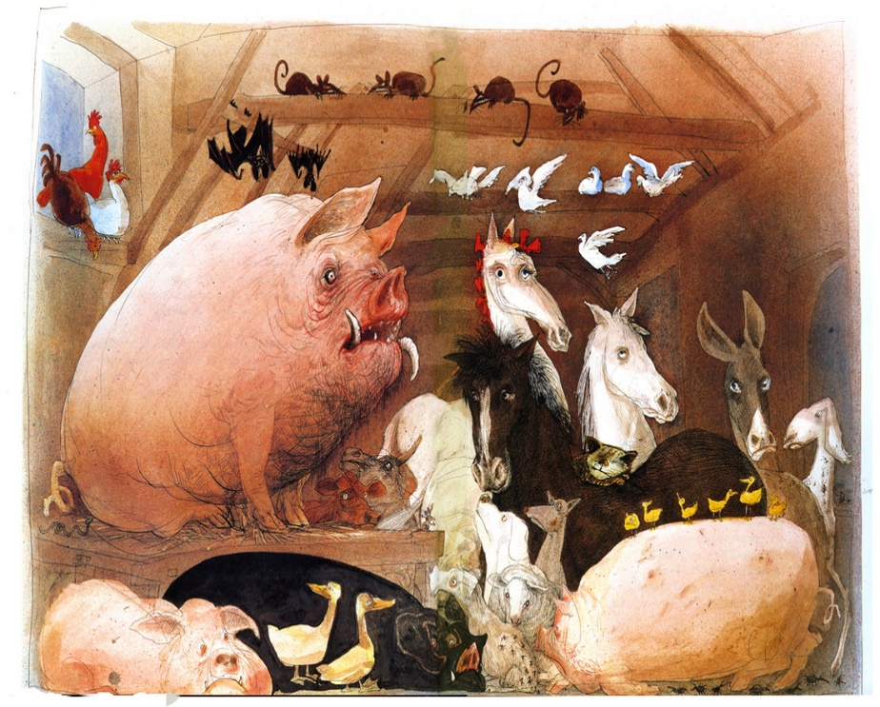It is Old Major, a prize-winning boar, who shares his dreams with the other animals. He tells them that the cause of all their suffering is man. With man gone, the animals would enjoy the abundance the land provides and build a new society based on equality. He says that Jones has no concern for the animals—that he uses them until they are no longer productive. He butchers the pigs and drowns the dogs when they get old. Old Major predicts that Jones will even sell Boxer, the horse, and the hardest and most faithful worker on the farm, to the slaughterhouse once he is no longer able to work.
3. He encourages the animals to work for this revolution. He warns them never to become like man and to always treat each other as equals.
4. Three nights later, Old Major dies, and the task of preparing the animals for the revolution falls to the pigs, who are smarter than the others and who later teach themselves to read. Three young pigs, the intellectual Snowball, the domineering Napoleon and the eloquent Squealer, organize Old Major’s dream of the future into a political philosophy called Animalism.
5. When the drunken Mr. Jones fails to feed the animals one night, the animals drive him and his men off the farm. They change the name to “Animal Farm,” and the pigs, who seem to have assumed leadership, write the principles of Animalism, reduced to Seven Commandments, on the barn wall.
6. These are to be the unalterable rules by which the animals will live ever after:

1. Whatever goes upon two legs is an enemy.  
2. Whatever goes upon four legs, or has wings, is a friend.  
3. No animal shall wear clothes.  
4. No animal shall sleep in a bed.  
5. No animal shall drink alcohol.  
6. No animal shall kill any other animal.  
7. All animals are equal.

1. At first the revolution seems to be a success. All of the animals, directed and supervised by the pigs, work hard to bring in the harvest. But there are indications from the beginning that the pigs treat themselves specially.
2. They remain the supervisors, doing no physical labour, and they take extra food (mild and windfall apples) for themselves instead of sharing with the others.
3. Meanwhile Jones, with the aid of his neighbours, tries to retake the farm. They are driven off at the “Battle of the Cowshed” by the military tactics of Snowball and the strength of Boxer. Both are decorated as heroes for their roles in the victory. 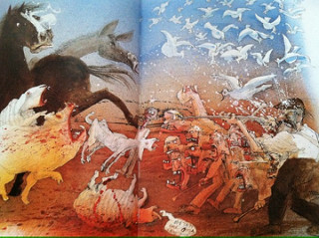
4. A power struggle for control of Animal Farm develops between Snowball and Napoleon, and it culminates with the building of a windmill. When the animals seem about to vote in favour of the project, Napoleon, who opposes the plan, unleashes nine dogs he has been training secretly to follow his orders without question.
5. Snowball is chased off the farm, barely escaping the jaws of the dogs. In a turnabout, Napoleon orders that work on the windmill begin. The work is difficult, and the animals suffer in the process.
6. 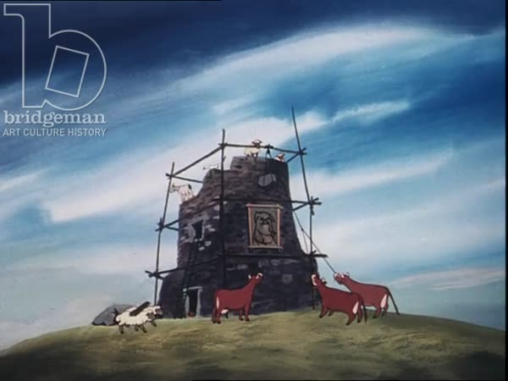When a storm blows the windmill down, Napoleon blames the exiled Snowball and condemns him as an enemy. Napoleon exploits the animals’ fear that Jones will return and their fear of his fierce dogs to consolidate his power. He uses Squealer to lie to the animals and convince them that things aren’t what they seem.
7. As work on the second windmill begins, Napoleon and the pigs become more and more corrupt. They change the commandments, move into Jones’s house, and drink whisky. Napoleon even kills other animals who dare to stand up to his authority.
8. The second windmill is blown up in an attack by Frederick, after he steals wood from Animal Farm, by paying for it with counterfeit money. But Napoleon pronounces this defeat to be a great victory, and work begins on a third attempt to build a windmill. None of the promises of leisure time and comfort come true—no heat or electricity in the barn, no machines to do their hard work.
9. In fact, life grows harder for all of the animals, except the pigs, and food is scarcer. When Boxer, the hardest worker on the farm, is hurt, Napoleon sells him to the horse slaughterer. Squealer convinces the others that Boxer died in the hospital after getting the best treatment. Old Major’s prediction about Boxer has come true, but it is Napoleon who is the villain. 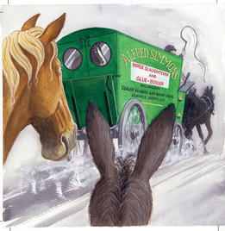
10. 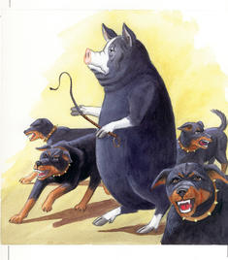In the end, the pigs completely subvert the ideals of Animalism. They are the new masters. They walk on two legs. They violate and change each of the Seven Commandments. Ultimately, these commandments are erased and replaced with only one: “All animals are equal, but some animals are more equal than others.”
11. In the final scene, Mr. Pilkington comes for a tour and Napoleon announces some changes. The name is changed back to “Manor Farm,” and a new level of understanding is reached between pig and man. The book ends when someone cheats in a card game. The animals, watching from outside, cannot tell the difference between the pigs and the men.

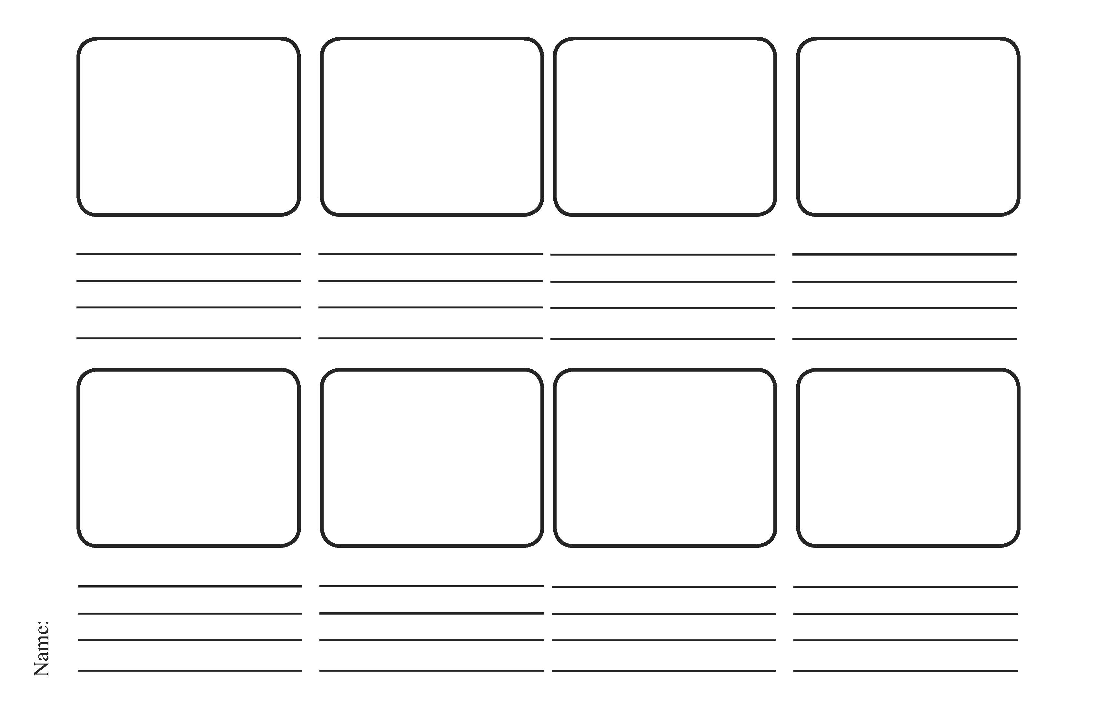

**In your own words, from memory, storyboard the plot of animal farm**



**In your own words, from memory, storyboard the plot of animal farm**

**What’s in a name?**

In Animal Farm, many of the character’s names have symbolic significance. Think about the importance and significance of the following names. What might they suggest? How do they connect with what we know about that character? (Some ideas are provided on the next page to compare your ideas against)

|  |  |  |
| --- | --- | --- |
| Name | What does it suggest? | How does it connect with what we know about the character? |
| Mr Jones |  |  |
| Old Major |  |  |
| Napoleon |  |  |
| Snowball |  |  |
| Boxer |  |  |
| Clover |  |  |
| Squealer |  |  |
| Moses |  |  |

**What’s in a name?**

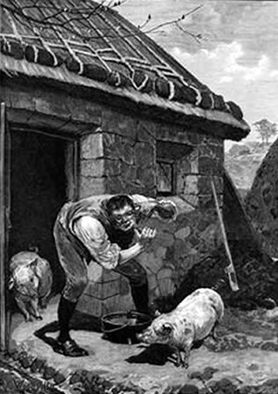**Mr Jones –** As the surname ‘Jones’ is very common, it could suggest that Mr Jones is perhaps a typical farmer with nothing that distinguishes him or makes him special. If Jones is a typical farmer, then it helps emphasise the idea that life on farms up and down the land are run much in the same way, and are therefore just as ripe for rebellion.

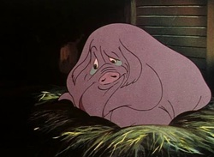**Old Major –** In the armed forces, ‘major’ is a high military rank, which helps us to understand this character’s status. This is shown in the opening chapter, with Major addressing his adoring audience, stirring up rebellion. The words ‘old major’ also conjure up images of a wise character, as there is often a belief that wisdom comes with age, whilst a major in an army is capable of managing huge numbers of soldiers. The adjective ‘old’ is significant as the reader automatically expects this character to be towards the end of their life. This is quickly proved as Major does indeed pass away in chapter 2, leading to the power struggle that we see later on.

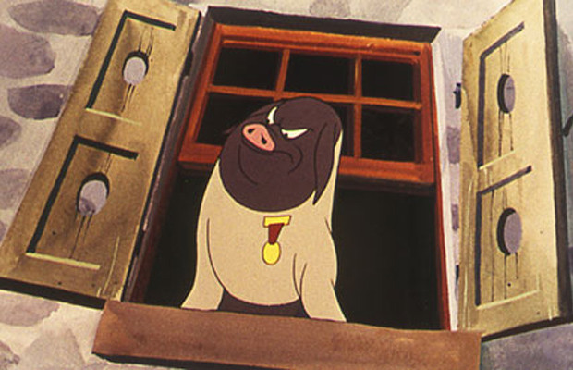**Napoleon –** Most readers will think about Napoleon Bonaparte when they see this name, which is precisely what Orwell intended. The historical figure Napoleon was a French military leader who gained fame for his success on the battlefield, whilst also being known for always getting his own way. He was considered by many to be a ruthless leader who ruled with an iron fist. We see much the same character in the Napoleon of animal farm: a character who uses violence and force to get what he wants.

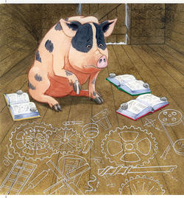**Snowball –** The interestingly named snowball is a character with good intentions. He clearly wants what is best for the farm. The purity of his character might link to the ‘snow’ in his name, which represents purity and innocence. The word ‘Snowball’ is interesting as it might hint at the idea of ‘the snowball effect’: the idea that if a snowball runs downhill, it gains momentum and size. This connects quite nicely with Snowball’s campaigns, which win over the hearts of many animals and ‘gather momentum’ much in the same way…before Napoleon’s dogs run him off the farm that is.

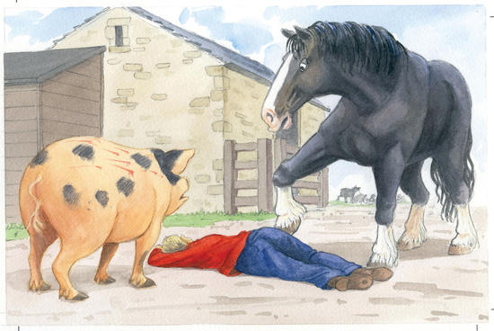**Boxer –** One of the most loved characters in literature. His name links in many ways to his character. Firstly, boxers are fighters, which links into Boxer’s fighting spirit and unwillingness to ever give up. The name also clearly hints at his strength and physical prowess, which is mentioned many times in the novel. Finally the plosive ‘b’ sound in his name is quite punchy, almost aggressive sounding. This connects to events in the novel where we see his incredible strength unleashed on the stable lad.

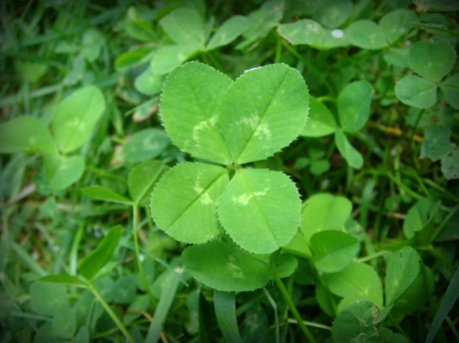**Clover –** Clovers are small grass-type plants considered to be a symbol of luck. In Animal Farm, the character clover seems to be very down to earth, which might link to the idea of clovers being a plant and therefore part of the earth. Interestingly, clover is considered to be lucky (four leaved clover) which is ironic considering how unlucky life is for animals on the farm!

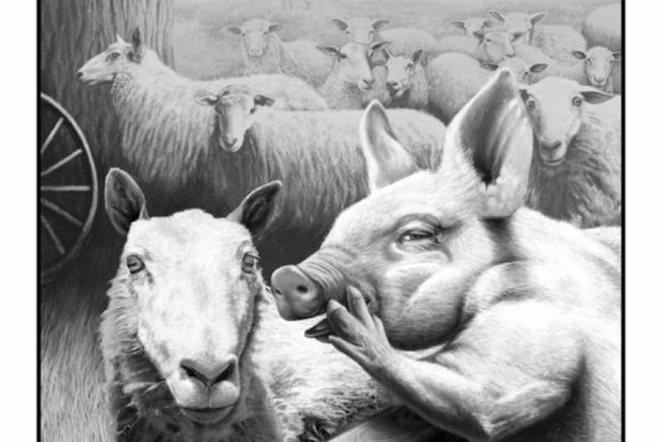**Squealer –** In the novel, squealer is the mouthpiece for Napoleon’s propaganda. The name might help to emphasise how Squealer speaks, but it might also hint at how Squealer is a character that isn’t to be trusted, given that the word has negative connotations.

**Moses –** Moses is a figure from the bible who delivers the 10 commandments. It’s significant that Moses the raven in Animal Farm is always delivering news to the farm, whilst also spreading rumours about the mystical heaven of ‘Sugarcandy Mountain’ which again creates the sense that Moses is a vaguely religious creature.

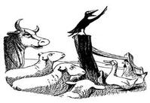

**Context**

**Animal farm is basically an *Allegory* for the rise and fall of communism in Russia. Orwell admitted that he intended for the book to serve as an attack on Stalin (leader of the communist party in Russia) and how the ideals of communism became corrupted. Basically, he felt that the idea of everyone being equal (communism) had been ruined by the greed and violence of Stalin. Orwell based certain characters on key historical figures:**

**Snowball – Lenin**

**Napoleon – Stalin**

**Mr Jones – The old Tsarist regime**

**Boxer and the other animals – the workers and ordinary people of Russia**

**Task 1: Produce a small fact file about these historical figures**

|  |  |  |  |
| --- | --- | --- | --- |
| **Lenin** | **Stalin** | **Tsarism** | **Russian Working Class** |
|  |  |  |  |

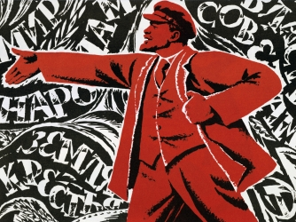**Context Continued**

**Below is a table comparing historical events with those in Animal Farm. See if you can make connections between what went on in history and events in the novel. An example has been done for you.**

|  |  |
| --- | --- |
| **Event From History** | **Event in the Novel** |
| **There were chronic food shortages in Russia and a general sense of unrest. In 1917, led by Lenin, The tsar Nicholas ii was overthrown.** | **Having not been fed, the cows raid the food store. Jones is eventually expelled from the farm and the rebellion is successful.** |
| **At first, under Lenin, the communist ideology was popular and quite successful** |  |
| **Within the ranks of the soviet union was Stalin, who eventually overthrew Lenin in 1922** |  |
| **Stalin was a brutal leader and history suggests he is responsible for millions of deaths. Any opponents to his ideas were quickly murdered.** |  |
| **Over the years, the ideals of communist were eroded. Stalin was essentially a dictator and the Russian people were as poor and hungry as ever** |  |
| **Stalin ruled with an iron grip until his death in 1953.** |  |

**Key Quotes**

**For each of these quotes, consider the following:**

1. **What does this quote mean?**
2. **What does the quote suggest?**
3. **What are the key words in the quote?**
4. **What do these words mean (synonyms) and what are the connotations of these words and the effect?**
5. **What do you think Orwell’s message/intention was? Can you find any links to context?**

**Chapter 1:**

Major: Man is the only real enemy we have. Remove Man from the scene, and the root cause of hunger and overwork is abolished forever

Major: You, Boxer, the very day that those great muscles of yours lose their power, Jones will sell you to the knacker, who will cut your throat and boil you down for the foxhounds.

Major: And among us animals let there be perfect unity, perfect comradeship in the struggle. All men are enemies. All animals are comrades

Major: In fighting against Man, we must not come to resemble him. Even when you have conquered him, do not adopt his vices.

Description of Boxer: Boxer was an enormous beast, nearly eighteen hands high, and as strong as any two ordinary horses put together. A white stripe down his nose gave him a somewhat stupid appearance, and in fact he was not of first-rate intelligence, but he was universally respected for his steadiness of character and tremendous powers of work

**For each of these quotes, consider the following:**

1. **What does this quote mean?**
2. **What does the quote suggest?**
3. **What are the key words in the quote?**
4. **What do these words mean (synonyms) and what are the connotations of these words and the effect?**
5. **What do you think Orwell’s message/intention was? Can you find any links to context?**

**Chapter 2:**

THE SEVEN COMMANDMENTS  
1. Whatever goes upon two legs is an enemy.   
2. Whatever goes upon four legs, or has wings, is a friend.   
3. No animal shall wear clothes.   
4. No animal shall sleep in a bed.   
5. No animal shall drink alcohol.   
6. No animal shall kill any other animal.   
7. All animals are equal.

**Chapter 3:**

Nobody stole, nobody grumbled over his rations, the quarrelling and biting and jealousy which had been normal features of life in the old days had almost disappeared.

Boxer: I will work harder!

**Chapter 4:**

"I have no wish to take life, not even human life," repeated Boxer, and his eyes were full of tears.

**Chapter 5:**

(Snowball and Napoleon) These two disagreed at every point where disagreement was possible

(Snowball’s expulsion) At this there was a terrible baying sound outside, and nine enormous dogs wearing brass-studded collars came bounding into the barn. They dashed straight for Snowball, who only sprang from his place just in time to escape their snapping jaws.

**For each of these quotes, consider the following:**

1. **What does this quote mean?**
2. **What does the quote suggest?**
3. **What are the key words in the quote?**
4. **What do these words mean (synonyms) and what are the connotations of these words and the effect?**
5. **What do you think Orwell’s message/intention was? Can you find any links to context?**

Boxer: Napoleon is always right.

**Chapter 6:**

All that year the animals worked like slaves. But they were happy in their work; they grudged no effort or sacrifice, well aware that everything they did was for the benefit of themselves and those of their kind who would come after them, and not for a pack of idle, thieving human beings

**Chapter 7:**

They were always cold, and usually hungry as well.

Whenever anything went wrong it became usual to attribute it to Snowball.

And so the tale of confessions and executions went on, until there was a pile of corpses lying before Napoleon's feet and the air was heavy with the smell of blood, which had been unknown there since the expulsion of Jones.

(A tearful Clover after the slaughter of the pigs and hens)*:* If she herself had had any picture of the future, it had been of a society of animals set free from hunger and the whip, all equal, each working according to his capacity, the strong protecting the weak

They had come to a time when no one dared speak his mind, when fierce, growling dogs roamed everywhere, and when you had to watch your comrades torn to pieces after confessing to shocking crimes.

**Chapter 8:**

It had become usual to give Napoleon the credit for every successful achievement and every stroke of good fortune.

**Chapter 9:**

Besides, in those days they had been slaves and now they were free, and that made all the difference, as Squealer did not fail to point out.

**Chapter 10:**

But the luxuries of which Snowball had once taught the animals to dream, the stalls with electric light and hot and cold water, and the three-day week, were no longer talked about. Napoleon had denounced such ideas as contrary to the spirit of Animalism

Somehow it seemed as though the farm had grown richer without making the animals themselves any richer-except, of course, for the pigs and the dogs.

Four legs good, two legs better!

The single commandment to replace the others: ALL ANIMALS ARE EQUAL  
BUT SOME ANIMALS ARE MORE EQUAL THAN OTHERS.

**For each of these quotes, consider the following:**

1. **What does this quote mean?**
2. **What does the quote suggest?**
3. **What are the key words in the quote?**
4. **What do these words mean (synonyms) and what are the connotations of these words and the effect?**
5. **What do you think Orwell’s message/intention was? Can you find any links to context?**

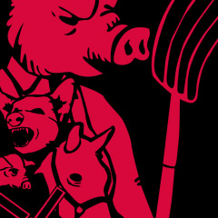

No question now, what had happened to the faces of the pigs. The creatures outside looked from pig to man, and from man to pig, and from pig to man again; but already it was impossible to say which was which.

**Themes**

**Explore the themes of the novel by completing the table below**

|  |  |  |  |  |
| --- | --- | --- | --- | --- |
| **Theme** | **Characters that link with the theme (explain HOW)** | **Events that link with the theme** | **Key quotes associated with the theme** | **Why did Orwell include this theme in the novel?** |
| Power |  |  |  |  |
| Corruption |  |  |  |  |
| Dreams |  |  |  |  |
| Violence |  |  |  |  |
| Foolishness |  |  |  | Don’t forget to EXPLAIN and JUSTIFY your ideas when exploring themes |
| Leadership |  |  |  |  |

**Revision – Character Profile – Old Major**

**Themes –** What themes does this character connect with and how?

**Plot –** What happens to them in the story? Summarise their role

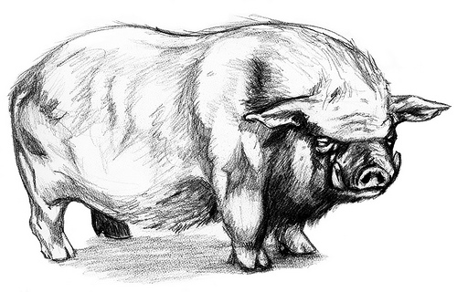

**Quotes –** Write down 3 key quotes that relate to this character and explore their meaning & effect.

**Characterisation –** How would you describe this character’s personality? How would the reader react to this character?

**Revision – Character Profile – Mr Jones**

**Themes –** What themes does this character connect with and how?

**Plot –** What happens to them in the story? Summarise their role

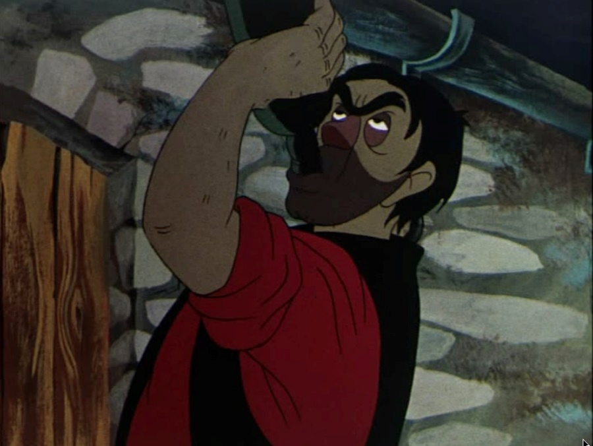

**Quotes –** Write down 3 key quotes that relate to this character and explore their meaning & effect.

**Characterisation –** How would you describe this character’s personality? How would the reader react to this character?

**Revision – Character Profile – Boxer**

**Themes –** What themes does this character connect with and how?

**Plot –** What happens to them in the story? Summarise their role

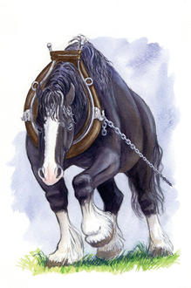

**Quotes –** Write down 3 key quotes that relate to this character and explore their meaning & effect.

**Characterisation –** How would you describe this character’s personality? How would the reader react to this character?

**Revision – Character Profile – Napoleon**

**Themes –** What themes does this character connect with and how?

**Plot –** What happens to them in the story? Summarise their role

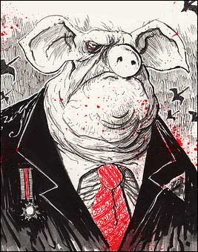

**Quotes –** Write down 3 key quotes that relate to this character and explore their meaning & effect.

**Characterisation –** How would you describe this character’s personality? How would the reader react to this character?

**Revision – Character Profile – Snowball**

**Themes –** What themes does this character connect with and how?

**Plot –** What happens to them in the story? Summarise their role

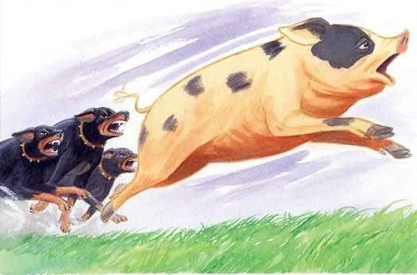

**Quotes –** Write down 3 key quotes that relate to this character and explore their meaning & effect.

**Characterisation –** How would you describe this character’s personality? How would the reader react to this character?

**Revision – Character Profile – Squealer**

**Themes –** What themes does this character connect with and how?

**Plot –** What happens to them in the story? Summarise their role

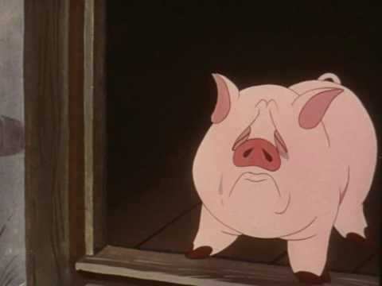

**Quotes –** Write down 3 key quotes that relate to this character and explore their meaning & effect.

**Characterisation –** How would you describe this character’s personality? How would the reader react to this character?

**Key Word Glossary**

Below is a table of key words which link with the text and will help you deepen your understanding of the text. Find out what the words mean and then make links to the text.

|  |  |  |
| --- | --- | --- |
| **Word** | **Meaning** | **Link to the novel** |
| Allegory |  |  |
| Fable |  |  |
| Symbolism |  |  |
| Propaganda |  |  |
| Manipulation |  |  |
| Corruption |  |  |
| Communism |  |  |
| Dictatorship |  |  |
| Idealism |  |  |
| Class Stratification |  |  |
| Naivety |  |  |
| Oppression |  |  |
| Hypocrisy |  |  |
| Psychological Warfare |  |  |
| Exploitation |  |  |
| Dystopian |  |  |

**Practise Questions**

Below are some practise questions. Spend 15 minutes planning then up to 60 minutes writing responses to the following questions.

1. How does Orwell use the character of Napoleon to explore ideas about power and control in Animal Farm?

Write about:

• how Orwell presents the character of Napoleon

• how Orwell uses the character of Napoleon to present ideas about power and control in the novel.

1. ‘All animals are equal, but some are more equal than others.’ How far is this idea important in Animal Farm?

Write about:

• what you think Orwell is saying about equality and inequality

• how Orwell presents these ideas through the events of the novel.

1. In what ways is Snowball an important character in the novel?

Write about:

* How Snowball is presented
* How you think Orwell uses the character of Snowball to reflect ideas about society

1. How does Orwell present the importance of the windmill in the novel?

Write about:

* How Orwell presents attitudes towards the windmill
* How you think Orwell uses the windmill to reflect ideas about society

1. Write about two occasions in the novel which you think are important.

Write about:

* What is important about each occasion & how Orwell shows their importance
* How Orwell uses these occasions to tell us something about society

1. In what ways is old Major’s speech important?

Write about:

* What old Major says & how Orwell presents old Major by the ways he writes about him
* The ways in which old Major’s speech comments on society

1. In what ways is Boxer an important character?

Write about:

* How Orwell presents Boxer in the novel
* How Boxer is used to make points about society

1. How does Orwell present the characters of Muriel and Benjamin in the novel?

Write about:

* How these two characters are presented
* How you think these characters reflect ideas about society

1. How does Orwell present the importance of The Seven Commandments in the novel?

Write about:

* Different attitudes towards the commandments
* What you think Orwell is trying to tell us about society through The Seven Commandments and the way they change in the novel

