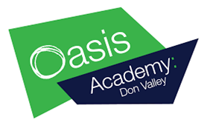
Education at home
History

Alongside completing your assigned BBC Bitesize work, here are some additional tasks to complete at home.

Watch a documentary: BBC iPlayer has amazing and free documentaries that explore a variety of geographical topics linked to the work you are doing in school from natural world to climate change. Use your knowledge organisers to identify topics you wish to know more about.

Project: Use your geographical skills to create a project on a country of your choosing. Below are some questions you must answer:
  - Where is this country located? (Continent, compass directions etc…)
  - Is this country a LIC, HIC or NEE? Why?
  - List some development indicators (GDP, literacy rate etc…)
  - What are some of the key physical features of the country?
  - What are some of the key human features of the country?
  - How do the topics you have studied this year apply to this country?

You can present this research project in any way you like – the more creative, the better!

