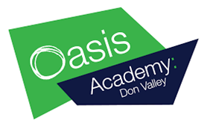
Education at home
German

Alongside completing your assigned BBC Bitesize work, here are some additional tasks to complete at home.

- Watch a DVD in German: on some DVDs you can change the language to watch it in German – this is a great way to listen to the German language and you will pick up some new words along the way. It would be fun to watch your favourite film in a different language - you could hear Elsa singing ‘Let it Go’ in German or laugh along with German Buzz Lightyear!

- Project: Use your 4 Knowledge Organisers to design a project all about yourself. You can include lots of information about yourself, your family, your pets, your hobbies, your school subjects and teachers. Make it really interesting, bright and colourful. You could present the information as a presentation with slides on a computer, as a poster, a leaflet, mini book, as a song or in any unique way you choose. Just make sure there is lots of great German.

- German A-Z: Use the online translator or a dictionary to make your own German A-Z – Can you find 5 new and useful words for each letter which you can then use in your German when we get back to school?
https://www.leo.org/german-english

