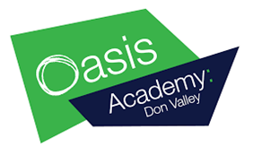
Education at home
History

Alongside completing your assigned BBC Bitesize work, here are some additional tasks to complete at home.

Watch a documentary: BBC iPlayer has amazing and free documentaries that explore a variety of historical topics linked to the work you are doing in school from the Tudors, through the suffragettes to World War Two and the holocaust. Use your knowledge organisers to identify topics you wish to know more about.

Project: Use your historical skills to create your own research project into a person from history.

Choose someone from the knowledge organisers and find out about …

- Their childhood and early life
- What they did that makes them important
- What the impact of their work was – how did it change the world?

You could present your work on a powerpoint presentation or in a booklet.

