Name........................................
Oasis Academy Don Valley
Work from home pack – Science Y8
Introduction
Welcome to the OADV Science work at home pack. This pack has been designed to consolidate the learning your student has been working on over their time with us. At the same time, some new sections of learning will be introduced to help support their education moving forward when we return to the Academy.
Below is an outline of the different lessons, the area of Science they cover and the expectations around the completion of the booklet.
At the back of the booklet is space to put any words you are unsure on and their definitions (use the links provided). There is also space for you to write any questions you want to ask about the content when you return to the Academy.
Finally, the last page is a reflection on the learning you have done and you must write a WWW and an EBI.
Lesson content
Week | Lesson | Topic
1 | 1 | Periodic Table
 | 2 | Keeping healthy 1
 | 3 | Keeping healthy 2
 | 4 | Energy from food 1 (new)
2 | 5 | Waves and pressure
 | 6 | Reactions 1
 | 7 | Reactions 2
 | 8 | Energy from food 2 (new)

Lesson tasks
Task | Notes | Timings
Link for revision | Using the link provided, read through the website and make short notes on scrap paper if required. | 15 minutes
Mini Assessment Questions | Questions will be answered in two parts known as drafts.  - Draft 1 – having read the information on the website, answer the questions using just your knowledge.  - Draft 2 – using your PURPLE pen, re-answer the questions using your knowledge organiser, the website provided, and your knowledge book. | 30 minutes  (15 minutes per draft)
Educake | Complete your assigned Educake for the lesson. | 15 minutes
Application | Attempt the exam based question to test your application. This will be marked when you return to the Academy. | 10 minutes
1. Periodic Table
Key learning outcomes
- Discuss the history of the Periodic Table and its arrangement.
- Compare the properties of metals and non-metals.
- Describe the structure of an atom and state why they are electronically neutral.
- Understand the trends and patterns shown in Group 1, Group 7, and Group 0 of the Periodic Table.

BBC Bitesize
The Periodic Table: https://www.bbc.co.uk/bitesize/guides/z84wjxs/revision/1
Reactivity of group 1 and 7 elements – video clip - https://www.bbc.co.uk/bitesize/clips/z7j34wx
‘Mini Assessment’ Questions
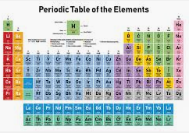
1. Draw the structure of an atom and label the 3 main parts with their names and charges.
2. Draw the electronic structure for lithium, sodium, fluorine, chlorine and neon.
3. Define element, compound and mixture and give examples for each.
4. Why is potassium more reactive than lithium? Use the words shielding, attraction, positive, negative.
5. Define exothermic and endothermic reactions and draw and label an energy diagram for each.
6. Compare the properties of metals and non-metals.

First draft – using the knowledge you gained from the website above – black pen
________________________________________________________________________________________________________________________________________________________________________________________________________________________________________________________________________________________________________________________________________________________________________________________________________________________________________________________________________________________________________________________________________________________________________________________________________________________________________________________________________________________________________________________________________________________________________________________________________________________________________________________________________________________________________________________________________________________________________________________________________________________________________________________________________________________________________________________________________________________________________________________________________________________________________________________________________________________________________________________________________________________________________________________________________________________________________________________________________________________________________________________________________________________________________________________________________________________________________________________________________________________________________________________________________________________________________________________________________________________________________________________________________________________________________________________________________________________________________________________________________________________________________________________________________________________________________________________________________________________________________________________________________________________________________________________________________________________________________________________________________________________________________________________________________________________________________________________________________________________________________________________________________________________________________________________________________________________________________________________________________________________________________________________________________________________________________________________________________________________________________________________________________________________________________________________________________________________________________________________________________________________________________________________________________________________________________________________________________________________________________________________________________________________________________________________________________________________________________________________________________________________________________________________________________________________________________________________________________________________________________________________________________________________________________________________________________________________________________________________________________________________________________________________________________________________________________________________________________________________________________________________________________________________________________________________________________________________________________________________________________________________________________________________________________________________________________________________________________________________________________________________________________________________________________________________________________________________________________________________________________________________________________________________________________________________________________________________________________________________________________________________________________________________________________________________________________________________________________________________________________________________________________________________________________________________________________________________________________________________________________________________________________
Final draft – using the website above and your knowledge organiser – purple pen
____________________________________________________________________________________________________________________________________________________________________________________________________________________________________________________________________________________________________________________________________________________________________________________________________________________________________________________________________________________________________________________________________________________________________________________________________________________________________________________________________________________________________________________________________________________________________________________________________________________________________________________________________________________________________________________________________________________________________________________________________________________________________________________________________________________________________________________________________________________________________________________________________________________________________________________________________________________________________________________________________________________________________________________________________________________________________________________________________________________________________________________________________________________________________________________________________________________________________________________________________________________________________________________________________________________________________________________________________________________________________________________________________________________________________________________________________________________________________________________________________________________________________________________________________________________________________________________________________________________________________________________________________________________________________________________________________________________________________________________________________________________________________________________________________________________________________________________________________________________________________________________________________________________________________________________________________________________________________________________________________________________________________________________________________________________________________________________________________________________________________________________________________________________________________________________________________________________________________________________________________________________________________________________________________________________________________________________________________________________________________________________________________________________________________________________________________________________________________________________________________________________________________________________________________________________________________________________________________________________________________________________________________________________________________________________________________________________________________________________________________________________________________________________________________________________________________________________________________________________________________________________________________________________________________________________________________________________________________________________________________________________________________________________________________________________________________________________________________________________________________________________________________________________________________________________________________________________________________________________________________________________________________________________________________________________________________________________________________________________________________________________________________________________________________________________________________________________________________________________________________________________

Complete EduCake (Home Education 1)
Application Question
There are eight elements in the second row (lithium to neon) of the periodic table.
(a) Figure 1 shows a lithium atom.
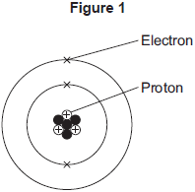
(i) What is the mass number of the lithium atom in Figure 1?
Tick (✔) one box.
3
4
7

(ii) What is the charge of an electron?

Tick (✔) one box.
–1
0
+1
(1)
(b) What is always different for atoms of different elements?
number of neutrons
number of protons
number of shells
(1)
(c) Figure 2 shows the electron arrangements of three different atoms, X, Y and Z.
These atoms are from elements in the second row (lithium to neon) of the periodic table.
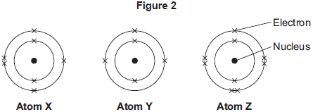
Which atom is from an element in Group 3 of the periodic table?

2. Keeping healthy 1
Key learning outcomes
- Analyse the hierarchy of organisation in living organisms.
- Understand the role of the respiratory system in the body.
- Understand the role of the circulatory system in the body.

BBC Bitesize
Breathing and circulation video - https://www.bbc.co.uk/bitesize/clips/zjchyrd
Respiration - https://www.bbc.co.uk/bitesize/guides/zq349j6/revision/1
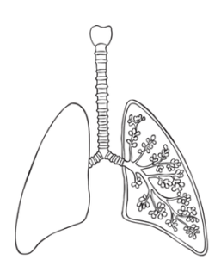
‘Mini Assessment’ Questions
1. Label the diagram of the lungs and give three adaptations of the alveoli for gas exhange.
2. Describe the process of inhalation and exhalation, using the key words contract, relax, muscle and diaphragm.
3. Explain the different between breathing and respiration.

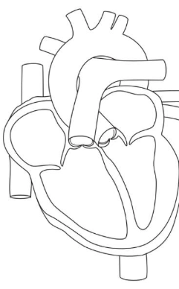
4. Describe the journey of blood through the heart and draw arrows on the diagram to show it.
5. Name the three main blood vessels in the human body. State their adaptations to their function.
6. Describe the role of the valves in the heart. Why are they important?

First draft – using the knowledge you gained from the website above – black pen
________________________________________________________________________________________________________________________________________________________________________________________________________________________________________________________________________________________________________________________________________________________________________________________________________________________________________________________________________________________________________________________________________________________________________________________________________________________________________________________________________________________________________________________________________________________________________________________________________________________________________________________________________________________________________________________________________________________________________________________________________________________________________________________________________________________________________________________________________________________________________________________________________________________________________________________________________________________________________________________________________________________________________________________________________________________________________________________________________________________________________________________________________________________________________________________________________________________________________________________________________________________________________________________________________________________________________________________________________________________________________________________________________________________________________________________________________________________________________________________________________________________________________________________________________________________________________________________________________________________________________________________________________________________________________________________________________________________________________________________________________________________________________________________________________________________________________________________________________________________________________________________________________________________________________________________________________________________________________________________________________________________________________________________________________________________________________________________________________________________________________________________________________________________________________________________________________________________________________________________________________________________________________________________________________________________________________________________________________________________________________________________________________________________________________________________________________________________________________________________________________________________________________________________________________________________________________________________________________________________________________________________________________________________________________________________________________________________________________________________________________________________________________________________________________________________________________________________________________________________________________________________________________________________________________________________________________________________________________________________________________________________________________________________________________________________________________________________________________________________________________________________________________________________________________________________________________________________________________________________________________________________________________________________________________________________________________________________________________________________________________________________________________________________________________________________________________________________________________________________________________________________________________________________________________________________________________________________________________________________________________________________________________
Final draft – using the website above and your knowledge organiser – purple pen
___________________________________________________________________________________________________________________________________________________________________________________________________________________________________________________________________________________________________________________________________________________________________________________________________________________________________________________________________________________________________________________________________________________________________________________________________________________________________________________________________________________________________________________________________________________________________________________________________________________________________________________________________________________________________________________________________________________________________________________________________________________________________________________________________________________________________________________________________________________________________________________________________________________________________________________________________________________________________________________________________________________________________________________________________________________________________________________________________________________________________________________________________________________________________________________________________________________________________________________________________________________________________________________________________________________________________________________________________________________________________________________________________________________________________________________________________________________________________________________________________________________________________________________________________________________________________________________________________________________________________________________________________________________________________________________________________________________________________________________________________________________________________________________________________________________________________________________________________________________________________________________________________________________________________________________________________________________________________________________________________________________________________________________________________________________________________________________________________________________________________________________________________________________________________________________________________________________________________________________________________________________________________________________________________________________________________________________________________________________________________________________________________________________________________________________________________________________________________________________________________________________________________________________________________________________________________________________________________________________________________________________________________________________________________________________________________________________________________________________________________________________________________________________________________________________________________________________________________________________________________________________________________________________________________________________________________________________________________________________________________________________________________________________________________________________________________________________________________________________________________________________________________________________________________________________________________________________________________________________________________________________________________________________________________________________________________________________________________________________________________________________________________________________________________________________________________________________________________________________________________________________

Complete EduCake (Home Education 2)
Application Questions
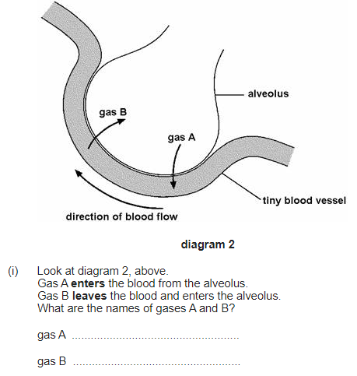
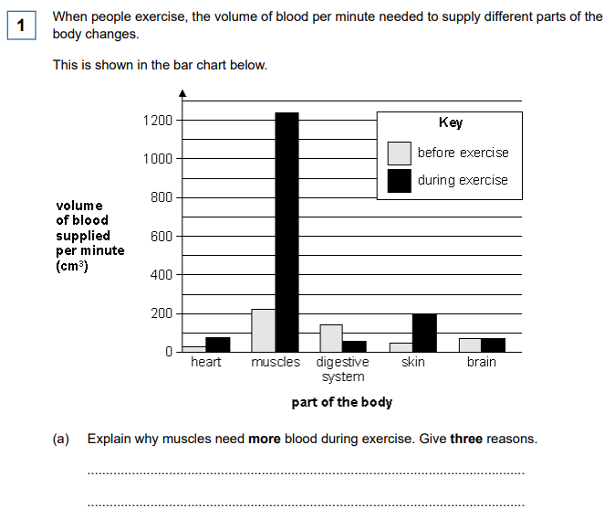
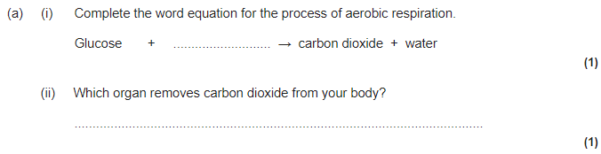
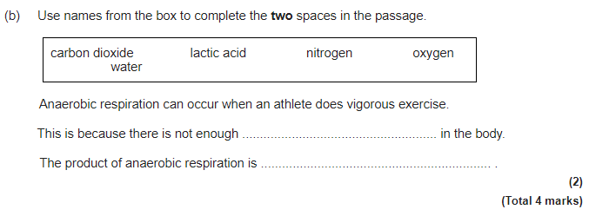
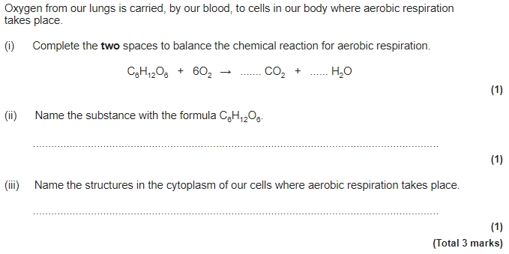

3. Keeping healthy 2
Key learning outcomes
- Compare aerobic and anaerobic respiration linking to exercise.
- Define communicable and non-communicable diseases giving examples.
- Discuss how the body can defend itself from disease.

BBC Bitesize
Respiration - https://www.bbc.co.uk/bitesize/guides/zq349j6/revision/1
Disease - https://www.bbc.co.uk/bitesize/guides/zxr7ng8/revision/1
‘Mini Assessment’ Questions
1. Define aerobic respiration and anaerobic respiration.
2. Write down the word equation for aerobic and anaerobic respiration. Which type of respiration is used when an athlete sprints? What about during a marathon? Explain why.
3. Create a balanced symbol equation for both types of respiration.
4. State the difference between communicable and non-communicable diseases, giving examples.
5. Describe the ways in which the body protects itself. Remember to inlcude both external and internal defences.
6. What are the risk factors associated with an increase in non-communicable diseases?

First draft – using the knowledge you gained from the website above – black pen
_____________________________________________________________________________________________________________________________________________________________________________________________________________________________________________________________________________________________________________________________________________________________________________________________________________________________________________________________________________________________________________________________________________________________________________________________________________________________________________________________________________________________________________________________________________________________________________________________________________________________________________________________________________________________________________________________________________________________________________________________________________________________________________________________________________________________________________________________________________________________________________________________________________________________________________________________________________________________________________________________________________________________________________________________________________________________________________________________________________________________________________________________________________________________________________________________________________________________________________________________________________________________________________________________________________________________________________________________________________________________________________________________________________________________________________________________________________________________________________________________________________________________________________________________________________________________________________________________________________________________________________________________________________________________________________________________________________________________________________________________________________________________________________________________________________________________________________________________________________________________________________________________________________________________________________________________________________________________________________________________________________________________________________________________________________________________________________________________________________________________________________________________________________________________________________________________________________________________________________________________________________________________________________________________________________________________________________________________________________________________________________________________________________________________________________________________________________________________________________________________________________________________________________________________________________________________________________________________________________________________________________________________________________________________________________________________________________________________________________________________________________________________________________________________________________________________________________________________________________________________________________________________________________________________________________________________________________________________________________________________________________________________________________________________________________________________________________________________________________________________________________________________________________________________________________________________________________________________________________________________________________________________________________________________________________________________________________________________________________________________________________________________________________________________________________________________________________________
Final draft – using the website above and your knowledge organiser – purple pen
______________________________________________________________________________________________________________________________________________________________________________________________________________________________________________________________________________________________________________________________________________________________________________________________________________________________________________________________________________________________________________________________________________________________________________________________________________________________________________________________________________________________________________________________________________________________________________________________________________________________________________________________________________________________________________________________________________________________________________________________________________________________________________________________________________________________________________________________________________________________________________________________________________________________________________________________________________________________________________________________________________________________________________________________________________________________________________________________________________________________________________________________________________________________________________________________________________________________________________________________________________________________________________________________________________________________________________________________________________________________________________________________________________________________________________________________________________________________________________________________________________________________________________________________________________________________________________________________________________________________________________________________________________________________________________________________________________________________________________________________________________________________________________________________________________________________________________________________________________________________________________________________________________________________________________________________________________________________________________________________________________________________________________________________________________________________________________________________________________________________________________________________________________________________________________________________________________________________________________________________________________________________________________________________________________________________________________________________________________________________________________________________________________________________________________________________________________________________________________________________________________________________________________________________________________________________________________________________________________________________________________________________________________________________________________________________________________________________________________________________________________________________________________________________________________________________________________________________________________________________________________________________________________________________________________________________________________________________________________________________________________________________________________________________________________________________________________________________________________________________________________________________________________________________________________________________________________________________________________________________________________________________________________________________________________________________________________________________________________________________________________________________

Complete EduCake (Home Education 3)
Application Questions
Q2.Nancy is a dancer.
(a) When Nancy dances her arms and legs are moved by pairs of antagonistic muscles.
How do antagonistic muscle pairs work?
Tick the correct box.
Both muscles contract at the same time.
One muscle is big and the other is small.
As one muscle contracts, the other relaxes.
One muscle is strong and the other is weak.
Both muscles relax at the same time.
1 mark
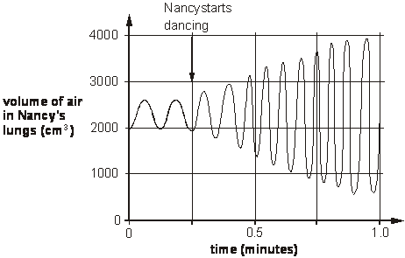
(b) As Nancy dances her breathing changes because she needs more oxygen.
The graph below shows how the volume of air in her lungs changes
when she dances.
From the graph, give one way her breathing changes when she
dances.
………….........................................................................................................
1 mark
(c) Nancy’s muscle cells produce carbon dioxide as she dances.
Which of the following shows how the carbon dioxide is removed from Nancy’s body?
Tick the correct box.
muscle cells bloodstream windpipe lungs nose
muscle cells windpipe lungs bloodstream nose
muscle cells bloodstream lungs windpipe nose
muscle cells windpipe bloodstream lungs nose
4. Energy from food 1 – balanced diets
Key learning outcomes
- Identify different food groups in relation to energy, balanced and unbalanced diets.

BBC Bitesize

https://www.bbc.co.uk/bitesize/guides/zyjx6sg/revision/1

‘Mini Assessment’ Questions
1. Name the different food groups and give their use in the body.
2. Why do different people have different energy needs when it comes to food?
3. Describe two effects of a poor diet and explain what problems they can cause the body.
4. What is meant by the term “a balanced diet”.
5. What effects does eating too much food have on the body, both internally and externally?
6. Analyse the food you eat in a typical day. Do you think you have a balanced diet? Give reasons for you answers.
First draft – using the knowledge you gained from the website above – black pen
______________________________________________________________________________________________________________________________________________________________________________________________________________________________________________________________________________________________________________________________________________________________________________________________________________________________________________________________________________________________________________________________________________________________________________________________________________________________________________________________________________________________________________________________________________________________________________________________________________________________________________________________________________________________________________________________________________________________________________________________________________________________________________________________________________________________________________________________________________________________________________________________________________________________________________________________________________________________________________________________________________________________________________________________________________________________________________________________________________________________________________________________________________________________________________________________________________________________________________________________________________________________________________________________________________________________________________________________________________________________________________________________________________________________________________________________________________________________________________________________________________________________________________________________________________________________________________________________________________________________________________________________________________________________________________________________________________________________________________________________________________________________________________________________________________________________________________________________________________________________________________________________________________________________________________________________________________________________________________________________________________________________________________________________________________________________________________________________________________________________________________________________________________________________________________________________________________________________________________________________________________________________________________________________________________________________________________________________________________________________________________________________________________________________________________________________________________________________________________________________________________________________________________________________________________________________________________________________________________________________________________________________________________________________________________________________________________________________________________________________________________________________________________________________________________________________________________________________________________________________________________________________________________________________________________________________________________________________________________________________________________________________________________________________________________________________________________________________________________________________________________________________________________________________________________________________________________________________________________________________________________________________________________________________________________________________________________________________________________________________________________________________________________________________________________________________________________________________________________________________________________________________________________________________________________________________________________
Final draft – using the website above and your knowledge organiser – purple pen
____________________________________________________________________________________________________________________________________________________________________________________________________________________________________________________________________________________________________________________________________________________________________________________________________________________________________________________________________________________________________________________________________________________________________________________________________________________________________________________________________________________________________________________________________________________________________________________________________________________________________________________________________________________________________________________________________________________________________________________________________________________________________________________________________________________________________________________________________________________________________________________________________________________________________________________________________________________________________________________________________________________________________________________________________________________________________________________________________________________________________________________________________________________________________________________________________________________________________________________________________________________________________________________________________________________________________________________________________________________________________________________________________________________________________________________________________________________________________________________________________________________________________________________________________________________________________________________________________________________________________________________________________________________________________________________________________________________________________________________________________________________________________________________________________________________________________________________________________________________________________________________________________________________________________________________________________________________________________________________________________________________________________________________________________________________________________________________________________________________________________________________________________________________________________________________________________________________________________________________________________________________________________________________________________________________________________________________________________________________________________________________________________________________________________________________________________________________________________________________________________________________________________________________________________________________________________________________________________________________________________________________________________________________________________________________________________________________________________________________________________________________________________________________________________________________________________________________________________________________________________________________________________________________________________________________________________________________________________________________________________________________________________________________________________________________________________________________________________________________________________________________________________________________________________________________________________________________________________________________________________________________________________________________________________________________________________________________________________________________________________________________________________________________________________________________________________________________________________________________________________________________

Complete EduCake (Home Education 4)
Application Questions
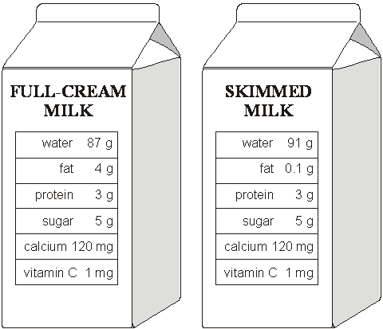
Q2.The drawings show the amounts of different substances in 100g of full-cream milk and 100g of skimmed milk.

(a) Use the information in the drawings to complete the sentence.
When skimmed milk is made from full-cream milk, most of the
............................................ is taken out. 1 mark

(b) (i) Look at the drawings.
Which substance in milk do we need for strong bones and teeth?
..........................................................
1 mark
(ii) How are substances carried around the body?
................................................................................................................
1 mark
(c) (i) Which animals produce milk to feed their young?
Tick the correct box.
amphibians birds
mammals reptiles
1 mark
(ii) A baby fed on its mother’s milk gets fewer infections. What is the reason for this? Tick the correct box.
The milk contains antibodies.
The milk contains water.
The milk is at body temperature.
The milk is a liquid.
1 mark
5. Waves and pressure
Key learning outcomes
- Compare the effects of pressure in solids, liquids and gases.
- Describe the electromagnetic spectrum and uses of each wave.
- Evaluate sound as a wave linking properties to uses.
- Define reflection and refraction using diagrams to support the understanding.
- Explain how the eye works and can see different colours.
- Compare transverse and longitudinal waves linking their properties to their use.
BBC Bitesize

https://www.bbc.co.uk/bitesize/topics/zw982hv (light waves, features of waves, sound waves – click on the ‘Revise’ links)

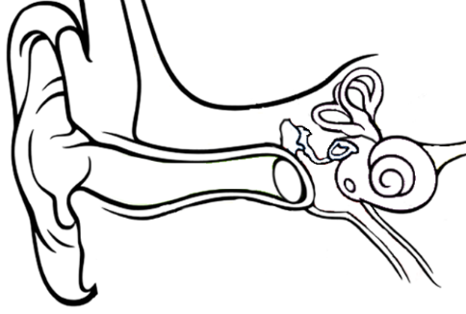
‘Mini Assessment’ Questions
1. Label the parts of the ear and describe how sound travels.
2. Define the terms amplitude, frequency and wavelength.
3. Explain the difference between transverse and longitudinal waves, using labelled diagrams.
4. Compare sound waves and electromagnetic waves. What type of waves are they? Can they travel through a vacuum? How fast do they travel?
5. List the 7 parts of an electromagnetic spectrum in order of wavelength from smallest to largest. State some uses of these waves.
6. Describe reflection and refraction, drawing diagrams to show the light rays. Include in your answer the law of reflection.

First draft – using the knowledge you gained from the website above – black pen
______________________________________________________________________________________________________________________________________________________________________________________________________________________________________________________________________________________________________________________________________________________________________________________________________________________________________________________________________________________________________________________________________________________________________________________________________________________________________________________________________________________________________________________________________________________________________________________________________________________________________________________________________________________________________________________________________________________________________________________________________________________________________________________________________________________________________________________________________________________________________________________________________________________________________________________________________________________________________________________________________________________________________________________________________________________________________________________________________________________________________________________________________________________________________________________________________________________________________________________________________________________________________________________________________________________________________________________________________________________________________________________________________________________________________________________________________________________________________________________________________________________________________________________________________________________________________________________________________________________________________________________________________________________________________________________________________________________________________________________________________________________________________________________________________________________________________________________________________________________________________________________________________________________________________________________________________________________________________________________________________________________________________________________________________________________________________________________________________________________________________________________________________________________________________________________________________________________________________________________________________________________________________________________________________________________________________________________________________________________________________________________________________________________________________________________________________________________________________________________________________________________________________________________________________________________________________________________________________________________________________________________________________________________________________________________________________________________________________________________________________________________________________________________________________________________________________________________________________________________________________________________________________________________________________________________________________________________________________________________________________________________________________________________________________________________________________________________________________________________________________________________________________________________________________________________________________________________________________________________________________________________________________________________________________________________________________________________________________________________________________________________________________________________________________________________________________________________________________________________________________________________________________________________________________________________________________________
Final draft – using the website above and your knowledge organiser – purple pen
____________________________________________________________________________________________________________________________________________________________________________________________________________________________________________________________________________________________________________________________________________________________________________________________________________________________________________________________________________________________________________________________________________________________________________________________________________________________________________________________________________________________________________________________________________________________________________________________________________________________________________________________________________________________________________________________________________________________________________________________________________________________________________________________________________________________________________________________________________________________________________________________________________________________________________________________________________________________________________________________________________________________________________________________________________________________________________________________________________________________________________________________________________________________________________________________________________________________________________________________________________________________________________________________________________________________________________________________________________________________________________________________________________________________________________________________________________________________________________________________________________________________________________________________________________________________________________________________________________________________________________________________________________________________________________________________________________________________________________________________________________________________________________________________________________________________________________________________________________________________________________________________________________________________________________________________________________________________________________________________________________________________________________________________________________________________________________________________________________________________________________________________________________________________________________________________________________________________________________________________________________________________________________________________________________________________________________________________________________________________________________________________________________________________________________________________________________________________________________________________________________________________________________________________________________________________________________________________________________________________________________________________________________________________________________________________________________________________________________________________________________________________________________________________________________________________________________________________________________________________________________________________________________________________________________________________________________________________________________________________________________________________________________________________________________________________________________________________________________________________________________________________________________________________________________________________________________________________________________________________________________________________________________________________________________________________________________________________________________________________________________________________________________________________________________________________________________________________________________________________________________________

Complete EduCake (Home Education 5)
Application Questions
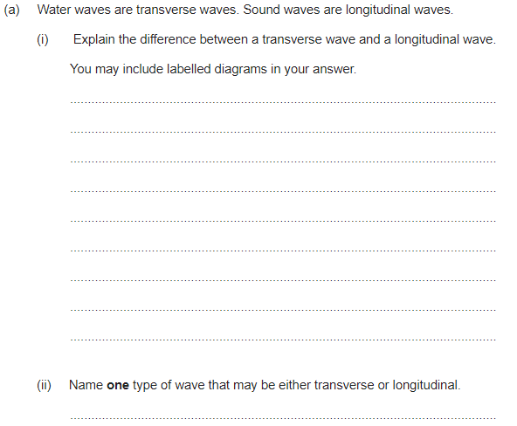
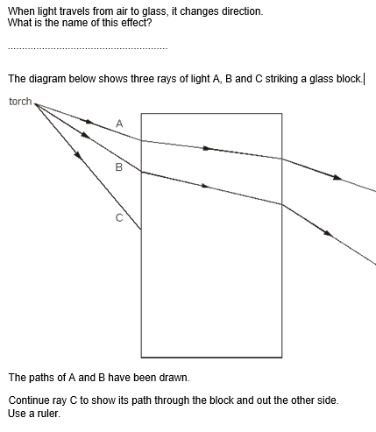
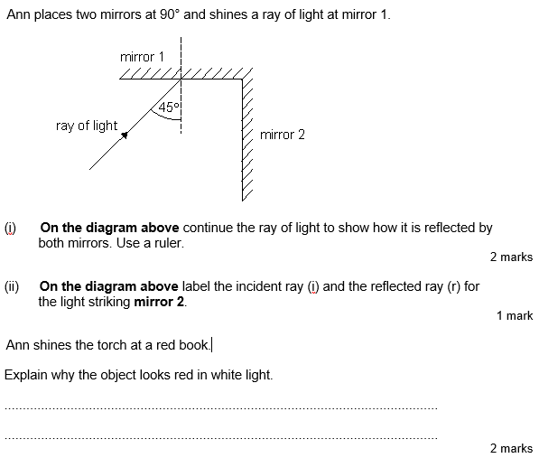

6. Reactions 1
Key learning outcomes
- Describe the reactivity series of metals and their associated reactions.
- Create word equations and balanced symbol equations for a range of different reactions.
- Compare the reactions of metals with oxygen and metals with acids and carbonates.
- Describe factors that can affect the rate of a reaction.

BBC Bitesize

https://www.bbc.co.uk/bitesize/guides/zqd2mp3/revision/1

https://www.bbc.co.uk/bitesize/guides/zct4fcw/revision/1
‘Mini Assessment’ Questions
1. Define conservation of mass and give an example using the reaction of hydrogen and oxygen.
2. Write a general equation for the reactions of: metal and acid, metal carbonate and acid, metal hydroxide and acid, metal and oxygen.
3. Complete the following equations:
Iron + hydrochloric acid ->
Aluminium + nitric acid ->
Lead + sulfuric acid ->
Aluminium chloride + sodium ->
Methane + oxygen ->
Magnesium + oxygen ->

4. Describe how we can measure the rate of a reaction and state the equation we use to calculate it, stating the appropriate units in your answer.
5. State the 4 factors that can affect the rate of a reaction.
6. Choose a factor from question 5 and explain how this affects the rate of a reaction, referring to successful collisions.

First draft – using the knowledge you gained from the website above – black pen
______________________________________________________________________________________________________________________________________________________________________________________________________________________________________________________________________________________________________________________________________________________________________________________________________________________________________________________________________________________________________________________________________________________________________________________________________________________________________________________________________________________________________________________________________________________________________________________________________________________________________________________________________________________________________________________________________________________________________________________________________________________________________________________________________________________________________________________________________________________________________________________________________________________________________________________________________________________________________________________________________________________________________________________________________________________________________________________________________________________________________________________________________________________________________________________________________________________________________________________________________________________________________________________________________________________________________________________________________________________________________________________________________________________________________________________________________________________________________________________________________________________________________________________________________________________________________________________________________________________________________________________________________________________________________________________________________________________________________________________________________________________________________________________________________________________________________________________________________________________________________________________________________________________________________________________________________________________________________________________________________________________________________________________________________________________________________________________________________________________________________________________________________________________________________________________________________________________________________________________________________________________________________________________________________________________________________________________________________________________________________________________________________________________________________________________________________________________________________________________________________________________________________________________________________________________________________________________________________________________________________________________________________________________________________________________________________________________________________________________________________________________________________________________________________________________________________________________________________________________________________________________________________________________________________________________________________________________________________________________________________________________________________________________________________________________________________________________________________________________________________________________________________________________________________________________________________________________________________________________________________________________________________________________________________________________________________________________________________________________________________________________________________________________________________________________________________________________________________________________________________________________________________________________________________________________________________________
Final draft – using the website above and your knowledge organiser – purple pen
______________________________________________________________________________________________________________________________________________________________________________________________________________________________________________________________________________________________________________________________________________________________________________________________________________________________________________________________________________________________________________________________________________________________________________________________________________________________________________________________________________________________________________________________________________________________________________________________________________________________________________________________________________________________________________________________________________________________________________________________________________________________________________________________________________________________________________________________________________________________________________________________________________________________________________________________________________________________________________________________________________________________________________________________________________________________________________________________________________________________________________________________________________________________________________________________________________________________________________________________________________________________________________________________________________________________________________________________________________________________________________________________________________________________________________________________________________________________________________________________________________________________________________________________________________________________________________________________________________________________________________________________________________________________________________________________________________________________________________________________________________________________________________________________________________________________________________________________________________________________________________________________________________________________________________________________________________________________________________________________________________________________________________________________________________________________________________________________________________________________________________________________________________________________________________________________________________________________________________________________________________________________________________________________________________________________________________________________________________________________________________________________________________________________________________________________________________________________________________________________________________________________________________________________________________________________________________________________________________________________________________________________________________________________________________________________________________________________________________________________________________________________________________________________________________________________________________________________________________________________________________________________________________________________________________________________________________________________________________________________________________________________________________________________________________________________________________________________________________________________________________________________________________________________________________________________________________________________________________________________________________________________________________________________________________________________________________________________________________________________________________________________________________________________________________________________________________________________________________________________________________________________________________________________________________________________________________
Complete EduCake (Home Education 6)
Application Questions
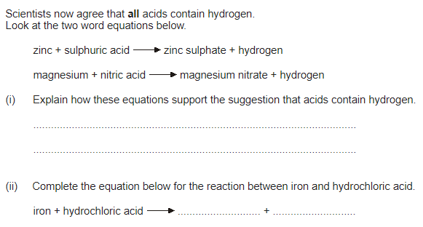
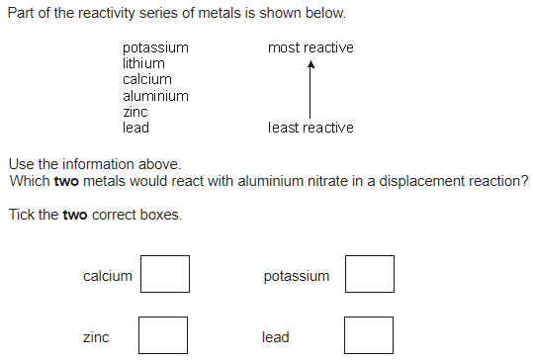
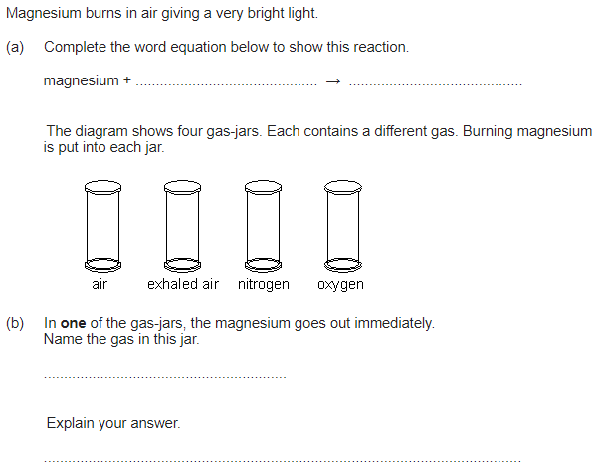
7. Reactions 2
Key learning outcomes
- Discuss the importance of the carbon cycle and effective recycling.
- Evaluate the use of fossil fuels and their effect on the environment.

BBC Bitesize

https://www.bbc.co.uk/bitesize/guides/z27thyc/revision/1

‘Mini Assessment’ Questions
1. Describe the journey of carbon through the carbon cycle, using the diagram below.
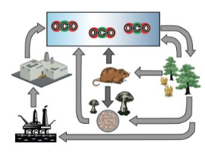
2. Name the three types of fossil fuel and how they are formed.
3. Compare complete and incomplete combustion, writing their general equation.
4. How have humans affected the carbon cycle? Refer to the burning of fossil fuels in your answer.
5. Compare climate change and global warming and state the effects of climate change on our planet.
6. Referring to the carbon cycle, explain how planting more trees would help us fight climate change.

First draft – using the knowledge you gained from the website above – black pen
________________________________________________________________________________________________________________________________________________________________________________________________________________________________________________________________________________________________________________________________________________________________________________________________________________________________________________________________________________________________________________________________________________________________________________________________________________________________________________________________________________________________________________________________________________________________________________________________________________________________________________________________________________________________________________________________________________________________________________________________________________________________________________________________________________________________________________________________________________________________________________________________________________________________________________________________________________________________________________________________________________________________________________________________________________________________________________________________________________________________________________________________________________________________________________________________________________________________________________________________________________________________________________________________________________________________________________________________________________________________________________________________________________________________________________________________________________________________________________________________________________________________________________________________________________________________________________________________________________________________________________________________________________________________________________________________________________________________________________________________________________________________________________________________________________________________________________________________________________________________________________________________________________________________________________________________________________________________________________________________________________________________________________________________________________________________________________________________________________________________________________________________________________________________________________________________________________________________________________________________________________________________________________________________________________________________________________________________________________________________________________________________________________________________________________________________________________________________________________________________________________________________________________________________________________________________________________________________________________________________________________________________________________________________________________________________________________________________________________________________________________________________________________________________________________________________________________________________________________________________________________________________________________________________________________________________________________________________________________________________________________________________________________________________________________________________________________________________________________________________________________________________________________________________________________________________________________________________________________________________________________________________________________________________________________________________________________________________________________________________________________________________________________________________________________________________________________________________________________________________________________________________________________________________________________________________________________________________________________________________________________________________________
Final draft – using the website above and your knowledge organiser – purple pen
______________________________________________________________________________________________________________________________________________________________________________________________________________________________________________________________________________________________________________________________________________________________________________________________________________________________________________________________________________________________________________________________________________________________________________________________________________________________________________________________________________________________________________________________________________________________________________________________________________________________________________________________________________________________________________________________________________________________________________________________________________________________________________________________________________________________________________________________________________________________________________________________________________________________________________________________________________________________________________________________________________________________________________________________________________________________________________________________________________________________________________________________________________________________________________________________________________________________________________________________________________________________________________________________________________________________________________________________________________________________________________________________________________________________________________________________________________________________________________________________________________________________________________________________________________________________________________________________________________________________________________________________________________________________________________________________________________________________________________________________________________________________________________________________________________________________________________________________________________________________________________________________________________________________________________________________________________________________________________________________________________________________________________________________________________________________________________________________________________________________________________________________________________________________________________________________________________________________________________________________________________________________________________________________________________________________________________________________________________________________________________________________________________________________________________________________________________________________________________________________________________________________________________________________________________________________________________________________________________________________________________________________________________________________________________________________________________________________________________________________________________________________________________________________________________________________________________________________________________________________________________________________________________________________________________________________________________________________________________________________________________________________________________________________________________________________________________________________________________________________________________________________________________________________________________________________________________________________________________________________________________________________________________________________________________________________________________________________________________________________________________________________________________________________________________________________________________________________________________________________________________________________________________________________________________________________________________
Complete EduCake (Home Education 7)
Application Questions
Q5.When bath ‘bombs’ are dropped into bath water they colour the water and make the water smell of perfume.
(a) Bath bombs contain citric acid and sodium carbonate. When they react a gas is produced.
Complete the word equation for the reaction that takes place.
citric + sodium sodium + water + ...............................
acid carbonate citrate
1 mark
(b) A bath bomb was dropped into hot water and its mass was measured every thirty seconds, for three minutes.
The graph below shows the results.
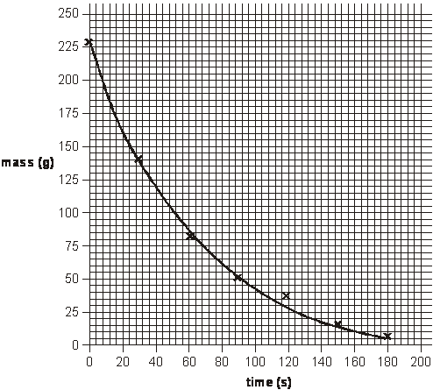
Between which two times on the graph does the mass of the bath bomb
decrease fastest? Tick the correct box.
between 0 s and 30s
between 30 s and 60s
between 90 s and 120s
between 150 s and 180s
1 mark

(c) The reactants in a bath bomb were 176g at the start.
129g of sodium citrate and 14g of water are produced in the reaction.
Calculate the mass of gas produced in the reaction.
...............................................................................................................
1 mark
(d) Complete the word equation for the reaction between citric acid and calcium carbonate. Use the equation in part (a) to help you.
citric + calcium water + ............................... + ...............................
acid carbonate
1 mark

8. Energy from food 2 – the digestive system
Key learning outcomes
- Describe and explain the process of human digesetion.

BBC Bitesize

https://www.bbc.co.uk/bitesize/guides/z9pv34j/revision/1

‘Mini Assessment’ Questions
1. Name the organs involved in human digestion and describe what each does.
2. Describe the different stages of digestion from food entering the mouth, to leaving the body through the anus.
3. What are the three main digestive enzymes and what describe what type of food each breaks down (don’t forget to say what the food is broken down into).
4. How is the small intestine adapted for absorption of nutrients?
5. Explain the difference between the small intestine and the large intestine.
6. Describe and explain the process of egestion.

First draft – using the knowledge you gained from the website above – black pen
________________________________________________________________________________________________________________________________________________________________________________________________________________________________________________________________________________________________________________________________________________________________________________________________________________________________________________________________________________________________________________________________________________________________________________________________________________________________________________________________________________________________________________________________________________________________________________________________________________________________________________________________________________________________________________________________________________________________________________________________________________________________________________________________________________________________________________________________________________________________________________________________________________________________________________________________________________________________________________________________________________________________________________________________________________________________________________________________________________________________________________________________________________________________________________________________________________________________________________________________________________________________________________________________________________________________________________________________________________________________________________________________________________________________________________________________________________________________________________________________________________________________________________________________________________________________________________________________________________________________________________________________________________________________________________________________________________________________________________________________________________________________________________________________________________________________________________________________________________________________________________________________________________________________________________________________________________________________________________________________________________________________________________________________________________________________________________________________________________________________________________________________________________________________________________________________________________________________________________________________________________________________________________________________________________________________________________________________________________________________________________________________________________________________________________________________________________________________________________________________________________________________________________________________________________________________________________________________________________________________________________________________________________________________________________________________________________________________________________________________________________________________________________________________________________________________________________________________________________________________________________________________________________________________________________________________________________________________________________________________________________________________________________________________________________________________________________________________________________________________________________________________________________________________________________________________________________________________________________________________________________________________________________________________________________________________________________________________________________________________________________________________________________________________________________________________________________________________________________________________________________________________________________________________________________________________________________________________________________________________________________________________________
Final draft – using the website above and your knowledge organiser – purple pen
______________________________________________________________________________________________________________________________________________________________________________________________________________________________________________________________________________________________________________________________________________________________________________________________________________________________________________________________________________________________________________________________________________________________________________________________________________________________________________________________________________________________________________________________________________________________________________________________________________________________________________________________________________________________________________________________________________________________________________________________________________________________________________________________________________________________________________________________________________________________________________________________________________________________________________________________________________________________________________________________________________________________________________________________________________________________________________________________________________________________________________________________________________________________________________________________________________________________________________________________________________________________________________________________________________________________________________________________________________________________________________________________________________________________________________________________________________________________________________________________________________________________________________________________________________________________________________________________________________________________________________________________________________________________________________________________________________________________________________________________________________________________________________________________________________________________________________________________________________________________________________________________________________________________________________________________________________________________________________________________________________________________________________________________________________________________________________________________________________________________________________________________________________________________________________________________________________________________________________________________________________________________________________________________________________________________________________________________________________________________________________________________________________________________________________________________________________________________________________________________________________________________________________________________________________________________________________________________________________________________________________________________________________________________________________________________________________________________________________________________________________________________________________________________________________________________________________________________________________________________________________________________________________________________________________________________________________________________________________________________________________________________________________________________________________________________________________________________________________________________________________________________________________________________________________________________________________________________________________________________________________________________________________________________________________________________________________________________________________________________________________________________________________________________________________________________________________________________________________________________________________________________________________________________________________________________________________
Complete EduCake (Home Education 8)
Application Questions
Q1.
The table below shows the average energy needed for each sport for one hour.
sport | average energy need for  one hour (kJ)
bowling | 1030
tennis | 1760
football | 2260
running | 3700
(a) (i) Sofia plays football for two hours each week. She also goes bowling for two hours each week.
Explain why Sofia uses up her food reserves more quickly when playing football than when bowling.
.............................................................................................................
.............................................................................................................
1 mark
(ii) Athletes should not drink alcohol before taking part in sport.
Give two effects of alcohol which would affect an athlete’s performance.
1. .........................................................................................................
1 mark
2. .........................................................................................................
1 mark
(b) Some athletes take glucose tablets before a 100 metre race.
They can also obtain glucose from starch in their diet.
A starch molecule is made up of many glucose molecules joined together as shown below.
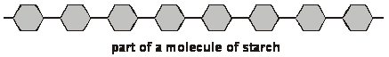
In the digestive system, starch is broken down into glucose:
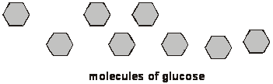
An athlete can obtain energy more quickly by eating glucose rather than starch.
Explain why.
.....................................................................................................................
1 mark
maximum 4 marks
Key word Definitions
Use the table below to write down any key words that you are unsure of. Use the links provided to find their meaning.
Key Word | What I think it means | What it actually means
Questions for the teacher
Use the space below to write down any questions you have about the learning that you would like to ask your teacher when you return to the Academy. The questions must be linked to the work in the booklet.
Question | Answer from the teacher

Reflection on your learning
Thank you for trying your best with the booklet. We know you have worked hard to maintain your education and consolidate old knowledge while learning some new knowledge.
Using the space below;
- Write a WWW (What Went Well) about your work in the booklet.
- Write an EBI (Even Better If) about your work in the booklet.

WWW
________________________________________________________________________________________________________________________________________________________________________________________________________________________________________________________________________________________________________________________________________

EBI
________________________________________________________________________________________________________________________________________________________________________________________________________________________________________________________________________________________________________________________________________

Using the space below, and giving reasons where you can;
- Write down the three parts of the booklet you enjoyed learning about the most.
- Write down two parts of the booklet you found the hardest to learn.

What did you enjoy the most?
________________________________________________________________________________________________________________________________________________________________________________________________________________________________________________________________________________________________________________________________________

Which parts did you find hardest to learn?
________________________________________________________________________________________________________________________________________________________________________________________________________________________________________________________________________________________________________________________________________

Thank you
OADV Team Science

