## http://www.waukeganparks.org/wp-content/uploads/2015/07/710146-events_header-300x300.png

**Reading Rockets**

Last term, Class Ahlberg’s highest Rocket Readers in a week was

73%

To be a Rocket Reader, children must read at home at least 3 times a week and it must be recorded in their home learning journals!

# During this topic, we will be exploring castles, knights and princesses. We will be reading different stories, such as Zog and the Princess Doctors and Dragon Bones.

# We will also be reading The Storybook Knight, and using our knowledge of different writing lenses to practice our writing.

We will be learning about Chinese New Year and looking at why this is a festival that is celebrated, where it is celebrated and how!

In Maths, we will be learning all about number bonds to 5, including addition with partitioning. We will also be exploring 0, as well as 6, 7, 8 and 9. We will be looking at doubles and halves and learning how to use all of the strategies we have learnt to solve these mathematical problems.

Time Travellers

**22nd January –** Lunar New year

**10th February –** Last day of term

**10th February** – full day topic experiences – information to follow.

**TBC -** Parent event

**TBC** – Monthly Meet – Phonics and writing.

# Class Ahlberg

# Spring Term 1 - 2022



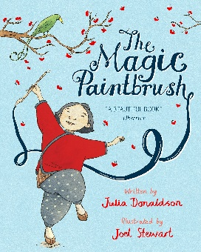

# Help at home by….

* Completing homework weekly – and encouraging *the children to do this on their own.*
* Reading 3 times a week and recording in their reading journal.
* Explore the curious questions on the Knowledge Organiser.
* Help your child to complete at least three tasks from the homework menu.
* Access Purple mash and explore the website using the logins in your home learning journals.

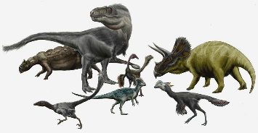

**HABITUDES OF THE TERM.**

Every half term, we are learning all about Oasis’ 9 habits. Last half term we focused on ‘***JOYFUL***’. This half term we are going to focus on the following:

Visit our Academy Twitter and Facebook pages to find out more about what happens at Oasis Don Valley! <http://facebook.com/OasisAcademyDonValley/>  @oasisdonvalley

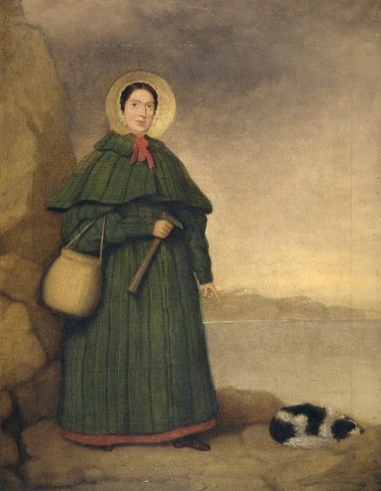

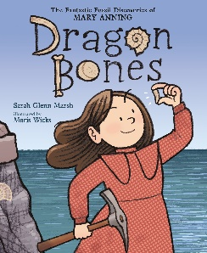

**

**Well done to Class Ahlberg’s STAR LEARNERS**

Well done to ALL of

Class Ahlberg, who performed in our Christmas Production as children in Spain! We even learnt how to sing the Spanish song Feliz Navidad!

Once the children are given their iPads, class teachers will add links and other useful tools for the children in this section of the newsletter.